RYDA Newsletter 03/2023

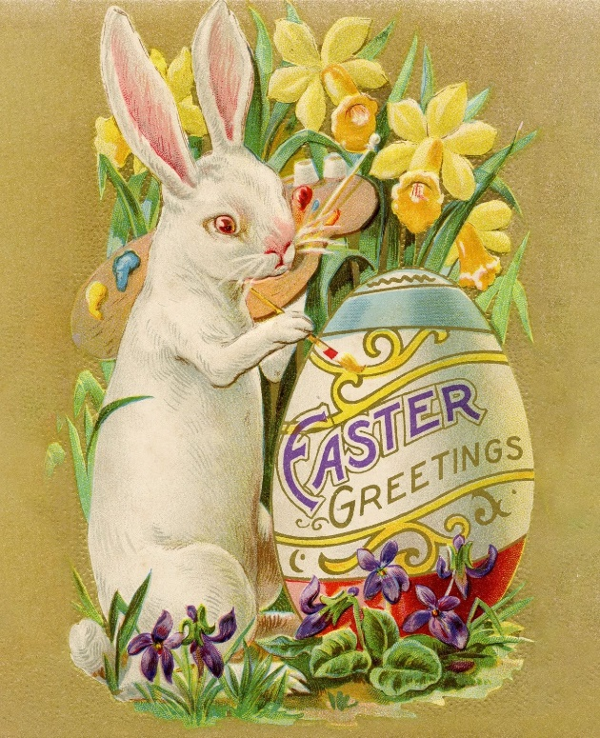
The Easter Bunny (also called the Easter Rabbit or Easter Hare) is a folkloric figure and symbol of Easter, depicted as a rabbit—sometimes dressed with clothes—bringing Easter eggs.
Originating among German Lutherans, the "Easter Hare" originally played the role of a judge, evaluating whether children were good or disobedient in behaviour at the start of the season of Eastertide, similar to the "naughty or nice" list made by Santa Claus. As part of the legend, the creature carries coloured eggs in its basket, as well as candy, and sometimes toys, to the homes of children. As such, the Easter Bunny again shows similarities to Santa and Christmas by bringing gifts to children on the night before a holiday.

Rabbits and hares
The hare was a popular motif in medieval church art. In ancient times, it was widely believed that the hare was a hermaphrodite. The idea that a hare could reproduce without loss of virginity led to an association with the Virgin Mary, with hares sometimes occurring in lluminated manuscripts and Northern European paintings of the Virgin and Christ Child. It may also have been associated with the Holy Trinity, as in the three hare’s motif.

Eggs
Eggs have been used as fertility symbols since antiquity. Eggs became a symbol in Christianity associated with rebirth as early as the 1st century AD and they became associated with Easter specifically in medieval Europe, when eating them was prohibited during the fast of Lent. A common practice in England at that time was for children to go door-to-door begging for eggs on the Saturday before Lent began. People handed out eggs as special treats for children prior to their fast.
As a special dish, eggs would probably have been decorated as part of the Easter celebrations. Eggs boiled with some flowers change their colour, bringing the spring into the homes, and some over time added the custom of. decorating the eggs. Many Christians of the Eastern Orthodox Church to this day typically dye their Easter eggs red, the colour of blood, in recognition of the blood of the sacrificed Christ (and, of the renewal of life in springtime). Some also use the colour green, in honour of the new foliage emerging after the long-dead time of winter. The Ukrainian art of decorating eggs for Easter, known as pysanky, dates to ancient, pre-Christian times. Similar variants of this form of artwork are seen amongst other eastern and central European cultures.
Pysanky Art

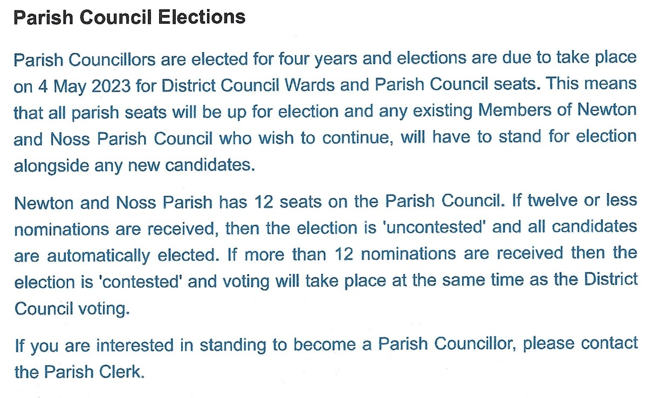

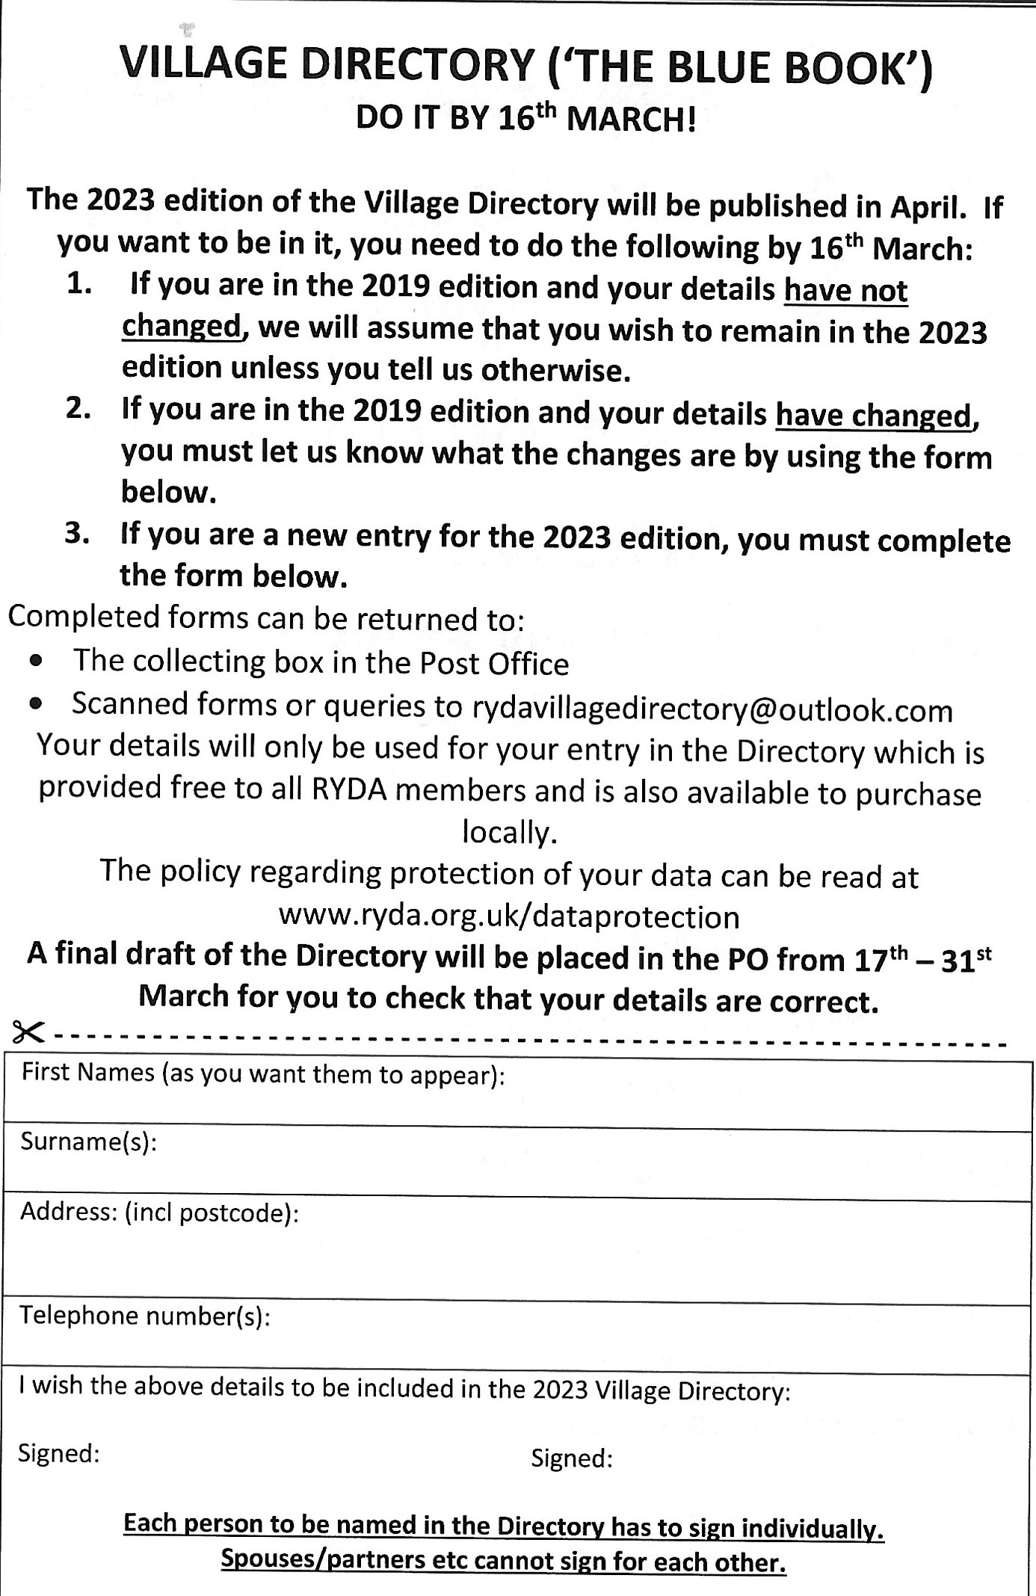

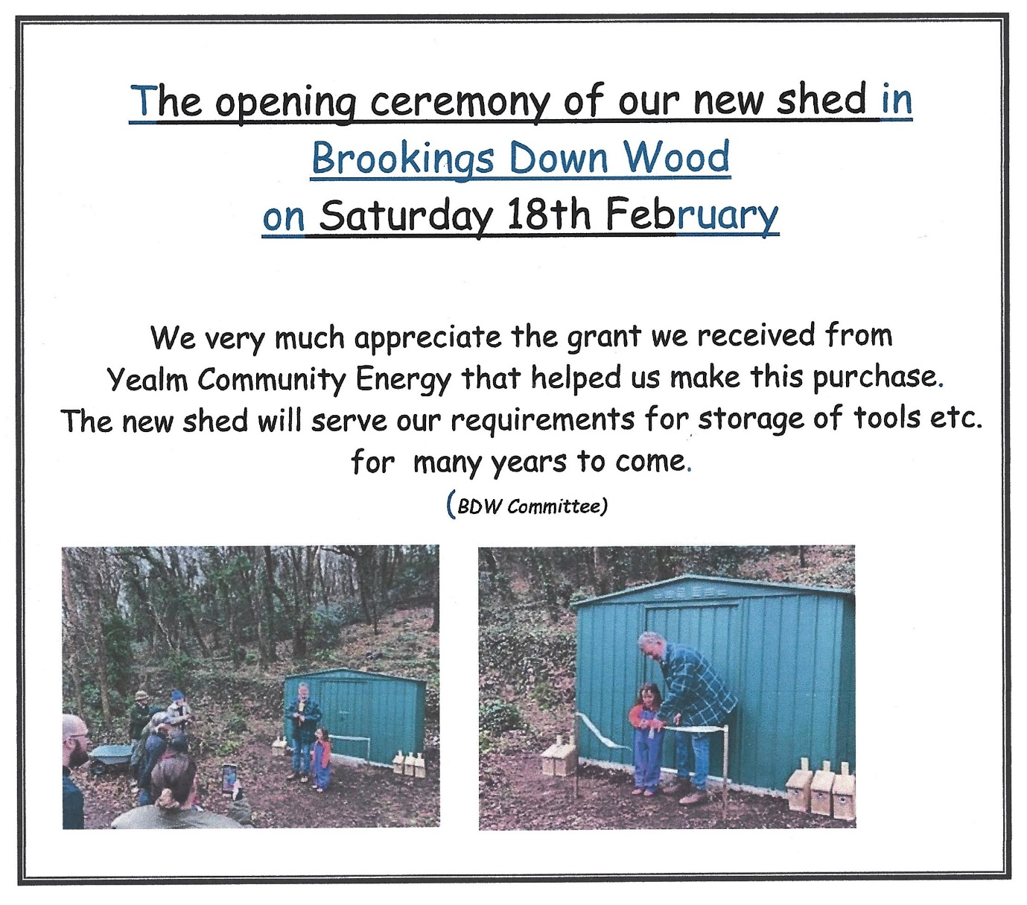

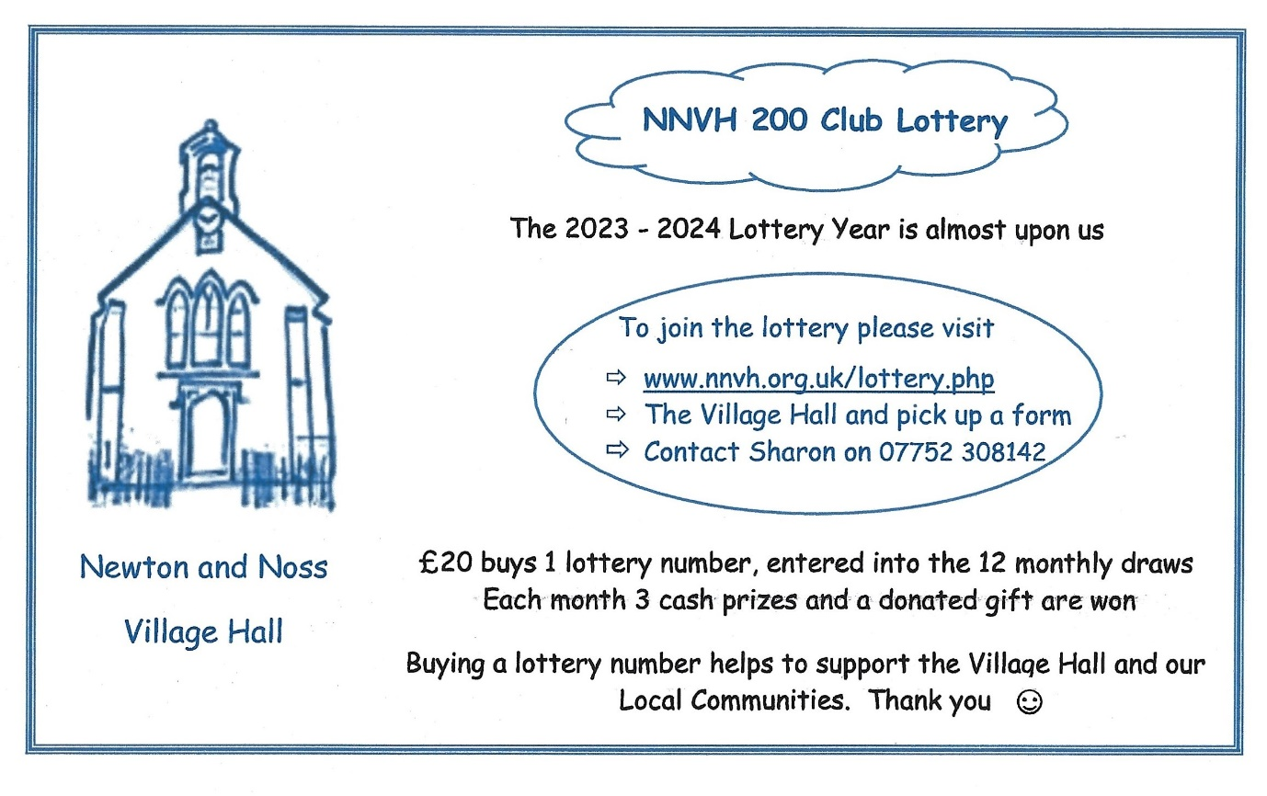

Planning

Newton Downs Farm Barn Conversion –– Application Reference 4462/22/FUL
This barn is within the Newton Downs Farm complex of buildings, sitting low in the landscape in a slight hollow. Although it has had several uses over recent years, it is now unused and falling into disrepair. The applicants wish to use the converted barn as their main house, repurposing the existing farmhouse as staff accommodation for the farm and Equus centre. Whilst the proposal will enable continuity for the business, the design is sympathetic to the existing structure and should enhance the general appearance of the site, a restriction to agricultural use should be applied.
Proposed barn conversion.
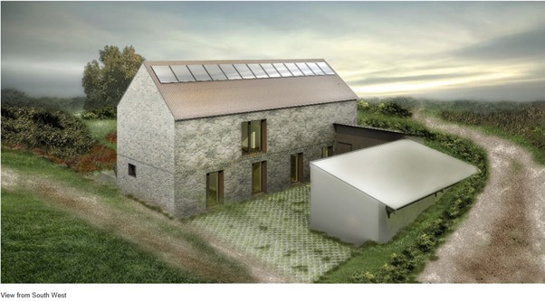

Briar Hill Farm, Court Road Extension to existing holiday park -– Application Reference 3993/22/FUL
This application is for an additional ten (10) holiday lodges, each with 3 bedrooms and associated access drive, parking, and landscaping. The proposed landscaping will include new native trees and shrubs, the creation of a new extensive wildflower meadow and related biodiversity enhancements.
A self-contained sewage system and surface water soakaway is proposed.
Two new publicly accessible electric vehicle fast charging points will also be provided on the site. Solar panels to an existing outbuilding and re-siting of gas tanks are also proposed.
An earlier application for an additional 14 lodges was withdrawn in 2021.
There is no doubt that this is a major extension of the current holiday park, which currently has 24 holiday lodges, and therefore raises several issues.
Increased visual impact. The site slopes gently to the south above the existing Briar Hill Farm Lodges and is easily visible at distance from high ground at several points to the south of the site. Whilst extensive planting is proposed, it can be expected that this will take from 5 to 10 years to grow sufficiently to provide any appreciable screening.
Significant development of a “green field” within the AONB and outside the “village settlement boundary”. Development outside the boundary should only be allowed “in exceptional circumstances and where it will meet an essential local need which cannot otherwise be met” (Newton and Noss Neighbourhood Plan N3P-1 b). Whilst there may be some demand for additional holiday accommodation, this cannot be said to meet a local need. Any development permitted outside the settlement boundary must “cause no significant adverse harm on natural or historic assets, important views and skylines, amenity, traffic parking or safety” (N3P-1 c).
Additional traffic emerging at a difficult junction on to Parsonage Road.
Future development. The application states that the additional lodges are necessary to secure a sustainable long-term future, you may wonder how the original current complement of 24 lodges, were viable, or if continuous expansion is necessary to the Business Plan.
Increased employment. The application states that there will be a requirement for two additional cleaners, one building maintenance worker and one further grounds maintenance worker, although only one will be full-time.
Two new publicly accessible electric vehicle fast charging points will also be provided on the site when there are no similar facilities in the parish.
Whilst there are positive aspects of this application, these may be outweighed by the potential negative aspects, what are your views?

92 Court Road. Construction of new detached 3 bed dwelling with associated access, parking & landscaping –Application Reference – 0072/23/FUL. (resubmission of 2581/22/FUL).
This application is the second for the site, the previous version being withdrawn in October 2022, which has outline permission and shows a substantial house on a relatively limited site.
The view below is borrowed from the Design and Access statement and as can be seen it is set well into the site, slightly behind the neighbouring houses.
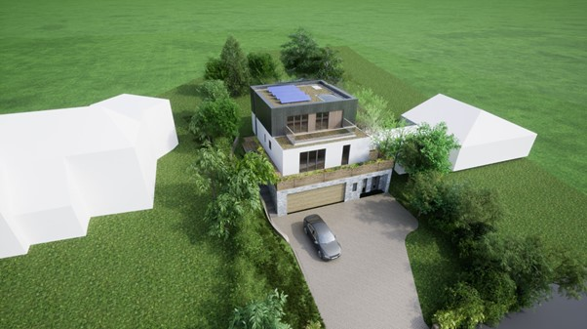
Whats On

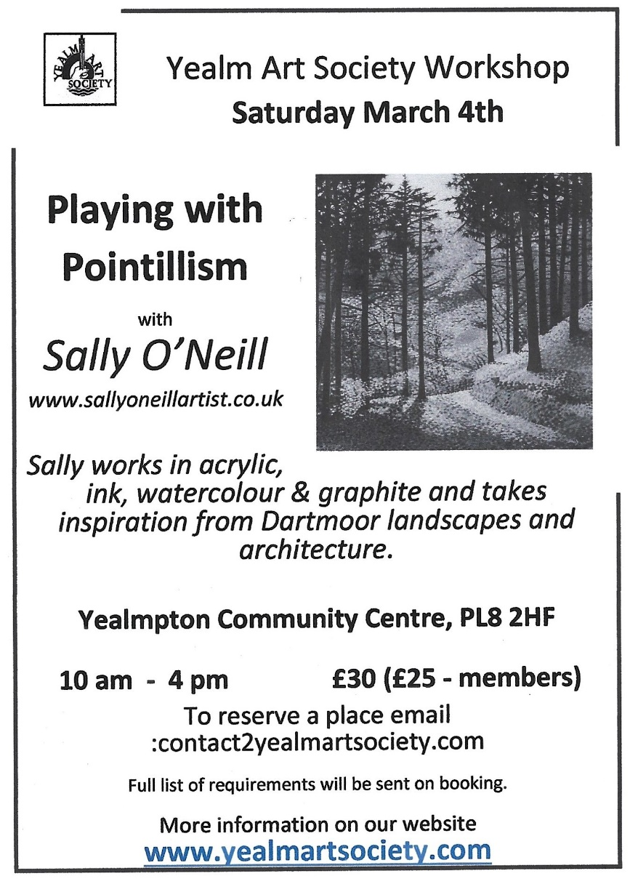

Meeting of the Parish Council:
Date: Thursday 9th March 2023
Time: 7 pm
Venue: Newton and Noss Village Hall, Noss Mayo
Members of the public are very welcome to attend. A copy of the agenda for March will be posted on the noticeboards and website a week before the meeting. Copies of the minutes of previous meetings can be
found on their website.

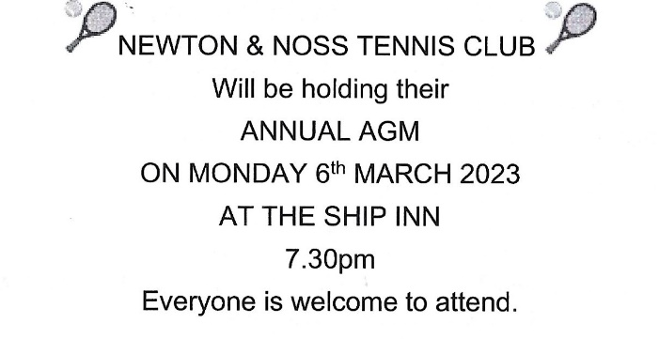
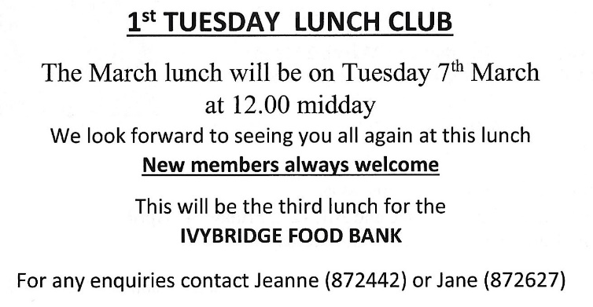

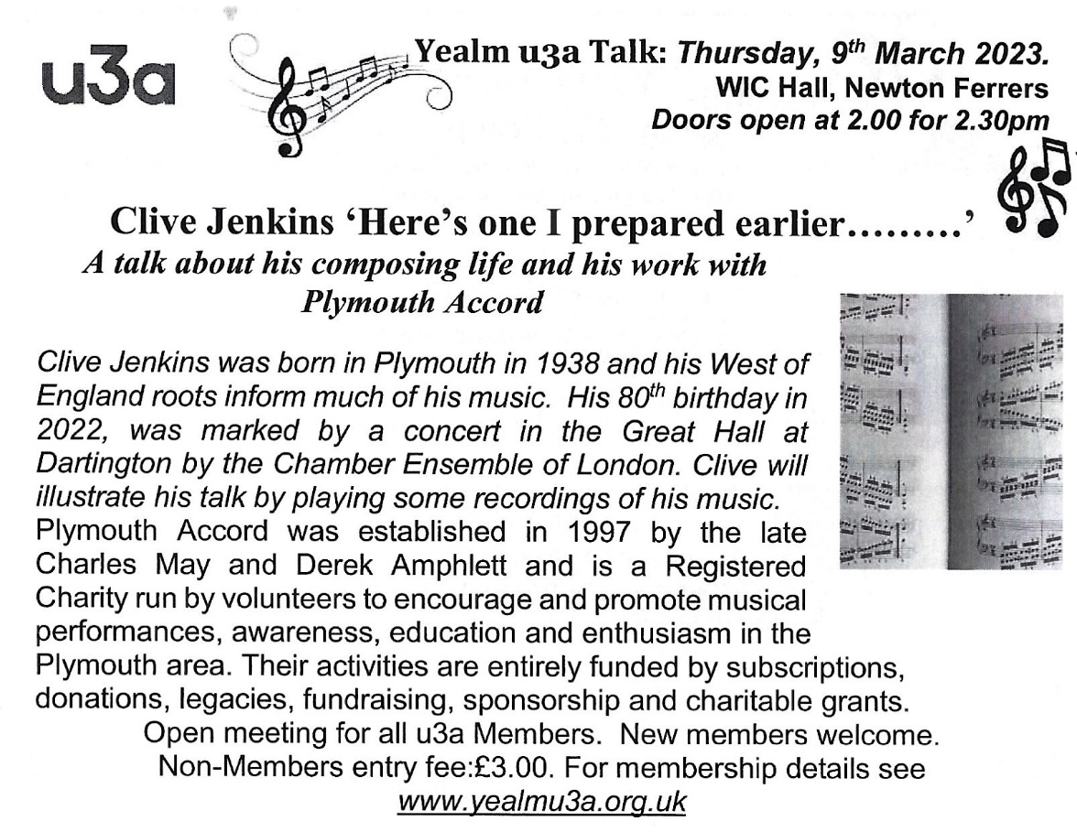

Ring for the King!

Calling all past, present and future bell ringers! You may have seen recently on the local news that there is a shortage of bell ringers to ring in every tower in Devon for the King’s coronation on May 6th. Here in Newton and Noss, we have two magnificent peals of bells and we are always on the look out for new ringers to come and join us.
We are having an Open Day on Saturday 11th March 2023 at Holy Cross church, Newton Ferrers, for people to come and see what we do, have a go at ringing a bell and consider joining the team to play the loudest instrument in the village! If you are aged 16+ (sorry we can’t take under 16s due to current legislation) and looking to learn a new skill, or maybe to revisit a skill you developed in the past, please come along any time between 11am and 4pm on 11th March, when you can find out more about learning to ring.
Refreshments and a light lunch will be available so please come and have a go! If you would like more information or to let us know that you will be coming, please phone me on 830344 or email me at nene_carr@hotmail.com. We look forward to seeing you.

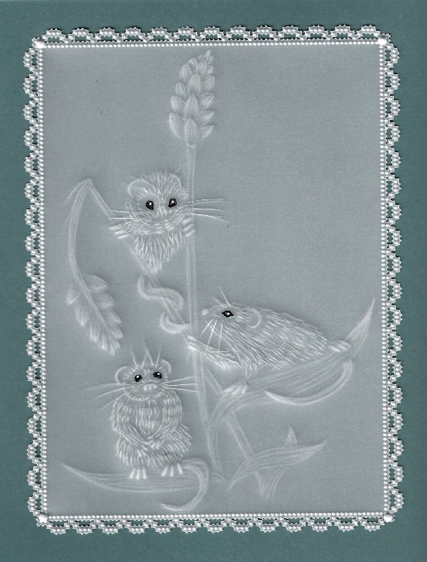

Yealm Parchment Craft Group
Newton & Noss WI hall
17th March 2-4pm £8
“Pure embossing
Equipment can be supplied if you don’t have it
Tel 07838375449

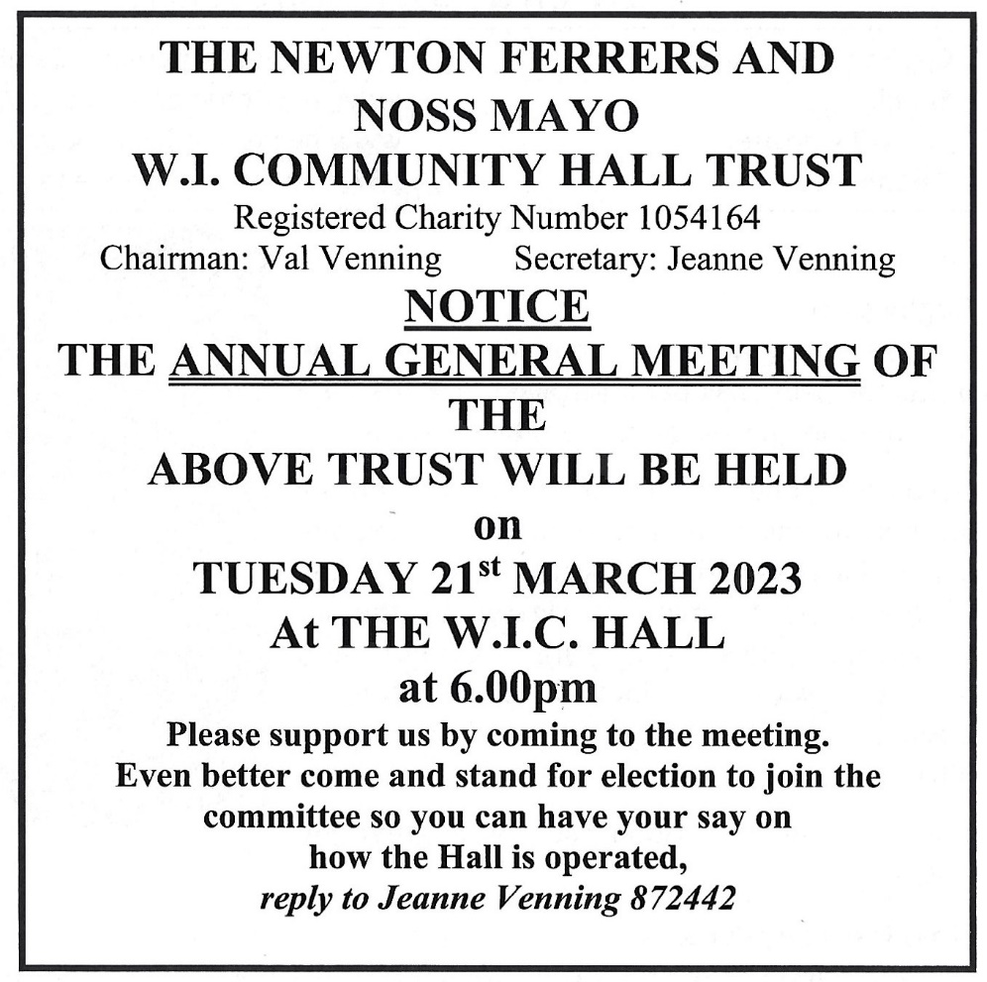

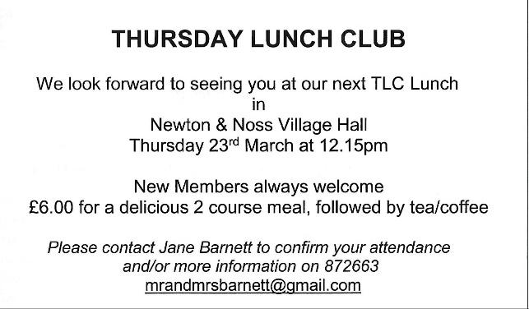

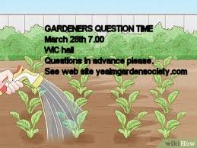

March 28th Newton & Noss WI Craft Group 2-4pm
Drop Spindle Spinning with Wendy
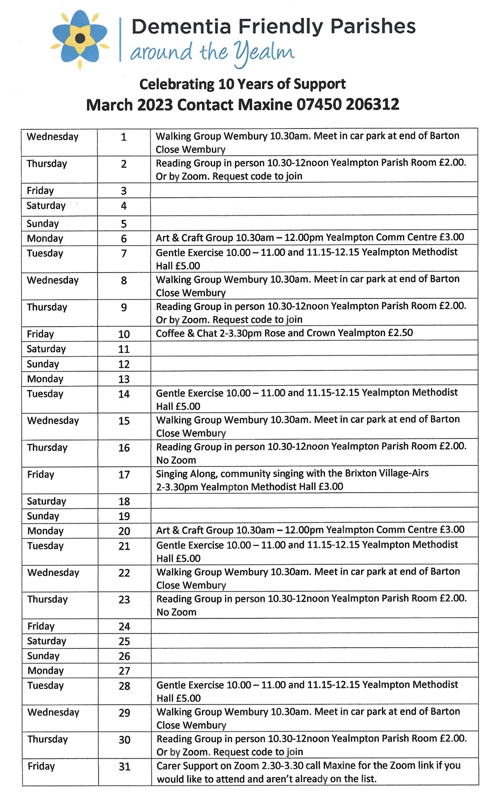
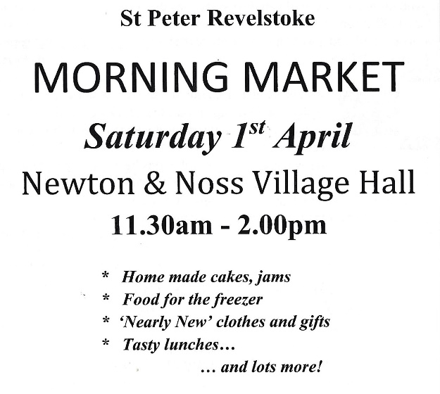

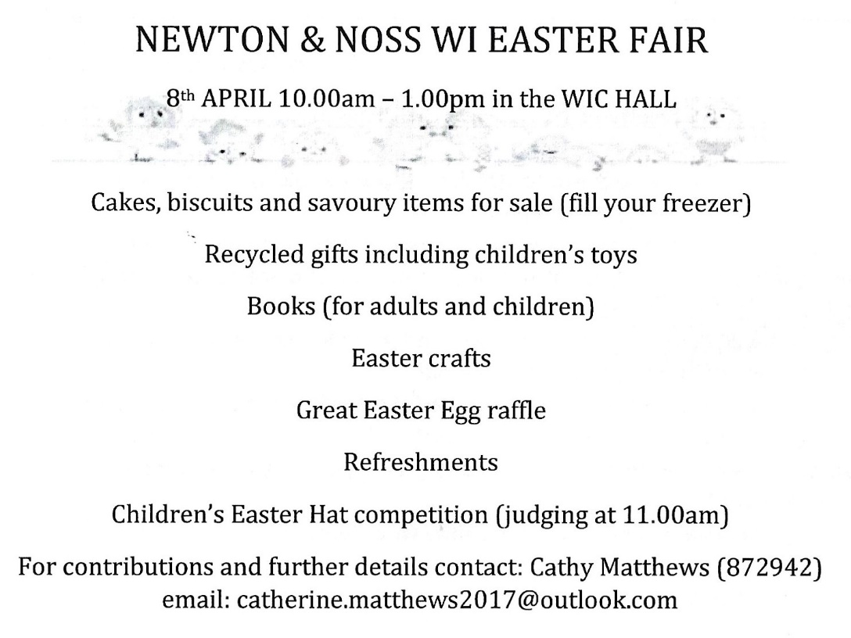

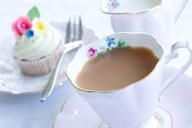
Pop Up Tea Room
Revelstoke Room & Garden,
Newton & Noss Village Hall
Friday 7th, Saturday 8th, Sunday 9th & Monday 10th April
10.30am – 4.30pm

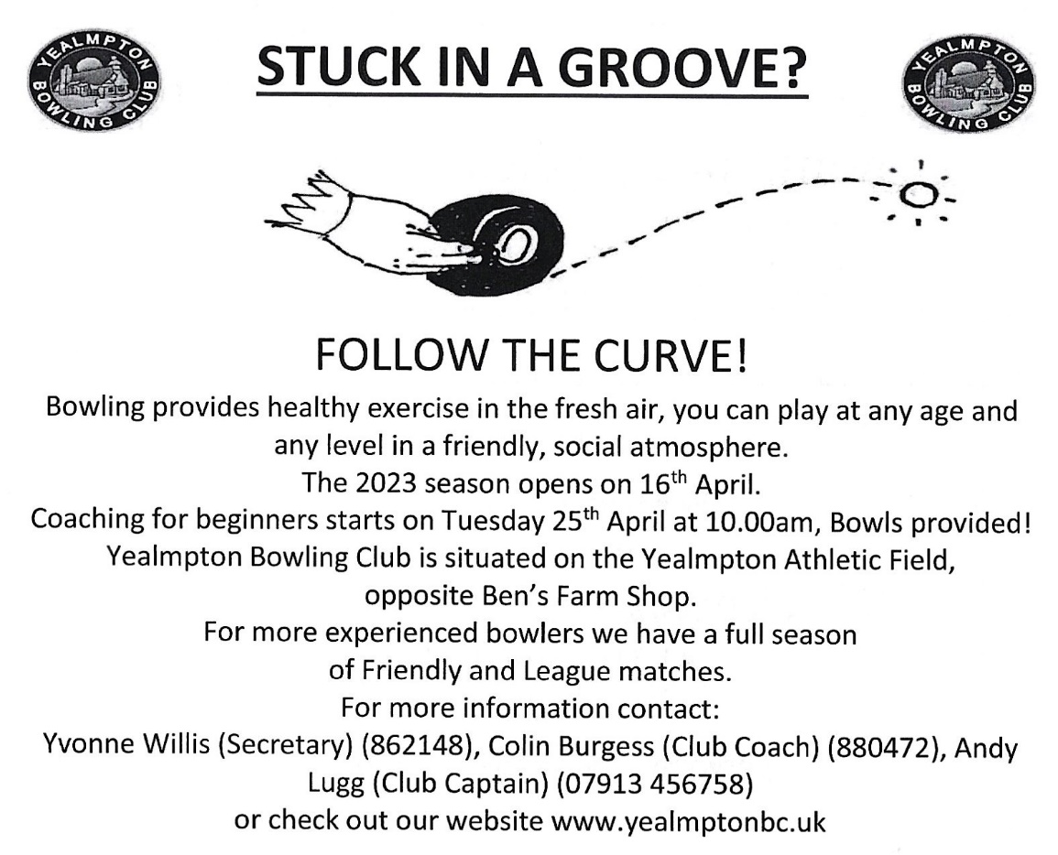

Harbour Clean Up is Sat 22 April

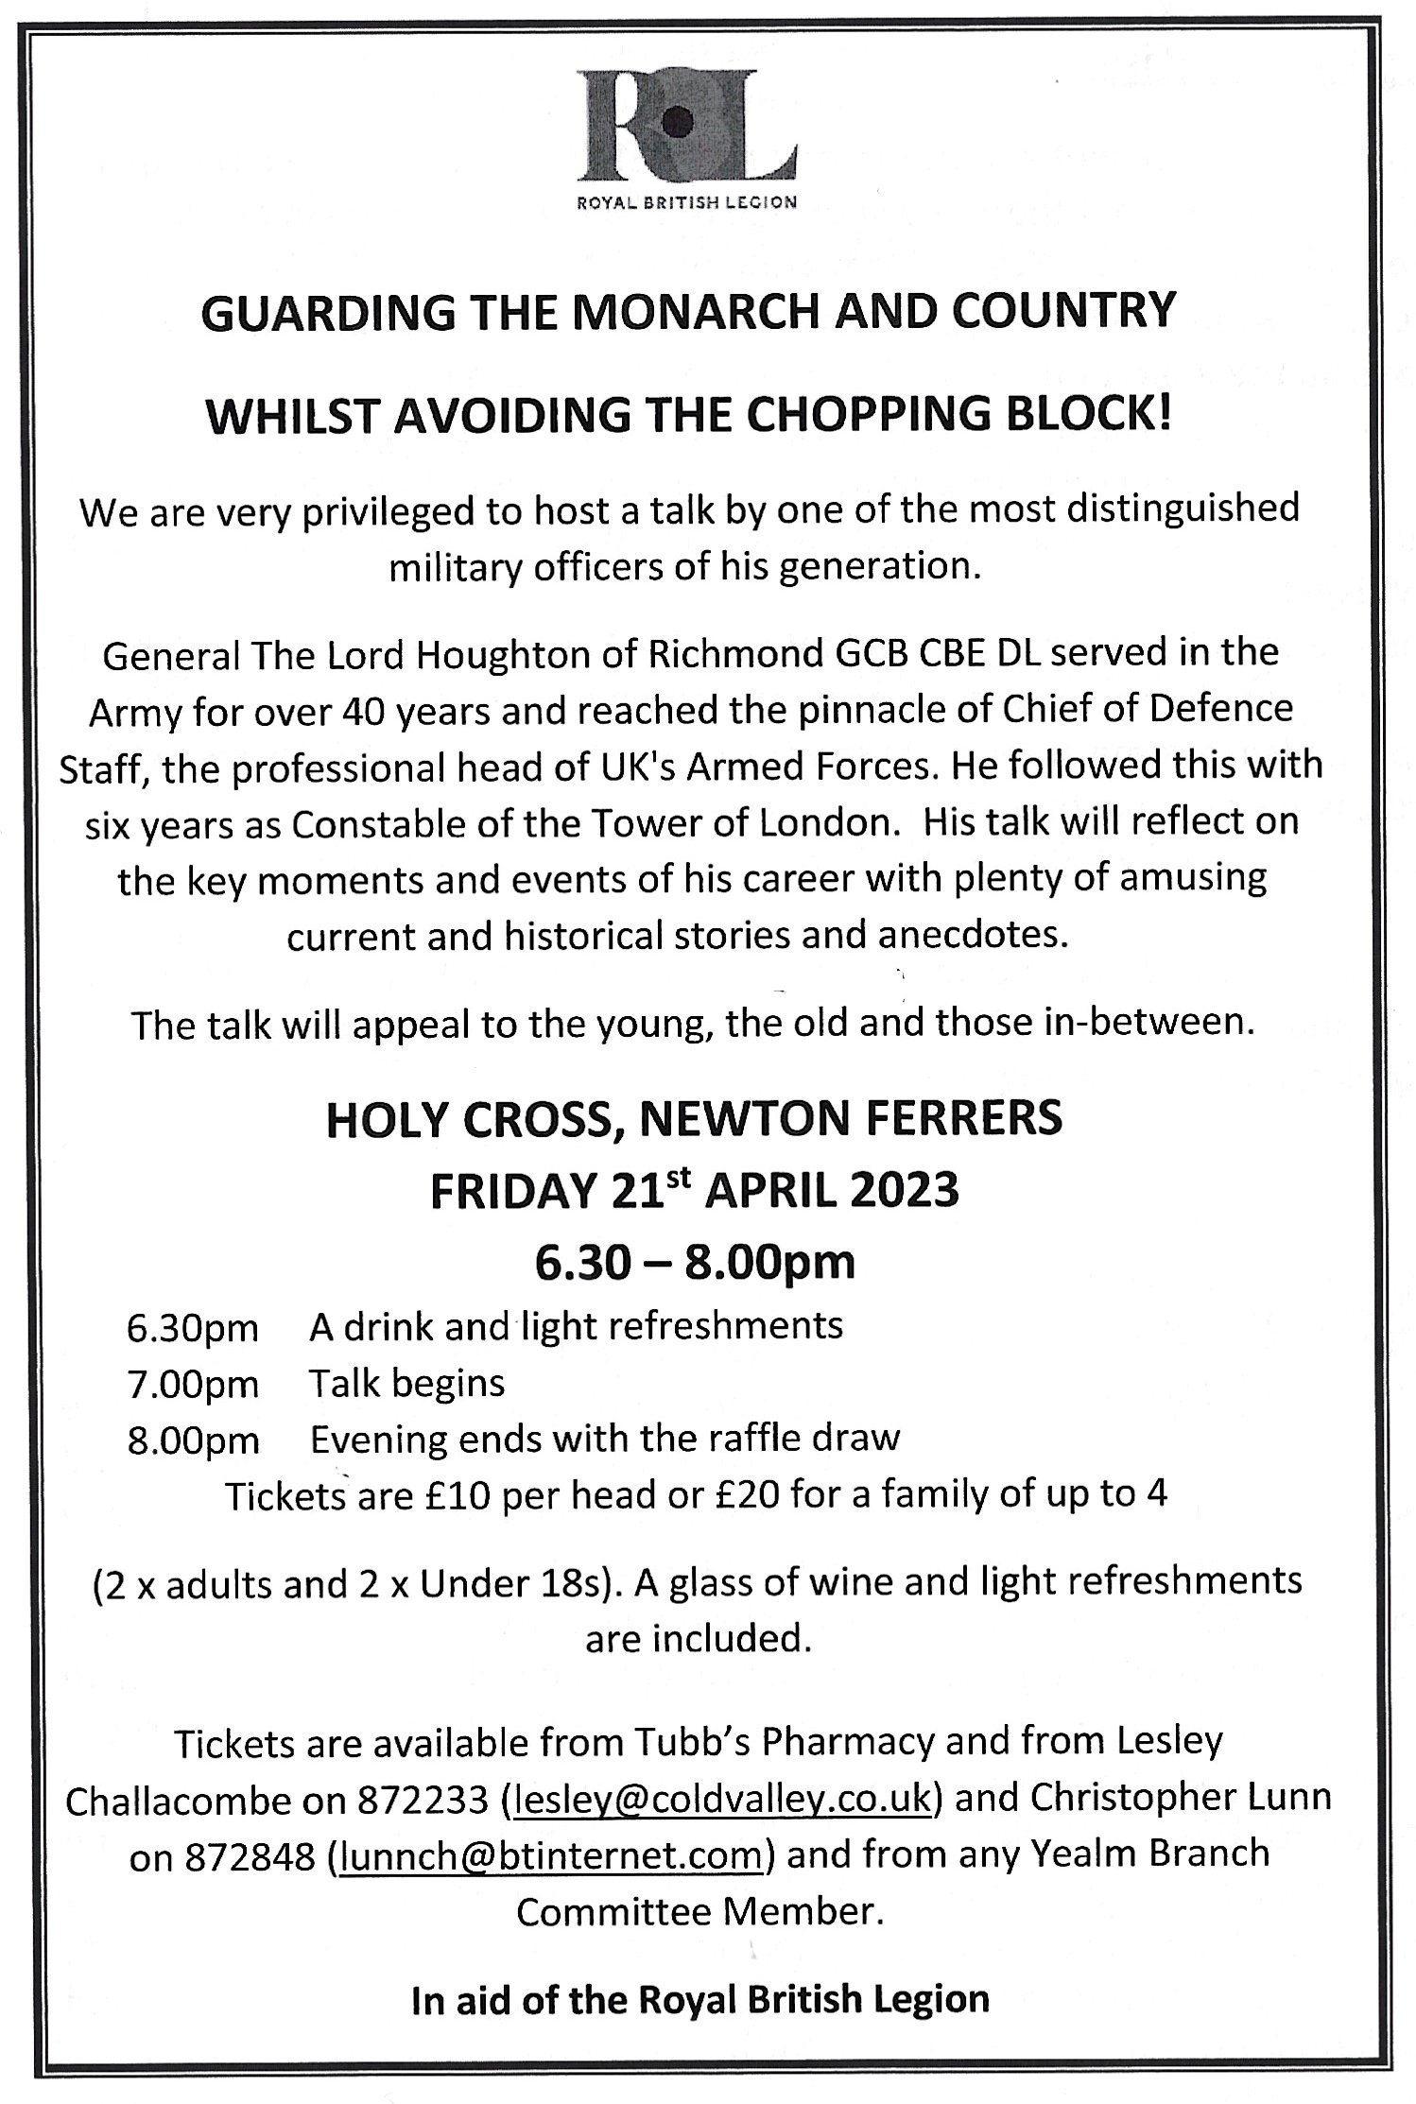
RYDA AGM Tuesday 25th April 7pm
WI Hall Newton Ferrers

