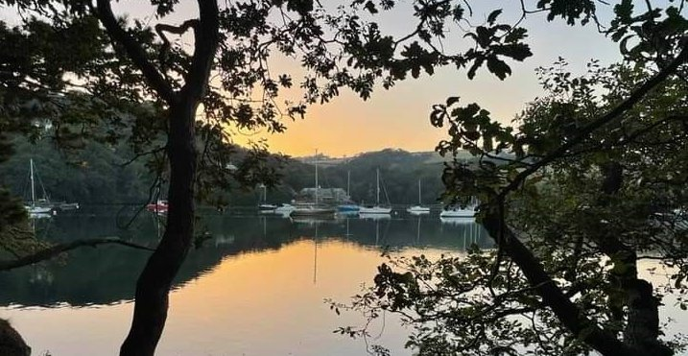
RYDA Newsletter 05/2023
May is named after the Greek goddess, Maia. The month is a time of great celebrations in the Northern Hemisphere. It is a time when flowers emerge and crops begin to sprout.
Many folklore customs have their roots planted firmly back in the Dark Ages, when the ancient Celts had divided their year by four major festivals. Beltane or ‘the fire of Bel’, had particular significance to the Celts as it represented the first day of summer and was celebrated with bonfires to welcome in the new season. Still celebrated today, we perhaps know Beltane better as May 1st, or May Day.
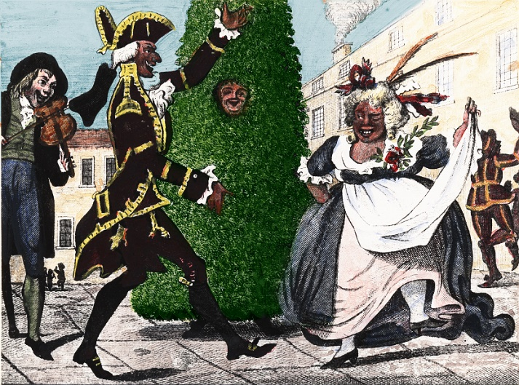
Down through the centuries May Day has been associated with fun, revelry and perhaps most important of all, fertility. The Day would be marked with village folk cavorting round the maypole, the selection of the May Queen and the dancing figure of the Jack-in-the-Green at the head of the procession. Jack is thought to be a relic from those enlightened days when our ancient ancestors worshipped trees.
These pagan roots did little to endear these May Day festivities with the either the established Church or State. In the sixteenth century riots followed when May Day celebrations were banned. Fourteen rioters were hanged, and Henry VIII is said to have pardoned a further 400 who had been sentenced to death.
The May Day festivities all but vanished following the Civil War when Oliver Cromwell and his Puritans took control of the country in 1645. Describing maypole dancing as ‘a heathenish vanity generally abused to superstition and wickedness’, legislation was passed which saw the end of village maypoles throughout the country.
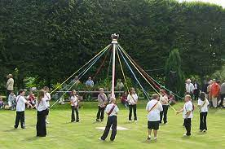
Dancing did not return to the village greens until the restoration of Charles II. ‘The Merry Monarch’ helped ensure the support of his subjects with the erection of a massive 40 metre high maypole in London’s Strand. This pole signalled the return of the fun times, and remained standing for almost fifty years.
Maypoles can still be seen on the village greens at Welford-on-Avon and at Dunchurch, Warwickshire, both of which stand all year round. Barwick in Yorkshire, claims the largest maypole in England, standing some 86 feet in height. Newton Ferrers School also erects a Maypole. Its great fun watching the knots appear while the children are learning.
May Day is still celebrated in many villages with the crowning of the May Queen. The gentlemen of the village may also been found celebrating with Jack-in-the-Green, otherwise found on the signs of pubs across the country called the Green Man.
May Day traditions in southern England include the Hobby Horses that still rampage through the towns of Dunster and Minehead in Somerset, and Padstow in Cornwall. The horse or the Oss, as it is normally called is a local person dressed in flowing robes wearing a mask with a grotesque, but colourful, caricature of a horse.
In Oxford, May Day morning is celebrated from the top of Magdalen College Tower by the singing of a Latin hymn, or carol, of thanksgiving. After this the college bells signal the start of the Morris Dancing in the streets below.
Further north in Castleton, Derbyshire, Oak Apple Day takes place on 29th May, commemorating the restoration of Charles II to throne. Followers within the procession carry sprigs of oak, recalling the story that in exile King Charles hid in an oak tree to avoid capture by his enemies.
It is important to remember that without ‘The Merry Monarch’ May Day celebrations might have come to a premature end in 1660.
Now will have May celebrations for King Charles III's coronation which will take place on Saturday 6 May 2023 at Westminster Abbey in London. ( I wonder if he will be a “merry monarch”)
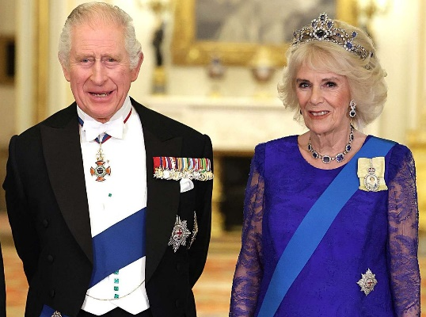
There will be an extra bank holiday across the UK on Monday 8 May.
Buckingham Palace has announced various events for the weekend, including a concert and laser light show at Windsor Castle on Sunday 7 May.
Pubs, clubs and bars across England and Wales will be able to stay open for an extra two hours on Friday and Saturday of the coronation weekend.
People are also being invited to hold street parties, and to take part in volunteering projects in their local community, as part of the Big Help Out initiative.
Separately, a campaign has been launched to recruit thousands of bell-ringers to mark the coronation under the "Ring for the King" scheme.

There are several stages to the service:
- The recognition: While standing beside the 700-year-old Coronation Chair, the monarch is presented to those gathered in the Abbey by the Archbishop of Canterbury. The congregation shouts "God Save the King!" and trumpets sound
- The oath: The sovereign swears to uphold the law and the Church of England
- The anointing: The King's ceremonial robe is removed and he sits in the Coronation Chair. A gold cloth is held over the chair to conceal the King from view. The Archbishop of Canterbury anoints the King's hands, breast and head with holy oil made according to a secret recipe, but known to contain ambergris, orange flowers, roses, jasmine and cinnamon. The oil created for Charles will not contain any ingredients derived from animals
- The investiture: The sovereign is presented with items including the Royal Orb, representing religious and moral authority; the Sceptre, representing power; and the Sovereign's Sceptre, a rod of gold topped with a white enamelled dove, a symbol of justice and mercy. Finally, the Archbishop places St Edward's Crown on the King's head
- The enthronement and homage: The King leaves the Coronation Chair and moves to the throne. Peers kneel before the monarch to pay homage
The Queen Consort will then be anointed in the same way and crowned.
The service will be screened at Holy Cross Church on a large screen at 10.00am Coffee and lunch available for a minimum donation of £5
Our villages will also be celebrating with “A Big Lunch” on Noss Green on 7/5/23. From 12.00noon Bring your own picnic and chair.

The bluebells in Court Woodland are looking really good top Photo by Dave Barton
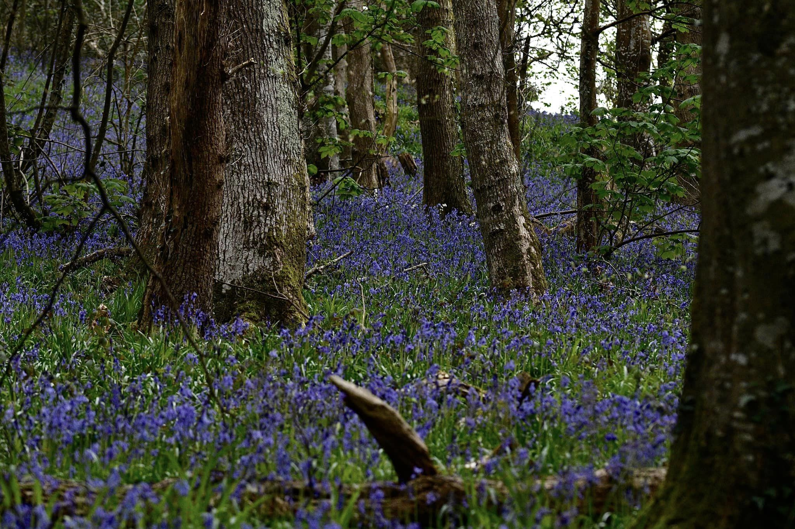
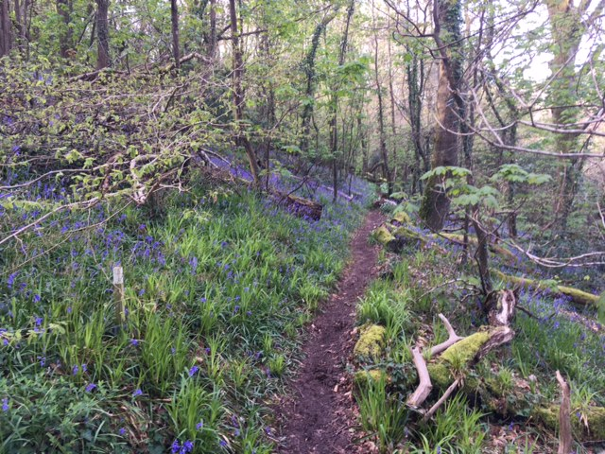
Photo by Peter Hall
Plymouth Ukraine Medical Aid

Thank you very much to everyone who gave to the above cause. £2,150 in cash was donated in various ways and we also took 4 car loads of medical and humanitarian items from Holy Cross to a central collection point in Plymouth where they were sorted and boxed. 2 transit vans and a coach filled with all this aid have now left for Ukraine.
The donation point in Holy Cross Church is suspended at the moment. However, PUMA are in the process of buying ambulance (which will be used to support children’s hospitals in West Ukraine…transporting and treating sick children. That is children that have been injured in the war or who have serious medical problems including cancer, TB and cerebral palsy) which together with the use of an articulated lorry, will be taking more aid in early summer.
Penny Page

A Devon bank has so many early pollen and nectar rich plants
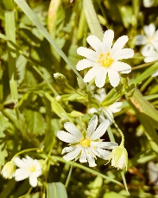
A simple Devon bank is a fantastic source for Bees in the early Spring months, so don’t be to keen and strim it down but let all the natural planting rise above the grass for a beautiful spring show.

Volunteer Transport
There has been a system providing volunteer transport in Newton and Noss for several years. In order to simplify the method of booking a lift the following changes are being made. The new organisation is called ‘Phone A Lift’ or PAL. The number to call will be under ‘Voluntary Transport’ in the pink section of the updated version of the Village Directory which is available from 25th April. The number is 0300 234 0250. On calling this number you will be connected to the coordinator who will take details and try to arrange your lift. The following lifts will be considered:- hospital [ one way unless only there for a short time ], GP/Dental/Eye Check appointments. If you need to be accompanied please make your own arrangements for someone to come with you. You will not be charged. However you may wish to make a donation! We are always looking for more volunteers as either drivers, coordinators or both. If you would like to help out please contact dickpage1@gmail.com
Woppy Keeling, a former Olympian cross-country skier and now a grandmother of 4, is raising money for 65 Degrees North (www.65degreesnorth.co.uk). This small but extremely effective charity has been up and running for about 10 years, has achieved some remarkable results already, and needs funds to enable carefully selected serving or former military people with physical and/or psychological injuries to participate in exciting and challenging expeditions.
On 13 May Woppy (aged 64) will swim 1 mile from The Mewstone to Wembury Beach. She will then, over the next 6½ days, walk the 117 mile coast-to-coast route ‘Two Moors Way’ from Wembury to Lynmouth, across Dartmoor and Exmoor. She will camp en route. She will then climb one of the challenging sea cliffs at Baggy Point.
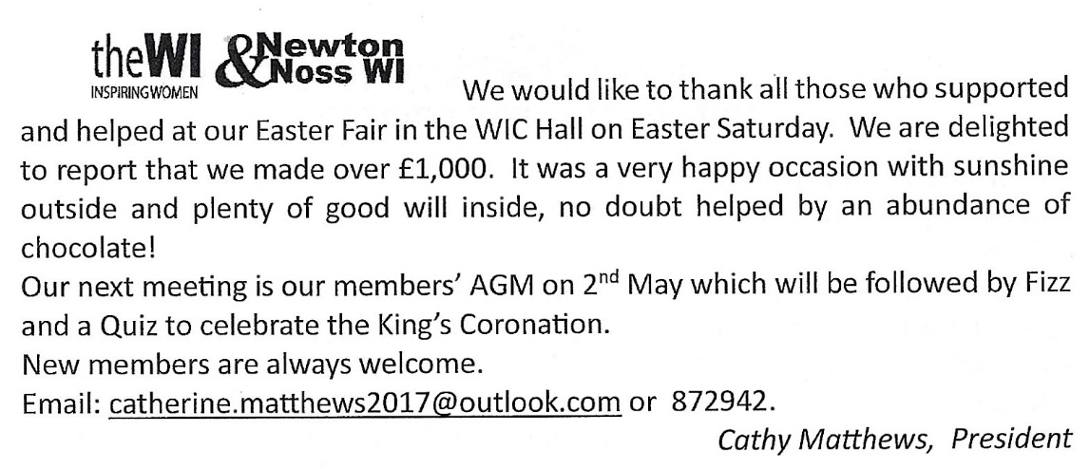
To help Woppy on her way, and to help this excellent charity which has already enabled wounded military people to stand on top of Everest, Kilimanjaro, and the highest mountains in South America, North America and Antarctica, as well as several other challenging expeditions, you can support her page on JustGiving (justgiving.com/page/woppykeeling).
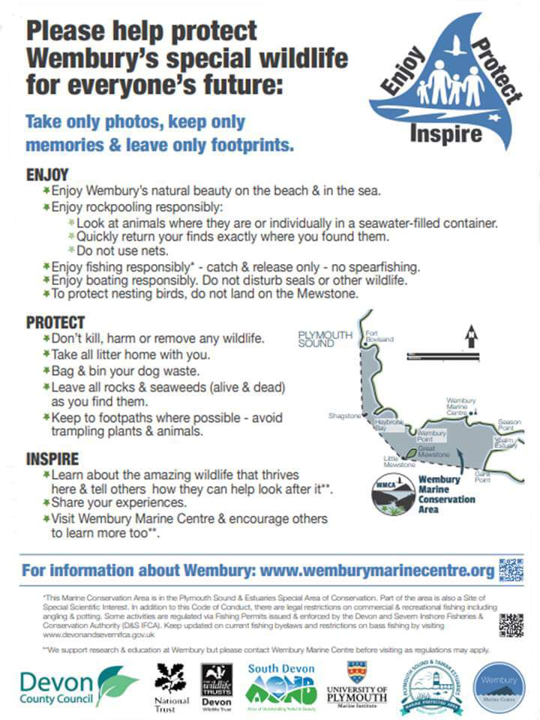

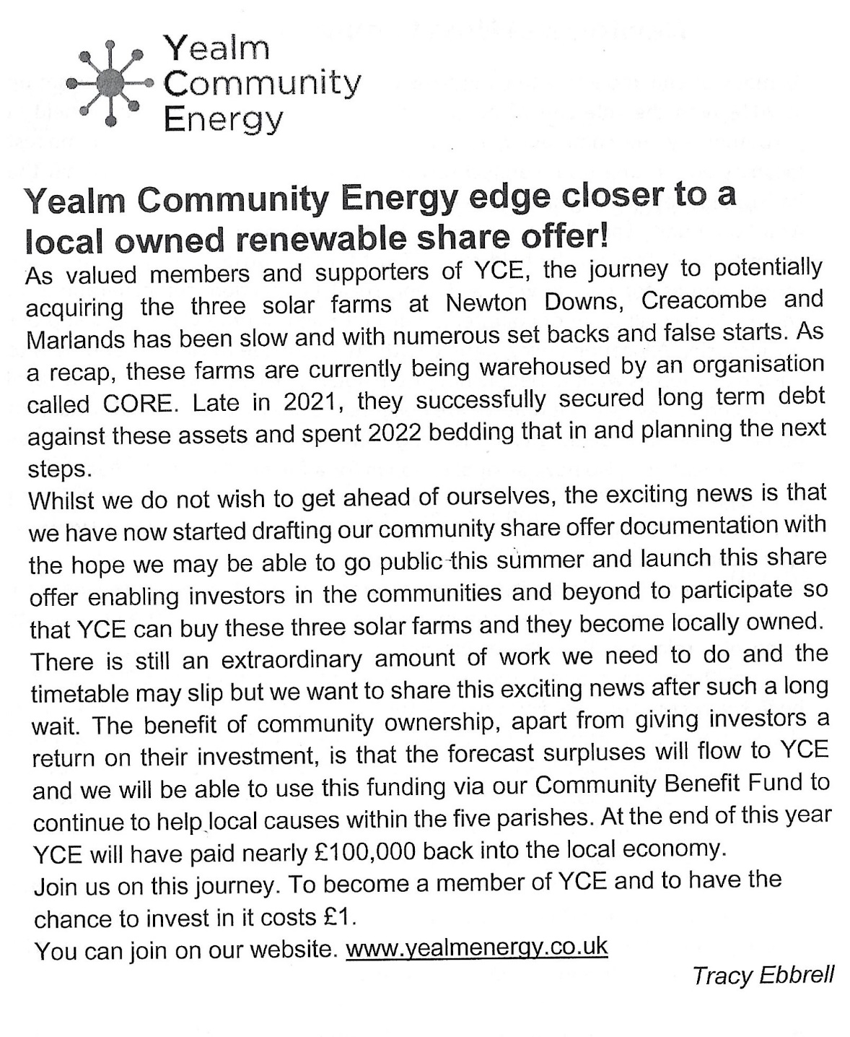

Planning
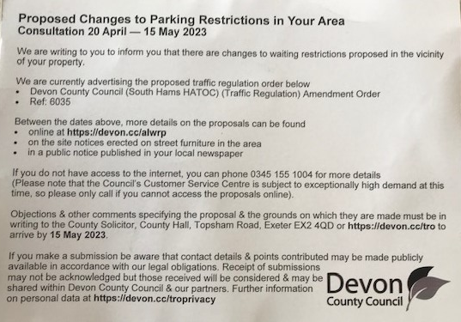

Consultations on a proposed Registration Scheme, new Permitted Development Rights and Use Classes for short-term lets in England
We are all aware that a significant proportion of properties in Newton and Noss are used as Second Homes and there are also many which are used for Holiday Homes, which are let either as whole or part premises. Although these Holiday Homes bring benefit for local businesses and employment, there is an adverse effect that many are unoccupied in the off season therefore reducing vibrancy for much for the year. It is likely that taken over the year total economic and social effect is negative.
The growth of innovative digital platforms has enabled a major expansion in the number of accommodation suppliers operating in the market and has led to a national increase in the short-term letting of residential premises. The Government are undertaking parallel consultations on the introduction of a Registration Scheme, plus a new Use Class for short-term letting and associated Permitted Development Rights Link to Consultation on Short-Term Letting Register Link to Consultation on New Use Class for Short-Term Lets
The RYDA would like to understand your views to help our response.
The first consultation is on the Government’s proposal for a “light touch registration scheme”. The other countries in the UK either already have or are introducing short-term letting Licensing schemes. As other short-term accommodation such as Hotels, Guest Houses and B&B are already subject to regulation, they are not included in these proposals.
The parallel Consultation concerns the introduction of a Use Classification and associated Permitted Planning Rights. This would mean that premises being let on a short-term basis would need to be classified as Use Class C5 (Short- Term Let), this change would be subject to a Permitted Development Right meaning that a planning Application would not be necessary. In areas where the number of Short-Term Let Premises were causing issues, then the Local Planning Authority could remove this Permitted Development Right, meaning that Planning Permission would be required.
Please tell us if you think that the proposals are required to help manage the growth of short-term lets or an unnecessary burden on business.

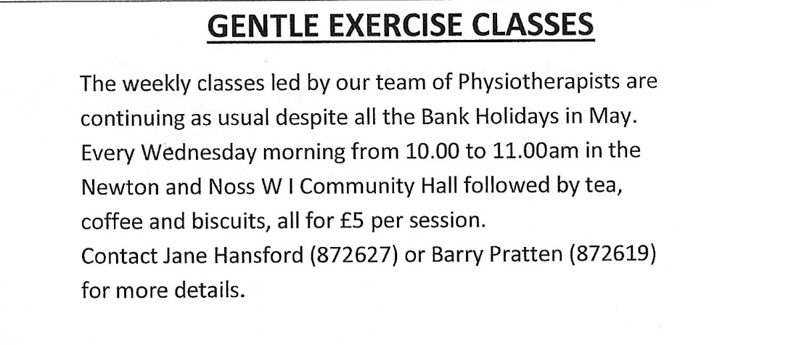
Whats on

Tuesday Lunch Club. 2nd May 12.00 £6 for 2 courses plus tea/coffee New members of any age welcome. Please contact either Jeanne (872442) or Jane (872627) Allergies can be catered for
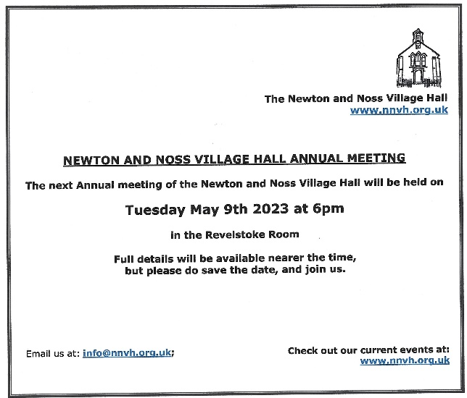

WI Craft Group Tuesday 9th May @ 2pm. Bees for the "Life on the Edge" project We will be doing wet felting. Please bring a towel, bubble wrap, scissors and a rolling pin. £1.50 Contact Lesley 07838375449. new members welcome
Holbeton Film Club presents Mrs Harris goes to Paris 13th May at 7pm
In 1950s London, a widowed cleaning lady falls madly in love with a couture Dior dress, & decided she must have one of her own. After working to raise the funds to pursue her dream, she embarks on an adventure to Paris that will change not only her own outlook -- but the very future of the House of Dior.

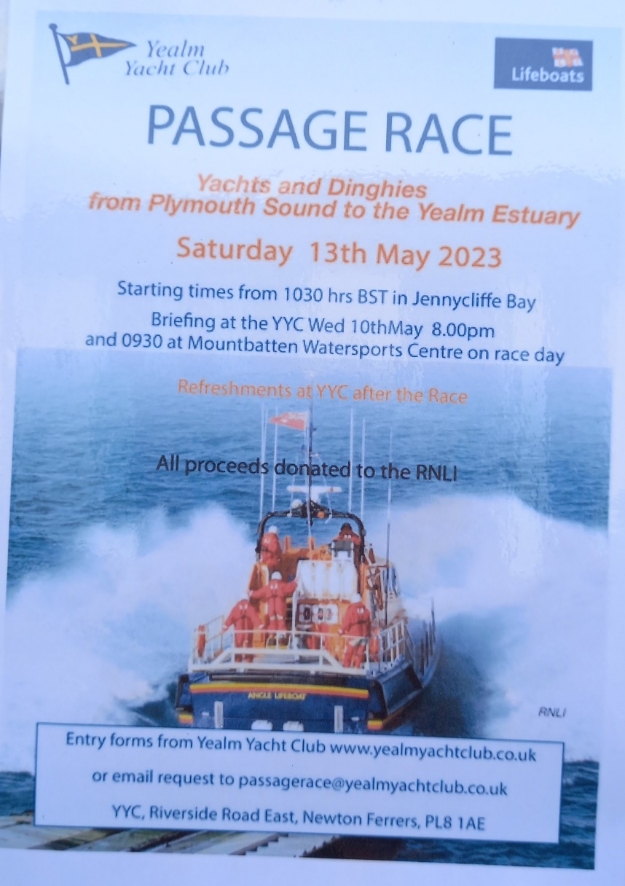

Yealm Parchment Craft Group meets on 19th May in the WI hall Newton Ferrers at 2pm this months project will be water colour on parchment with a guest tutor Pat Murphy. Equipment can be supplied. £8. Contact Lesley 07838375449. new members welcome

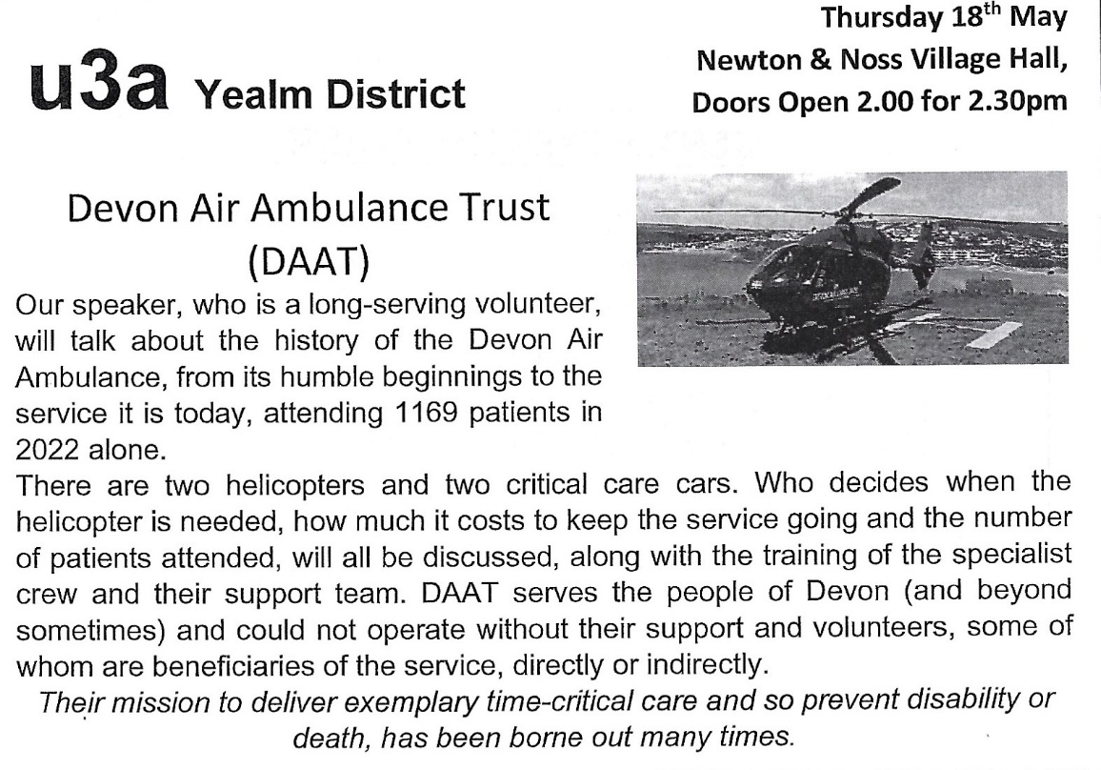

May 23rd 2-4pm WI Craft Group. Knit and natter. Contact Lesley 07838375449 new members welcome

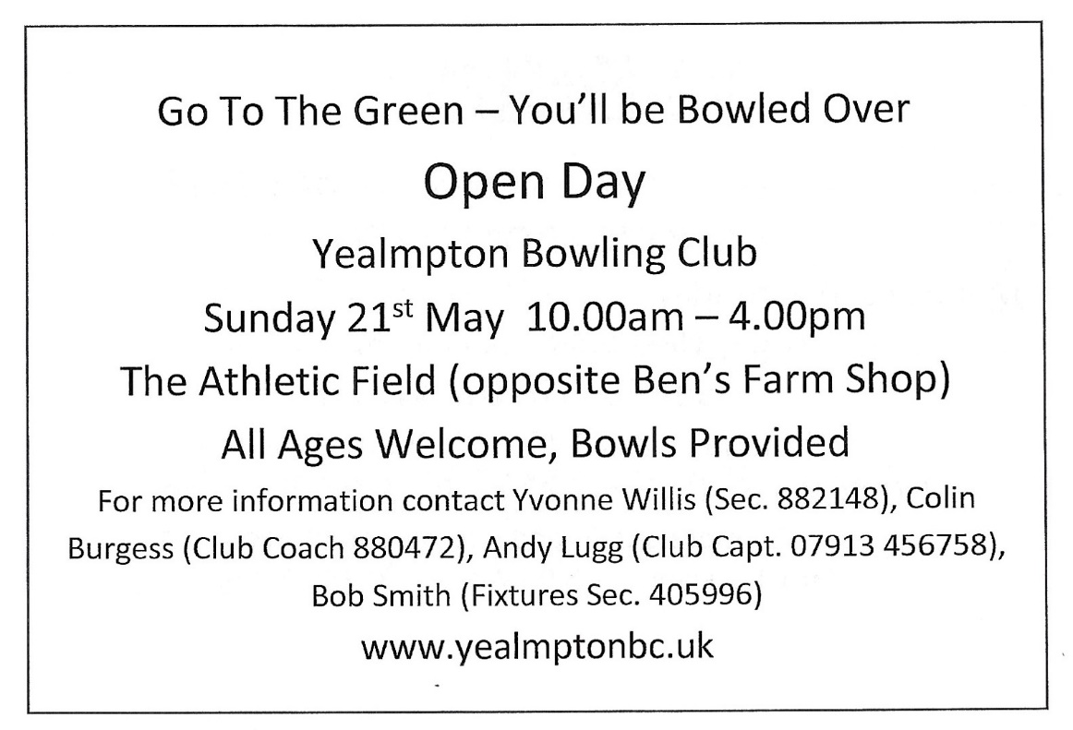

Not really in our patch, but it may be of interest
Thursday Lunch Club 25th May 12.15 £6 for 2 courses plus tea/coffee New members of any age welcome. Please contact mrandmrsbarnett@gmail.com Allergies can be catered for.

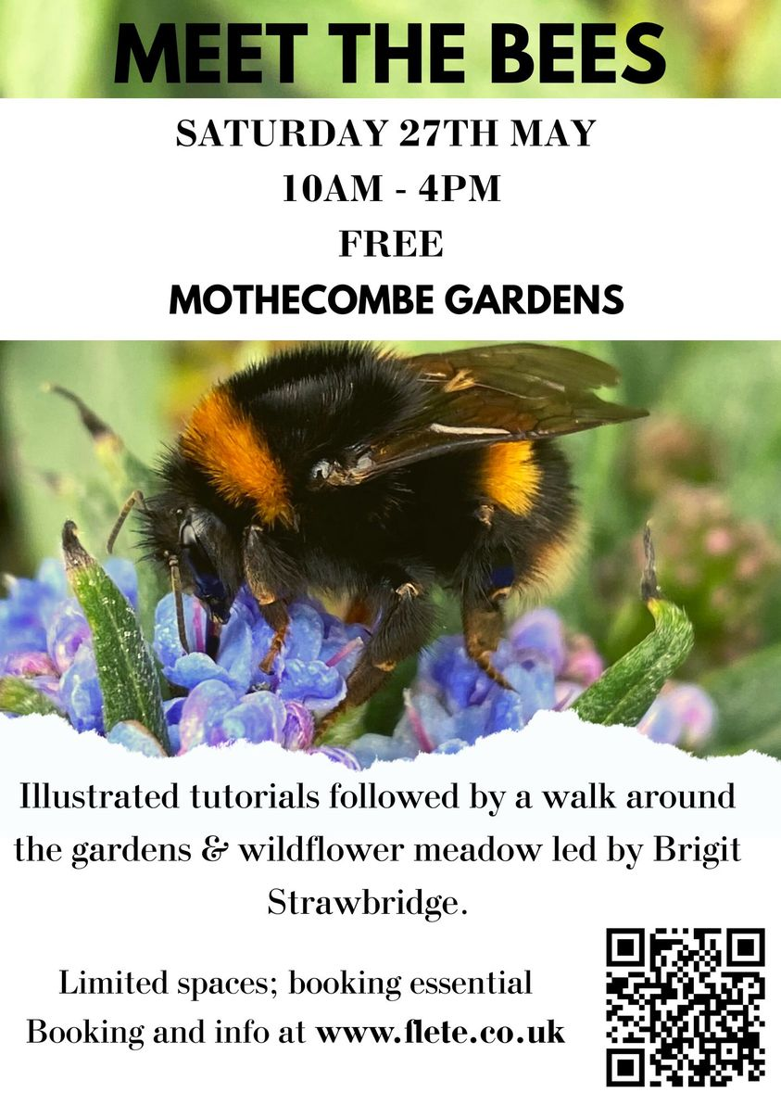

Learn About the Wonders of Noss Mayo
A 3-4 mile long walk on 27th May, taking you close to the coast and estuary and through wooded areas. As well as beautiful views you will learn about fishing in this area. (This walk features in “Exploring Green Lanes in the South Hams” & lead by the author)
Important booking Information
- Booking essential email valeriebelsey@gmail.com
- Adults £4 (free if you arrive by public transport, bike or on foot)
- Bring a drink and wear suitable clothing and footwear.
- Meet at recreation ground Noss Mayo PL8 1EL @ 10.00am

This walk is part of “Life on the Edge” & South Devon AONB
Other events can be found at

EVENTS MAY 2023

Here is a taste of the events planned for this month in the AONB
Click through to our website May events for full details of what is planned and booking info.

3rd May 6.15am Fishmarket tour, Brixham

4th May 6.30pm Crests and Bluesbells, Kingswear

6th May 12 noon Rockpool Safari, Wembury Marine Centre

7th May 7am Dawn Chorus Tour , Carswell Farm, Holbeton

7th May 12.30pm Extreme Rockpool Safari, Wembury Marine Centre

9th May 1.30pm Shoresearch Volunteer Survey, Wembury Marine Centre

9th May 6pm Hedgerows for Wildlife, online talk Devon Wildlife Trust

13th May 9am Restoring Nature: Regenerative Agriculture Literary Festival,. Sharpham

13th May 10am Birdwatching walk, East Soar Farm

17th May 6.15am Fishmarket Tour, Brixham

19th May 8am Birdwatching Safari Tour, Carswell Farm, Holbeton

20th May 11am Rockpooling, Castle Cove Dartmouth

20th May 12 noon Extreme Rockpool Safari, Wembury Marine Centre

21st May 2pm Defences of the Dart, Brownstone Battery, Kingswear

21st May 1pm Rockpool Safari, Wembury Marine Centre

24th May 6.15am Fishmarket Tour, Brixham

25th May 10am Guided Nature Walk, Berry Head, Brixham

27th May 10am Noss Mayo, both windswept and sheltered, Noss Mayo

28th May 2pm Orchard Farm Open Day, Mothecombe Stables, Mothecombe

29th May 11am Bank Holiday Seashore Crafts, Wembury Marine Centre

29th May 3.30pm Guided wildlife canoe tour, Bowcombe Creek, Kingsbridge

30th May 8pm Bat walk, Slapton Ley Field Centre

31st May 10am Snorkel Safari, Wembury Marine Centre

31st May 10am What lurks beneath pond dipping, Slapton Ley

Life on the Edge events supported by Heritage Lottery Fund

Save the Date

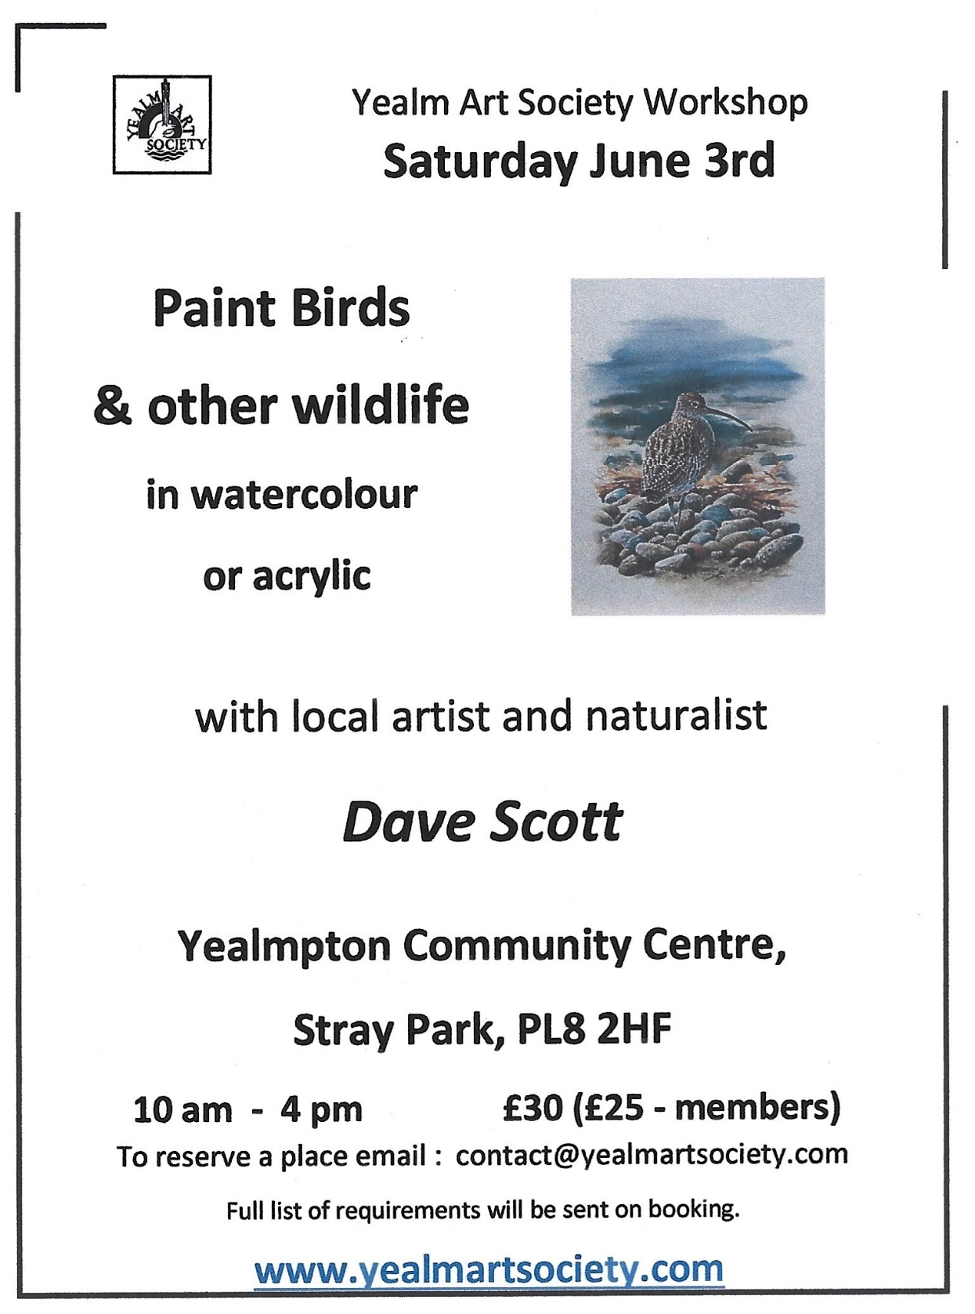

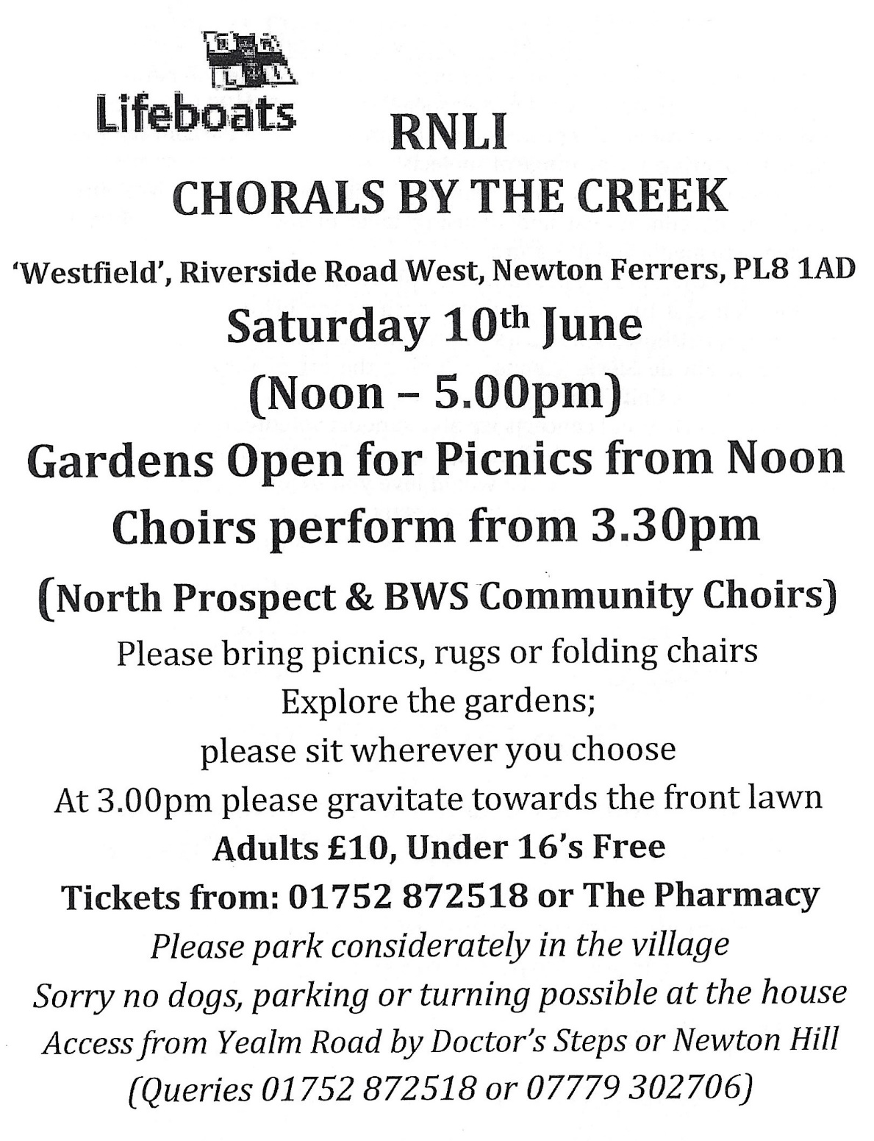

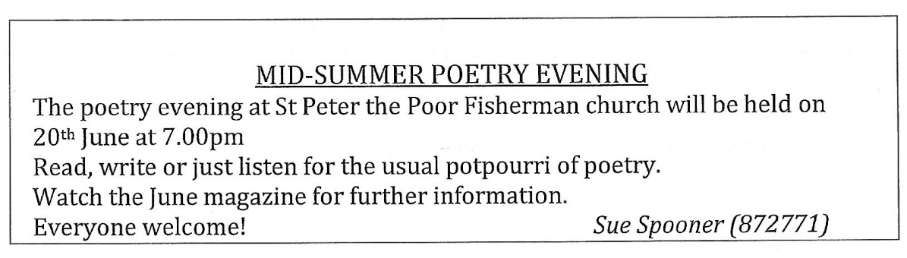

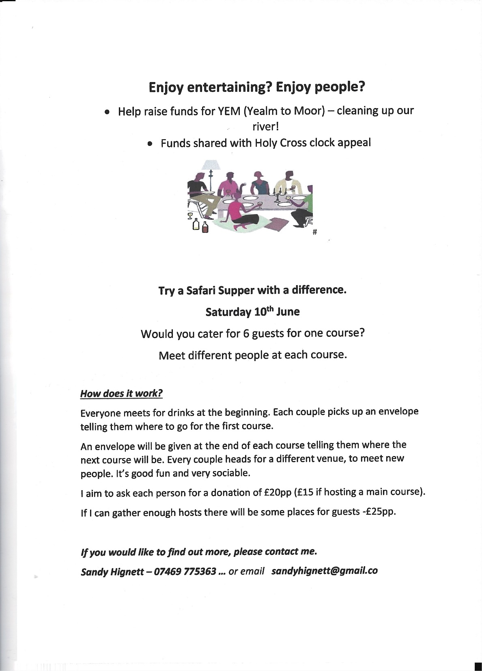

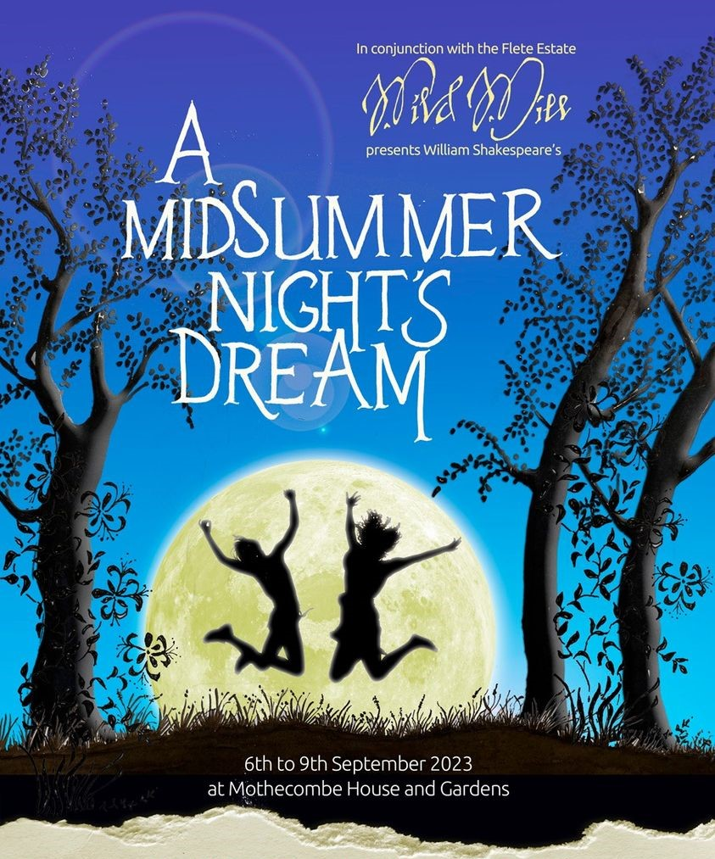
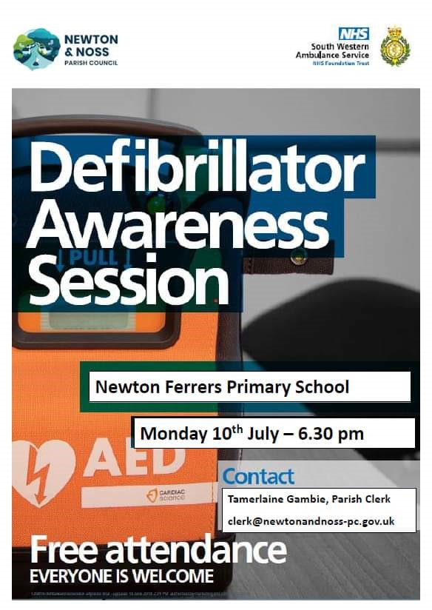

Kris Harris – Magician: Has been booked for 18th November 2023, in the WIC hall. There will also be a Cabaret.
This is a WI fund raising event open to all.
More details nearer the time

