RYDA Newsletter 03/2024
You probably use tons of expressions, idioms, proverbs, and slang phrases every day that don’t make literal sense. If you ever thought long and hard about why you say something a certain way, you could probably make a guess. However, some English expressions are so unusual that it is impossible to guess where on earth they originated from — unless you know the history.
Read The Riot Act – The Riot Act was first introduced in 1715. It allowed local authorities the power to disperse unlawful gatherings of more than 12 people on the streets of England’s towns and cities. The Act was passed by a nervous government in response to the growing threat from Jacobite Catholics opposed to the new Hanovarian King George I. The law required the local magistrate to read a proclamation aloud to the crowd that included the following stern warning; “Our sovereign Lord the King chargeth and commandeth all persons being assembled, immediately to disperse themselves, and peaceably to depart to their habitations, or to their lawful business, upon the pains contained in the act made in the first year of King George, for preventing tumults and riotous assemblies. God save the King”
Failure to observe such a warning was severe and could include imprisonment with hard labour for up to two years.
Sincere - The word ‘sincere’ has some interesting roots.; One story states that the word originates from the ancient marble quarries of Rome, where unscrupulous stone dealers used to cover imperfections in the marble with wax. The practice eventually became illegal, as the Roman Empire certified that all marble had to be ‘sine cera’ or ‘sincerus’, meaning ‘without wax’. So, to be sincere is to be genuine.
Its Raining Cats and dogs; - British houses used to have thatched roofs made out of thick straw. It was the only place where animals could get warm, so dogs, cats and pests (including mice and bugs) used to live in the roof. When it rained, it became slippery – and sometimes the animals would slip and fall off. These days, ‘it’s raining cats and dogs’ is a phrase used when it’s raining very heavily. This is also the reason why four poster beds developed. The idea of the bed’s 'roof' was to prevent nasty things from falling into your open mouth while you slept! The side curtains were added to keep out draughts.

Burning the Candle at Both ends; - Once upon a time, the only light in a house was provided by a candle called a taper, which was usually kept alight on a holder beside the fire.
If special visitors came and more light was required, the taper was lit at both ends.
These days, the phrase means to exhaust oneself by getting up early and working hard until late at night.
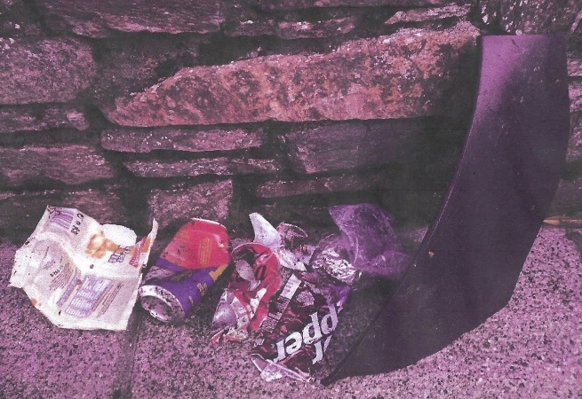
PLOGGING - Out on a recent run a member of the RYDA collected the litter seen in the picture, below. It is not uncommon to pick up this amount of litter on a weekly basis, most emanates from cars but some may blow out of recycling bins.
He says he has been running for many years picking up litter as he goes, as do many of us when out walking. Someone recently said to him that without realising it, he had become a “plogger”. Baffled, he thought he ought to look it up before deciding whether to take offence!! What is 'plogging'? History and origins... 'Plogging' is a new global movement that originated in Sweden. It takes advantage of jogging and other outdoor sports to pick up the litter that spoils our cities and natural spaces. The idea of this sustainable initiative is simplicity itself: the participants, 'ploggers', take to the streets with rubbish bags to pick up the litter they come across while exercising. The word 'plogging' comes from the Swedish plocka upp (pick up) and the English word jogging. The pioneer of this activity was Erik Ahlström, who, on leaving his hometown in 2016 to settle in Stockholm, started to clean up the rubbish in the areas where he practised his sport. Soon after, Ahlström's routine spread throughout Sweden as a result of popular events and today, thanks to social media, it is a global phenomenon involving over 20,000 people a day in more than 100 countries.
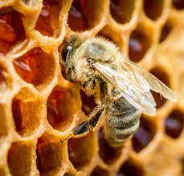
Mind your own beeswax & Crack a smile;- Our ancestors’ personal hygiene left much room for improvement. As a result, many people developed acne scars by adulthood. Women would spread beeswax over their skin to smooth out their complexions. When they were speaking to each other, if a woman began to stare at another woman's face, she was told to 'mind her own beeswax'. These days, this is a tongue in cheek way of telling someone to mind their own business. The wax-smoothing practice also led to the phrase ‘crack a smile’. When a woman with beeswax on her face smiled, the wax would sometimes crack!
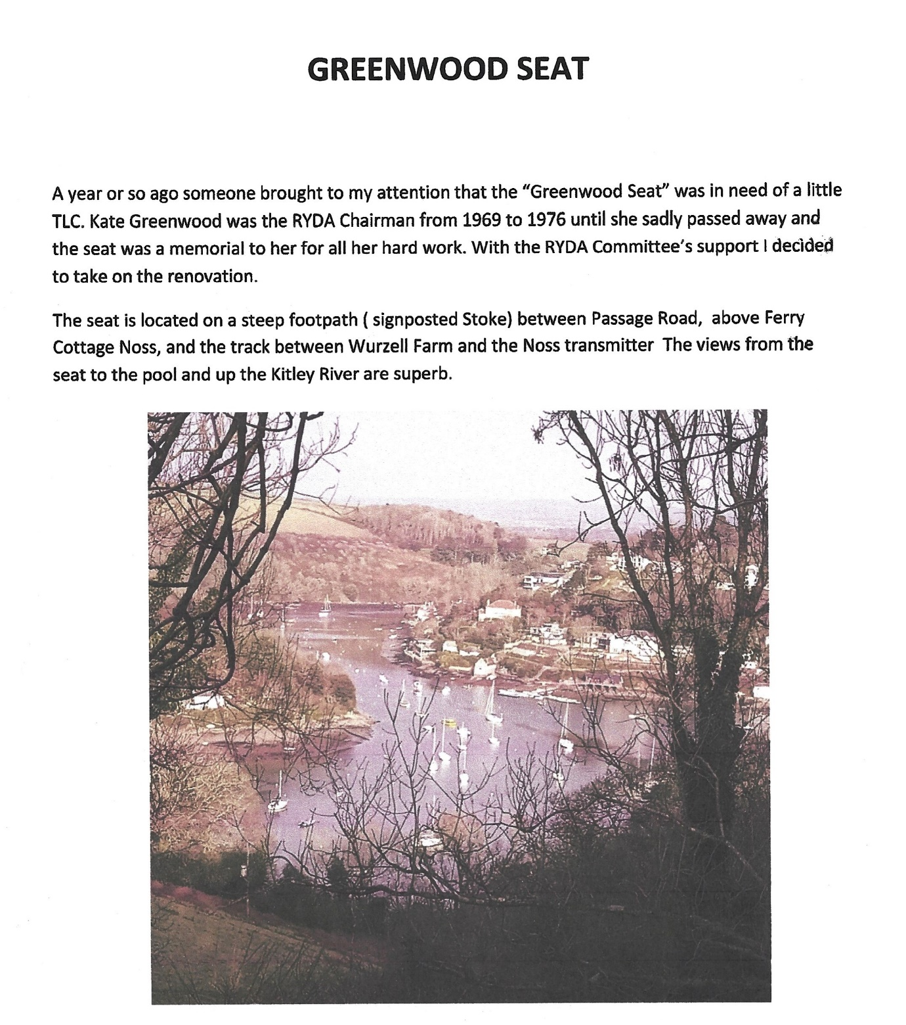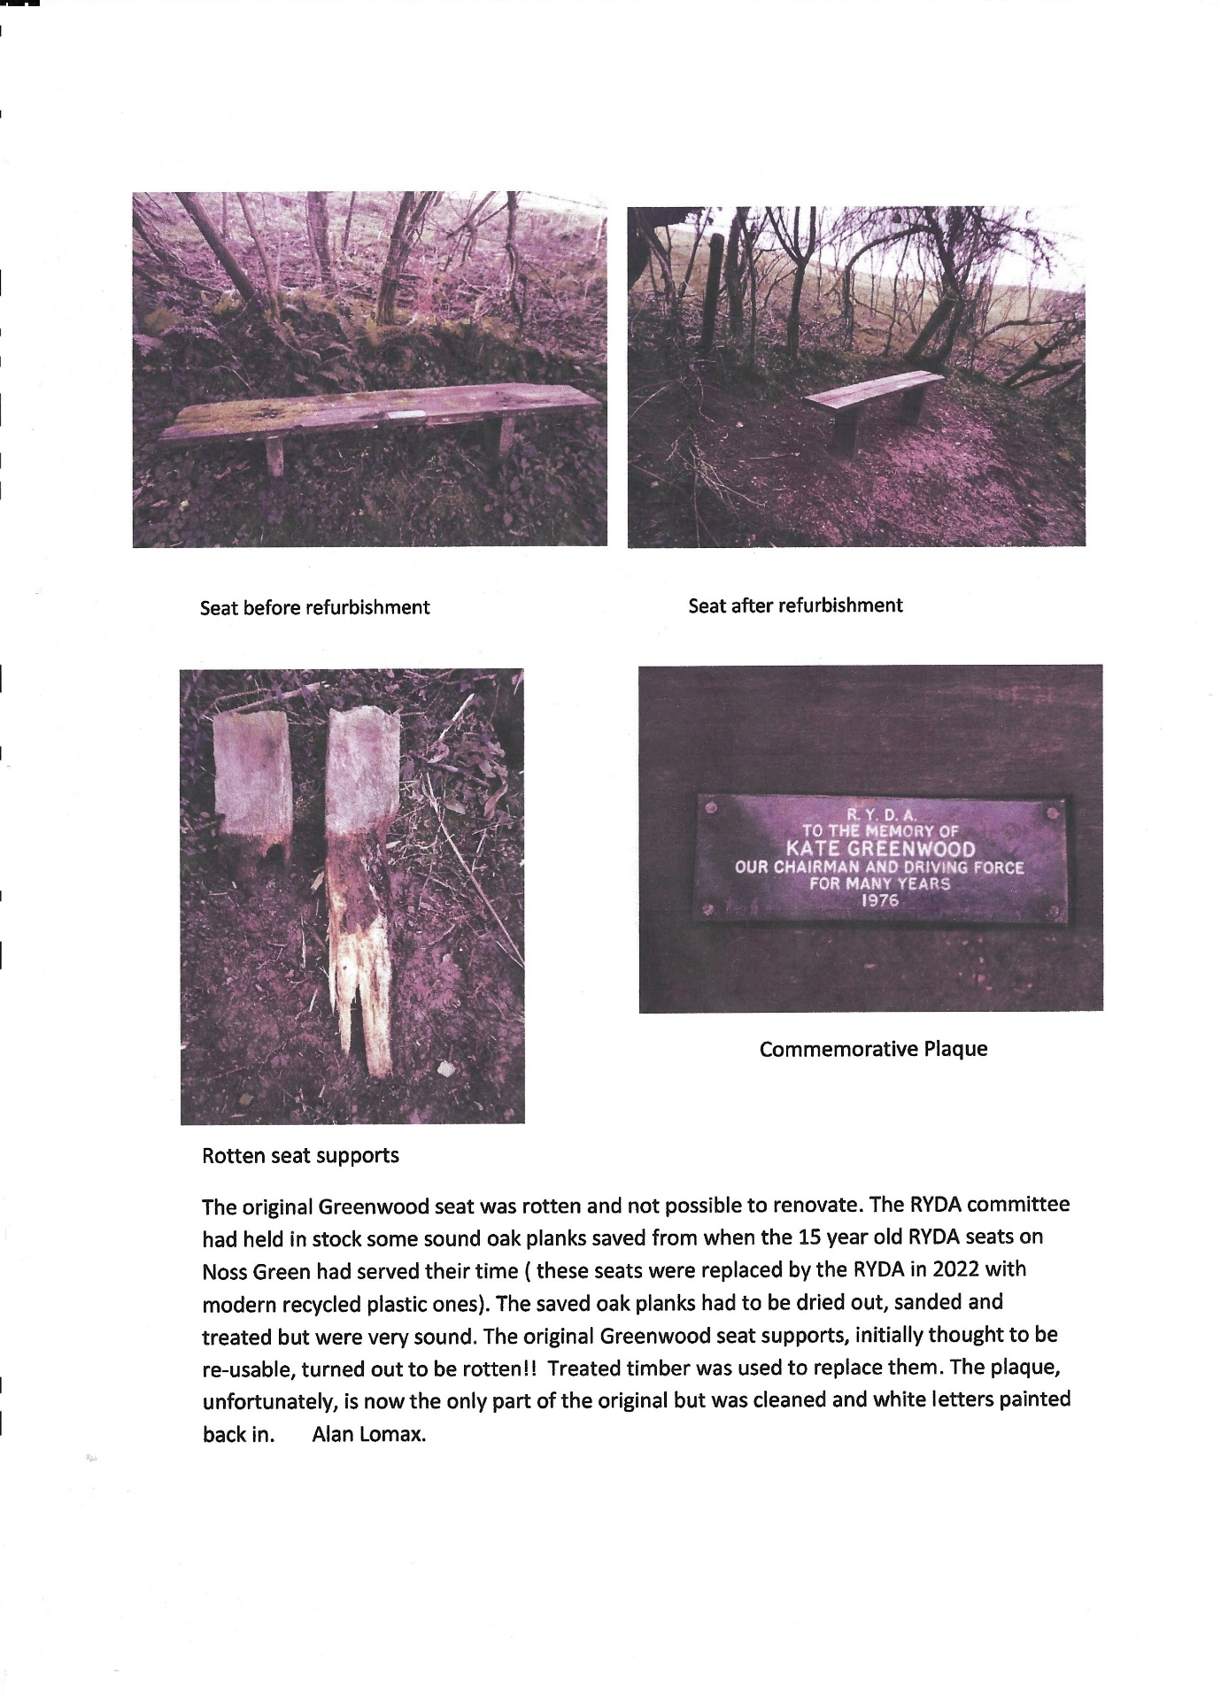Volunteer Transport for Medically related appointments - phone PAL [ Pone A Lift ] on 0300 234 0250. Your call will be diverted to a volunteer's mobile phone who will take the details and try to arrange transport by a local volunteer driver.'
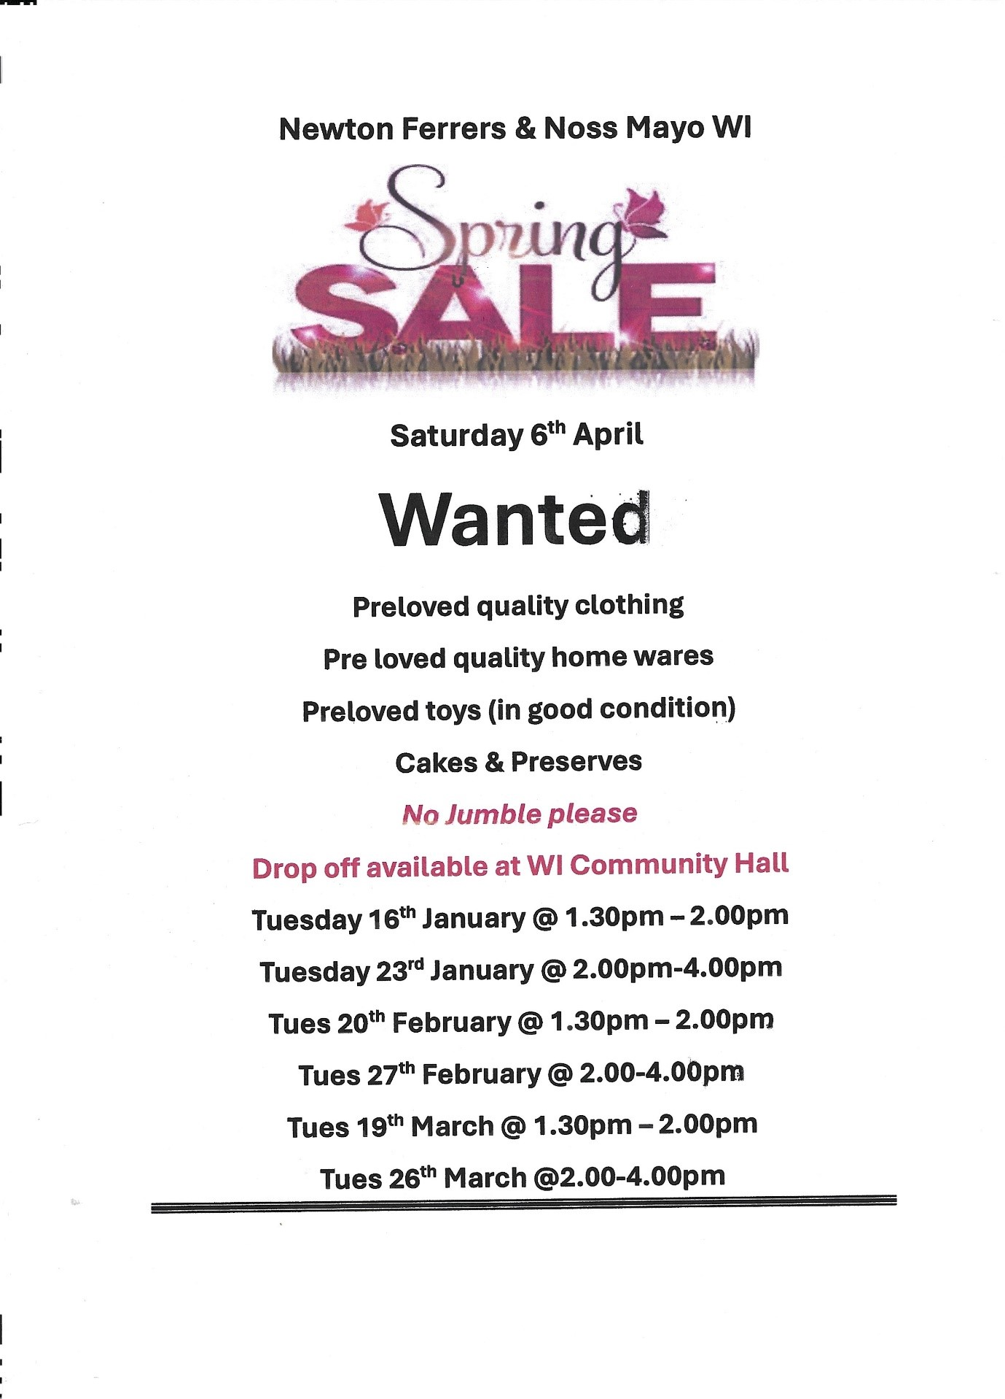 Do you use the WI Community Hall?
Could you find time to join the committee (approx. 4 meetings a year), and help the friendly team obtain quotes for maintaining the hall.
It isn’t arduous work as professionals are hired to do the work where applicable.
Can you take minutes?
Can you change a light bulb?
Would you know if a contractor is genuine?
Do you have mates or contacts in the building trade who might like local work?
Everyone is welcome to assist us we have potentially at least 4 spaces to fill in order to spread the workload.

Brookings Down & Eastern Hill Woods March 2024 Update
The month of March into early April starts to see a reduction in working party activity with a focus on final bits of path and step maintenance and light strimming to the sides of overgrown paths before we down tools for spring and summer.
Already, there is clear evidence of Bluebell and other shoots beginning to break ground therefore it’s important to give nature space to do its thing.
Our 2023 nest box audit had mixed results within both woods, with evidence of higher use in the newer boxes installed in 2022. Our feathered friends appear to be going for the mod-cons and better insulation of newer ones! We look forward to seeing what the forthcoming nesting season’s audit tells us.
We have further work to do clearing the tops of trees (brought down by storm Antoni in August), which are overhanging a stream. Our aim is to clear this debris to prevent the stream becoming blocked.
We have two separate Forest Schools using BDW and it is great to see children enjoying and learning about nature. Please take the opportunity to walk both BDW & EHW throughout the spring and summer and we hope that you enjoy what you see.
If you would like to donate by becoming a “Friend” or if you would like to sponsor a nest box, please contact our Treasurer Val Lomax - val@lomcroft.plus.com or 872444) for more details.
Paul Francombe – Chairman

I received a phone call from a villager, who had been experiencing scam phone calls. In this instance the nuisance call was a local number 01752 872215 trying to sell (or renew) appliance insurance.
Nearly a third of all fraud is made over the telephone.
Phone scammers will call you unsolicited, pretending to be from an organisation you trust, such as your bank, insurance company or the police.
These scam calls may be automated, or from a real person. They may ask you for your personal information like banking details, or tell you that you need to transfer money, or pay by card.
Protect yourself from scam phone calls
Many phone companies offer services that can protect you from scammers and other nuisance callers. These include:
- caller display
- incoming call blocking
- anonymous call rejection
For more information, contact your phone provider or read Ofcom’s Nuisance calls: phone services that can help
Report a suspicious phone call
If you've lost money or have been hacked as a result of responding to a phishing message, you should report it:
visit www.actionfraud.police.ukor call0300 123 2040.
Below are common warning signs of a phone scam:
- A claim that you have been specially selected.
- Use of high-pressure sales tactics and “limited-time” offers.
- Reluctance to answer questions about the business or the offer.
- Request that you “confirm your personal information”
There is a very useful booklet published by the Police called "The little booklet of Phone Scams" you can download it here

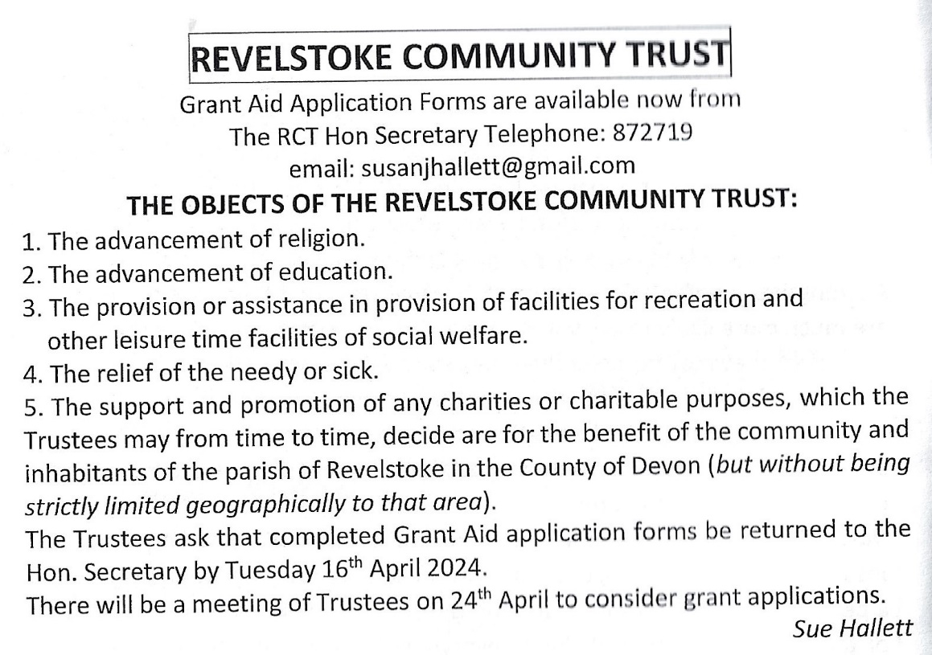

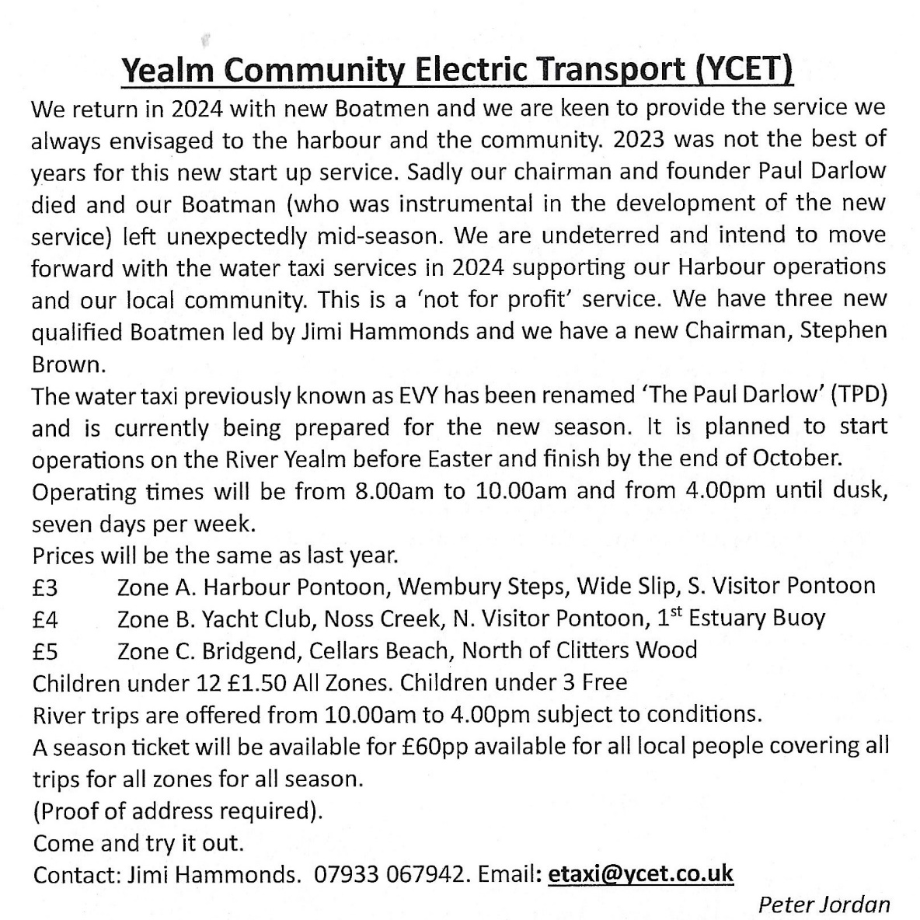

Planning
Ref.0145/24/HHO Pear Tree Cottage Newton Hill
application for two storey extension to replace existing single storey extension.

Ref. 0228/24/TPO 26 Court Road Newton Ferrers
Oak Quercus - remove major deadwood, reduce lowest primary branch back to edge of pavement, sever ivy at base of tree, deadwood and branch pose risk of failure onto road.

Ref. 0022/24/HHO 1 The Fairway, Newton Ferrers
application for a single storey front extension, with loft conversion & dormers.

Ref. 0198/24/HHO Coombe House Noss Mayo
application for construction of an earth sheltered garage and a living roof (garden).

Ref. 3965/23/HHO Whitemoor Cross Holbeton
application for installation of heat pump

Ref 0127/24/HHO Millmans 70 Ford
application for timber summer house with slate roof, in garden adjacent to parking area.
Neighbourhood Plan review.
Used by the Planning Department in South Hams in conjunction with the South Devon Joint Local Plan and National Planning legislation, our Neighbourhood Plan has been instrumental in guiding Planning Policy in the Parish; protecting the Waterfront, our Heritage, encouraging the right sort of Development and discouraging poor planning proposals and overdevelopment.
The Policies covered in the NP address Planning Permission criteria for Housing, Local Business, Infrastructure, Health and Wellbeing, Environment, Heritage and Conservation.
So, we are holding Consultation events to gather your thoughts the next will be on 17th March 9.30 – 4.30pm at Newton Ferrers WI Community Hall.
Please come along and let us know what changes you think need to be made

Whats On

5th March 1st Tuesday Lunch Club @12.00.noon £6 for 2 course meal plus tea or coffee. Newton Ferrers Community Hall. Allergies can be catered for. Please contact either Jeanne (872442) or Jane (872627) New members welcome

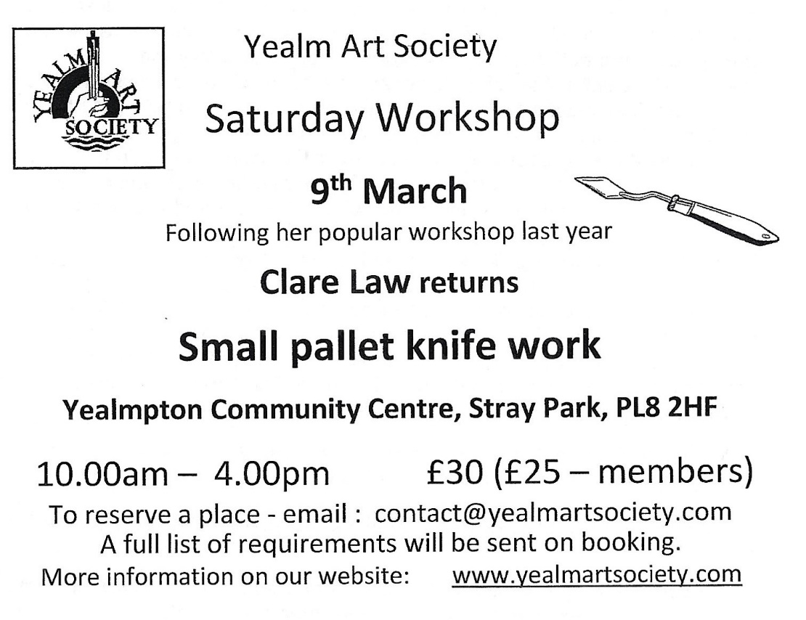
March 9th @ 7.30pm Holbeton Film Club, Holbeton village hall. Tickets on the door adults £4 £2 children Ice cream £1 cash only Doors open 7.00pm
Allelujah
When the geriatric ward in a small Yorkshire hospital is threatened with closure, it fights back by galvanizing the local community. The hospital invites a news crew to film the preparations for a concert honouring its most distinguished nurse.
Coming soon: The unlikely pilgrimage of Harold Fry & Oppenheimer

Tuesday 12 March 2024 12:00pm - 2:00pm Shoresearch Volunteer Survey
Join Devon Wildlife Trust’s Wembury Marine Centre for a Shoresearch Survey at Wembury Beach

14th March Community Police Surgery. Do go to the 1st Community Police Surgery which will take place in the WI Community Hall 2.30-4.00. PCSO Di Summers will be in attendance to answer your questions and concerns.
14th March Parish Council Surgery. The Parish Councillors and Clerk will be at the WI Community Hall to discuss any issues and concerns. 2.30-4.00 (same time as the Community Police Surgery)
14th March Annual Parish Council Meeting (held before PC meeting at 6pm) WI Community Hall, followed by the Parish Council meeting at 7pm
17th March 9.30 – 4.30pm Neighbourhood Plan review. At WI Community Hall
Used by the Planning Department in South Hams in conjunction with the South Devon Joint Local Plan and National Planning legislation, our Neighbourhood Plan has been instrumental in guiding Planning Policy in the Parish; protecting the Waterfront, our Heritage, encouraging the right sort of Development and discouraging poor planning proposals and overdevelopment.
The Policies covered in the NP address Planning Permission criteria for Housing, Local Business, Infrastructure, Health and Wellbeing, Environment, Heritage and Conservation.
So, we are holding Consultation events to gather your thoughts
Please come along and let us know what changes you think need to be made

PUMA

(Plymouth Ukraine Medical Aid)
FUNDRAISING SUPPER AND AUCTION
15th March 2024 - 1900 - YYC
Tickets: £25 from Dick Page 01752 872344; dickpage1@gmail.com
or Lesley Challacombe 01752 872233; lesley@coldvalley.co.uk
Stroke survivors and their partners are invited to the second meeting( for coffee and chat) Monday 18th March 10.30-12.00 in the W.I. meeting room in Newton Ferrers
We hope this will develop into a supportive monthly event
for information contact Fleur Holt and Pam Carter

19th March 14.00-16.00 WI talk on Women Spies of the first World War. Visitors & New members welcome

The Newton Ferrers & Noss Mayo
WI Community Hall Trust
Registered Charity 1054164
Chairman: Val Venning Secretary: Jeanne Venning
Notice
The Annual General Meeting of the above Trust will be held
On
Tuesday 21st March 2024
At 6.00pm
Please support us by coming to the meeting.
Even better come and stand for election to join the committee so that you can have your say on how the hall is operated.
Reply to Jeanne Venning 872442

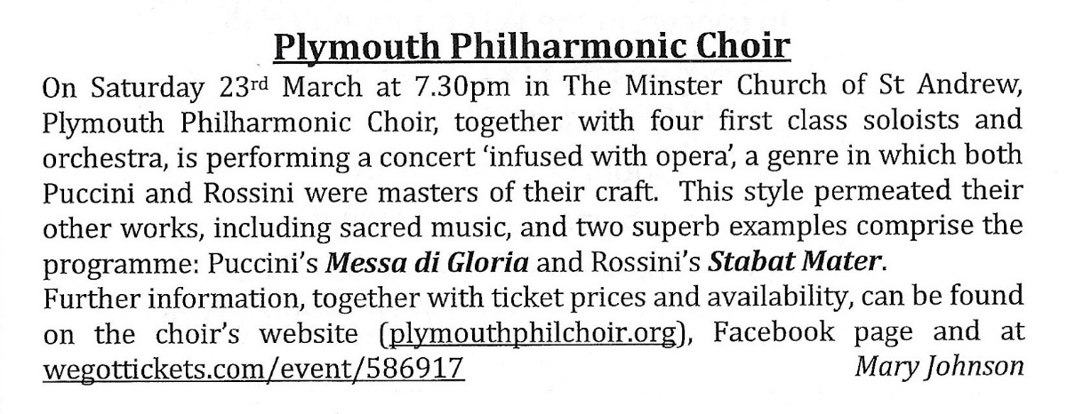

23rd March 11.30-14.00 St Peters Morning Market Newton & Noss Village hall
High water @ 04.41 & 17.07pm

Tuesday 26th March – Yealm Garden Society. 7:30pm start WI Hall Newton Ferrers
Camassia, Chris, Chelsea and Chaos
A light-hearted look behind the scenes of growing for a well-known multi award winning garden designer by Stella Exley, who is an independent hardy plant nurserywoman based in the beautiful South Hams. She regularly exhibits in Floral Marquees at all the major shows and is the proud holder of three National Plant Collections – Camassia, Sidalcea and Uvularia.
Non-members welcome £5

28th March Thursday Lunch Club @12.15 £6 Newton and Noss Village hall. The tide will be going out. Please contact mrandmrsbarnett@gmail.com Allergies can be catered for, also vegetarian option available. New members welcome

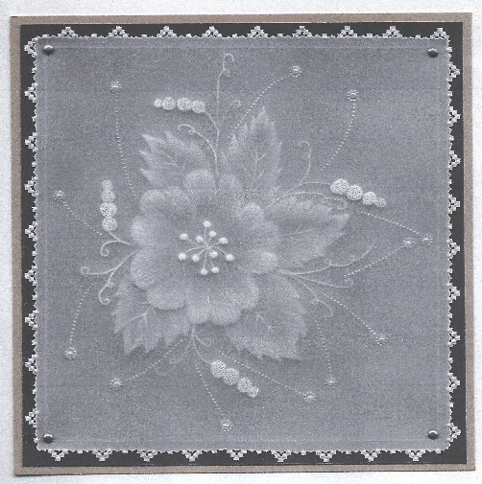
29th March Yealm Parchment Group meet in Newton Ferrers Community Hall. @ 2pm, with individual tables so you can maintain social distancing. Come along and experience this engrossing 15th Century art form. This month we will be doing white work which is pure embossing.
We are a small friendly group who work at their own pace. £8 Parchment, pattern, backing papers, written instructions and tuition included.
Tools can be provided if necessary. Tel Lesley 07838375449

30th March Yealm Art Society Exhibition Newton & Noss village hall This is the Yealm Art Society’s biggest event of the year which is held at The Village Hall, Noss Mayo over the Easter weekend. This is an opportunity for our members to showcase their works and for visitors to the exhibition to enjoy a wonderful display of hung paintings of all genres. Most paintings are for sale together with unframed browsers and art cards.

Rockpool Safari Saturday 30 March 2024 1:30pm - 3:00pm Wembury Marine Centre, Wembury, Devon
Join our Devon Wildlife Trust staff and volunteers for a guided tour of some of the best rockpools in the UK

Tots and Toddlers Rockpool Safari Sunday 31 March 2024 3:00pm - 4:00pm Wembury Marine Centre, Wembury, Devon
Join us on an extremely low tide to explore Wembury’s most amazing rockpools, rarely uncovered by the tide
Regular Weekly Events around the Parishes of the River Yealm
Please check with venue/organiser
Events may be cancelled around school holidays
Day | Time | Details | Venue/ contact number
Mon | 12.45-15.45 | Upholstery group | WI Hall Newton Ferrers
 | 9.00 -12.00 | Mens Shed | Mens Shed Yealmpton
 | 15.30- 16.30  (approx.) | Bridge improvers & beginners | Yealm Yacht Club contact Jane 873043
 | 16.00-18.15 | Ballet | WI Hall Newton Ferrers
 | 18.00-19.30 | Tai Chi | Newton & Noss Village Hall
 | 19.00-21.00 | Badminton | Yealmpton Gt Hall
Tues | 10.00-11.00 | Gentle Exercise | Yealmpton Methodist Church
 | 10.00-11.00 | Yoga | Yealmpton 0780971765
 | 10.00-12.00 | Bowling | Yealmpton Bowling Club
 | 10.30-11.30 | U3A Table Tennis | Newton & Noss Village Hall
 | 12.00 13.00 | Pickleball | Newton & Noss Village Hall
 | 18.15-19.15 | Yoga | Yealmpton 07985532992
 | 19.30-20.30 | Vinyasa Yoga | Yealmpton 07985532992
 | 19.30-21.30 | Bridge | Yealmpton 880613
Wed | 9 am-12.00 | Mens Shed | Mens Shed Yealmpton
 | 10.00-11.00 | Gentle exercise | WI Hall Newton Ferrers
 | 10.00-13.00 | Wembury Community Hub (tea, games etc) | Knighton Room,  Wembury Village Hall
 | 10.30 | Gentle Walking group | Car Park Barton Close Wembury
 | 12.15 | Pilates | Newton & Noss Village Hall
 | 14.00 | WI Choir | WI Hall Newton Ferrers
 | 17.45-19.30 | Karate | Yealmpton 0787360391
 | 18.00 | Bridge | WI Hall Newton Ferrers
 | 18.00 | Gig Exercise Class | Newton & Noss Village Hall
Thurs | 9.30 | Sarah’s fitness (alt weeks) | WI Hall Newton Ferrers
 | 9.30 – 11.00 | Stay & Play  Play group | Holbeton Village hall toobattycross906@btinternet.com
 | 10.00-12.00 | Artistik story time | Holy Cross Church
 | 10.30-11.30 | Reading Group | Yealmpton Parish Rooms
 | 12.45 | Yin to Yang Yoga | WI Hall Newton Ferrers
 | 19.00-21.00 | U3A Table Tennis | Newton & Noss Village Hall
 | 19.00 | Pilates | Rose & Crown function room
Fri | 10.15-12.00 | Digital Drop-In | WI Hall Newton Ferrers
 | 10.30 | Yealmpton & Brixton coffee | Yealmpton Community room
 | 10.30 | Songs & Stories | Yealmpton Methodist Church
 |  | Poetry Group | Yealmpton 07749206347
Sat | 10.30-12.30 | Accessible Bowls | WI Hall Newton Ferrers
 | 9 am-12.00 | Mens Shed | Mens Shed Yealmpton

Save the Date
1st April Yealm Art Society Exhibition & Sale N&N village hall 10.00-16.00
2nd April 12.00 noon 1st Tuesday Lunch Club
RYDA AGM 23/4/2024 Newton Ferrers Community Hall. 7pm.
Complimentary glass of wine or elderflower & guest speaker from Wembury Marine Centre

Revelstoke Community Trust annual meeting Wednesday 24th APRIL 2024 at which Grant Applications will be considered.
25th April @ 12.15 Thursday Lunch club N&N village hall

80th Anniversary of D-Day Beacon Lighting Event
The Parish Council and the Yealm Branch of the Royal British Legion are delighted to be organising a beacon lighting event, near the coast path at Carswell Farm, to commemorate the 80th Anniversary of D-Day on the evening of Thursday 6th June. The Parish Council and Yealm Branch of the Royal British Legion are busy planning this community event and further details will be available in the coming weeks.
In the meantime, please put this date in your diary as we would like to see you all there.
You can read more about this national event here: www.d-day80beacons.co.uk.

