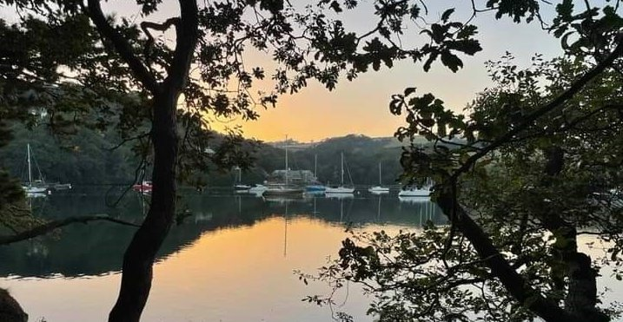
RYDA Newsletter 11/2023
The meaning of November comes from Novem, the Latin word for nine. The old Roman calendar started in March, making November the ninth month. When the Roman senate changed the calendar the new year started in January, and November became the eleventh month.
November is mainly known for fireworks night. The British soldier Guy Fawkes tried to blow up the English House of Lords in London to overthrow King James I and restore the Catholic Monarchy. He failed. November 5th is Guy Fawkes Day and observed all over the United Kingdom to remember the Gunpowder Treason.
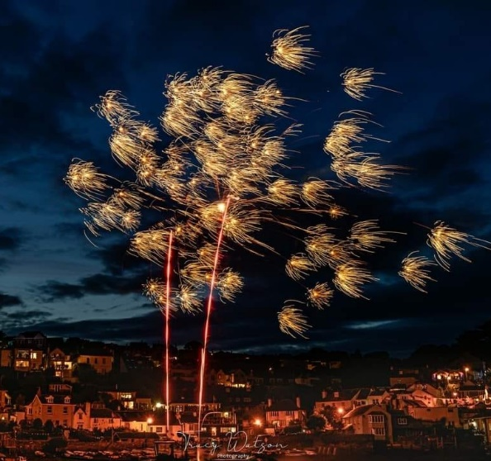
The first fireworks were made from gunpowder packed into long, narrow bamboo tubes. The resulting boom was thought to scare away evil spirits!
It was while watching the Regatta fireworks that I wondered what made the colours, the different sparkles, the whizz and bang. (these fabulous photos were taken by Tracy Watson)
The explosive, colourful displays made by fireworks are the result of several different chemical reactions. There are many different types of fireworks. One of the most common types of commercial fireworks that is often used in public fireworks displays functions similar to a rocket.
To set off a firework, the user lights a fuse. The heat travels along the fuse until it reaches the bottom of the main part of the firework, sometimes called the shell. This ignites the lift charge, which is made from black powder—a type of gunpowder—located at the bottom of the shell.
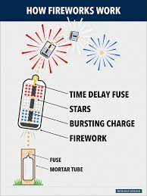
When ignited, the black powder reacts to create hot gases and lots of energy. These forces launch the shell out of the tube it is sitting in, also known as the mortar. The shell is filled with small pellets, known as stars. Once the firework reaches a certain height, a second fuse, sometimes called the timed fuse, ignites and activates the burst charge. This sets off the stars within the firework, which explode into a dazzling display of colours, sounds and other effects.
The appearance of each firework depends on what type of stars it tightly into a tube to create a slow burn. The result is a slow release of gas that creates a whistling sound within the tube.
The stars inside fireworks are made of metal salts, which are powdered combinations of metal and other chemical components.
When the stars ignite, the metal particles (in the metal salts) absorb a huge amount of energy. Once they begin to cool, the particles emit this extra energy in the form of light. The colour of this light depends on the type of metal :
Strontium: Red
Calcium: Orange
Sodium: Yellow
Barium: Green
Copper: Blue
Strontium + Copper: Purple
Magnesium, Aluminium + Titanium: White
Some stars contain metal salts, which produce brilliant colours, while others contain different chemical compounds that cause dazzling light effects, like strobing, sparkling and more.
Some stars even include chemicals that cause special sound effects. Potassium chlorate results in a louder sound, while the use of bismuth creates a crackling or popping effect. Other compounds can be packed tightly into a tube to create a slow burn. The result is a slow release of gas that creates a whistling sound within the tube.

Turning the Devil’s Boulder in Devon
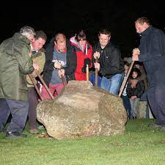
After nightfall men carrying crowbars with women lighting their way approach the huge stone close to the village church. As the church bells peal out the villagers set to work to turn the stone over. Apparently, the devil lives under the stone, and ‘turning the Devil’s boulder’ is meant to avert bad fortune.
One legend recalls that the stone was quarried on the other side of the River Torridge at a nearby village, apparently intended as a foundation stone for a church there. But the devil rolled it away to Shebbear – and continued doing this every night as the villagers repeatedly rolled it back during the day.
Interestingly the stone is not of a type found locally and may therefore have been transported there in ancient times for some ritualistic purpose.
Tar Barrel Rolling
This takes place in Hatherleigh, Devon. & Ottery St.Mary, Devon .
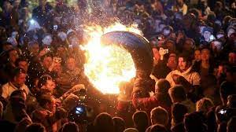
For reasons lost in antiquity, every year the Flaming Tar Barrels are rolled through the streets, to the delight of thousands of townsfolk. Starting with the junior barrels in late afternoon the sizes of the barrels grow until the final giant one is rolled through as midnight calls. It is a great honour to be allowed to take part in the barrel rolling and this has continued in some local families for generations. A gigantic bonfire crowned with Guy Fawkes himself, forms an impressive backdrop to the occasion.
This is an extremely ancient tradition, older than Guy Fawkes himself. Fire festivals around the time of Halloween are deeply rooted in British folklore and have been connected with the ritual burning of witches.

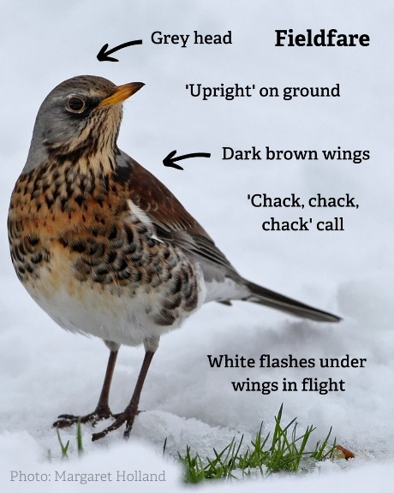
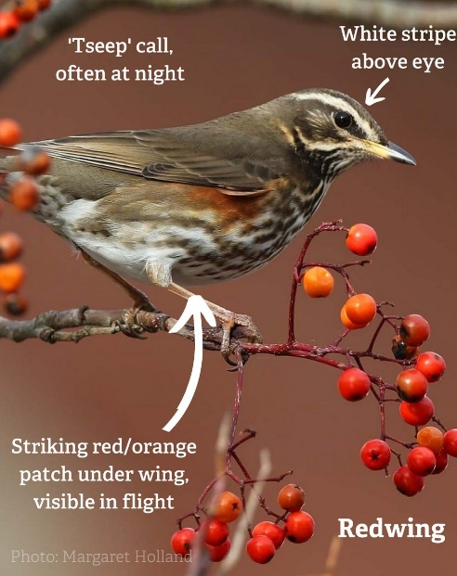
Redwings and fieldfares... can you tell the difference?
Both these birds are seasonal visitors to the UK, heading over to our shores to feast on autumn fruits and berries! They'll stay throughout winter, before heading back to their breeding grounds in the spring.
Though similar in appearance, there are several distinct differences:
Redwings are notably smaller than fieldfares, have a distinctive white eye stripe and rusty-red underwings
Fieldfares have a distinguishable grey head and back, white flashes under their wings in flight and a long black tail.

Did you know that birds choose the order they eat berries in? First, they eat the non-toxic berries which don't last long, like blackberries. Those with a longer 'shelf life', or with a mild toxicity, like ivy, are left until other food sources are scarce. Around the same time, nuts will be cracked, nibbled and hidden for later.
Here's 10 to look out for...
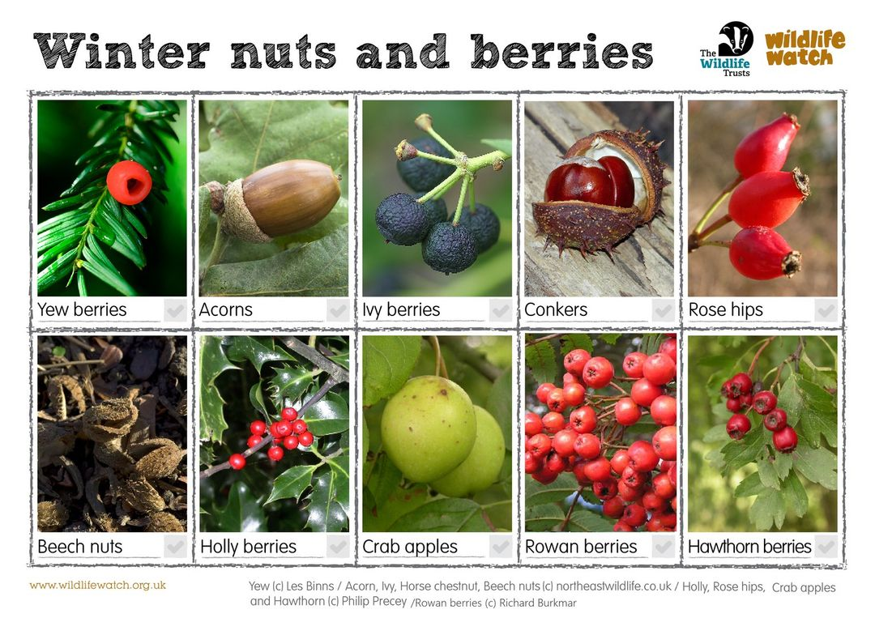

It’s the last chance to review the Neighbourhood Plan at Noss Village Hall
17 November 12.00 noon – 18.00pm , & 18 November 9.30 am– 12.30

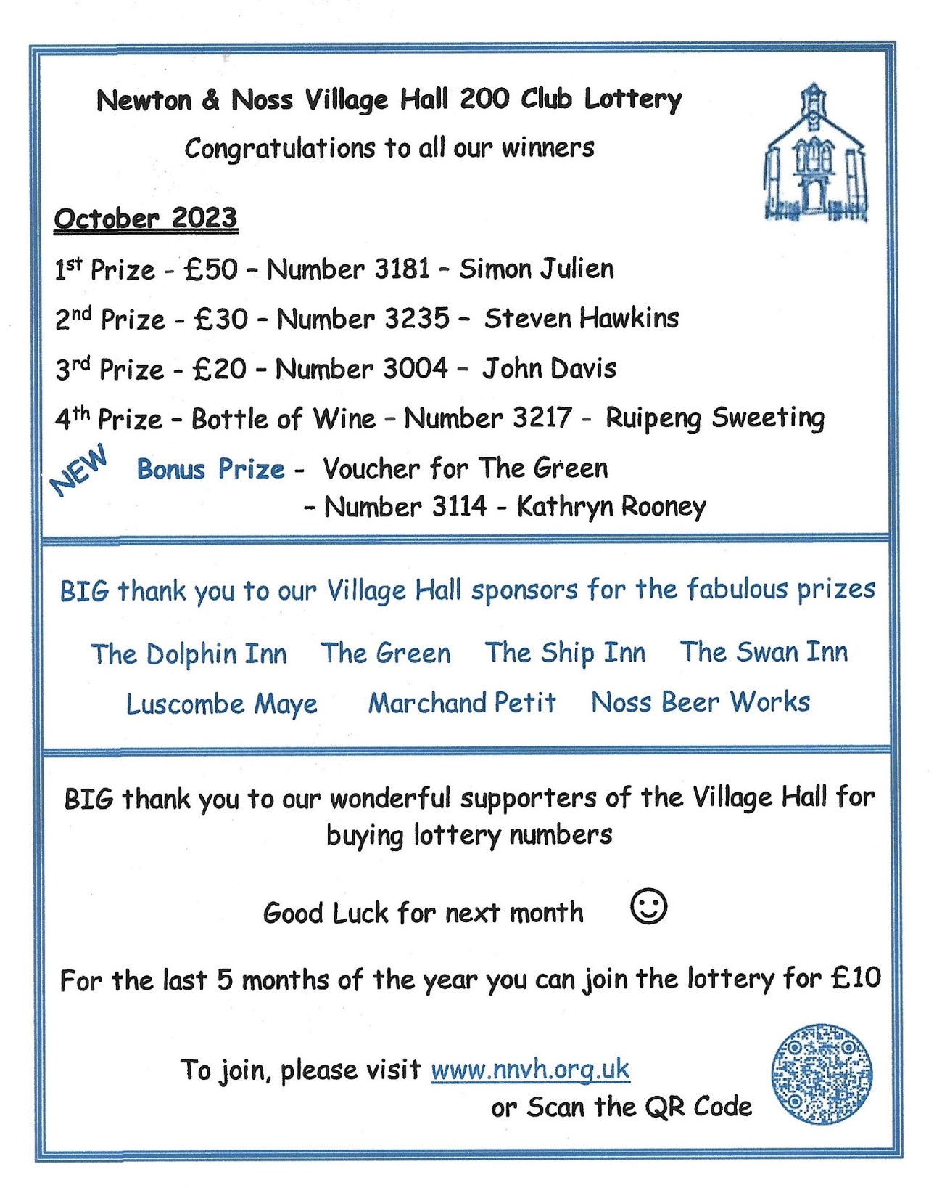
Planning

If you have any views on these, or other applications then please let us, the RYDA, the Parish Council and SHDC know what you think.
Ronsford, on Stoke Road, Noss, situated about 100m above St Peter's, where it is proposed to demolish the existing dwelling & garage, and construct a replacement dwelling with a larger garage, associated parking & landscaping. Application Reference 3341/23/FUL
Most of the bedrooms will be on the new ground floor whilst open plan living rooms etc are to be on the upper level and will access a deck area via large sliding glass doors. There is a risk of light pollution and glare if the new lighting and glazing is not well designed. Extensive landscaping and planting is planned, which once mature will help mitigate any adverse visual and biodiversity impact.

Cleve Moor (or is it Clevemoor?), Noss Mayo. This 5 bedroom house is located in an isolated position on the lane between The Old Rectory on Stoke Road and Middlecombe Lane, well outside any Village Settlement (Development) Boundary. The Application Reference is 3081/23/HHO and is for a single storey extension to an existing annex, which is well away from the existing house. This will allow an additional bedroom & the relocation of the kitchen. The accommodation in the annex will then consist of an entrance lobby, two bedrooms, one with en-suite, a kitchen, living / dining area and snug. The current annexe was granted permission to convert from an existing store / garage in 1993, to have just one bedroom, a bathroom and a store room and not to be used for self-contained accommodation, there was no mention of a kitchen. A similar proposal to this current application was refused in 2010 as it was deemed by SHDC to be "tantamount to a new dwelling in the countryside". This was against the planning policies then in force, many of which have been carried forward into the current policies, you may consider that this application would meet the same description.

13 The Fairway, Ref: 3198/23/HHO application for new two storey side extension

1 Membland Court, Ref: 3298/23/HHO application to replace small flat roof dormer with some internal alterations

Ronsford, Stoke Road Ref: 3341/23/FUL Demolition of existing dwelling & garage, construction of new replacement dwelling & garage with associated parking & landscaping

Cleve Moor, Noss Mayo. Ref: 3081/23/HHO application for single storey extension to existing annex for bedroom & relocation of kitchen

Land at SX 543 782 Noss Mayo Ref: 3306/23/TPO 46 Ash Trees to be felled due to Ash dieback within the area highlighted in red on submitted plan

What’s On
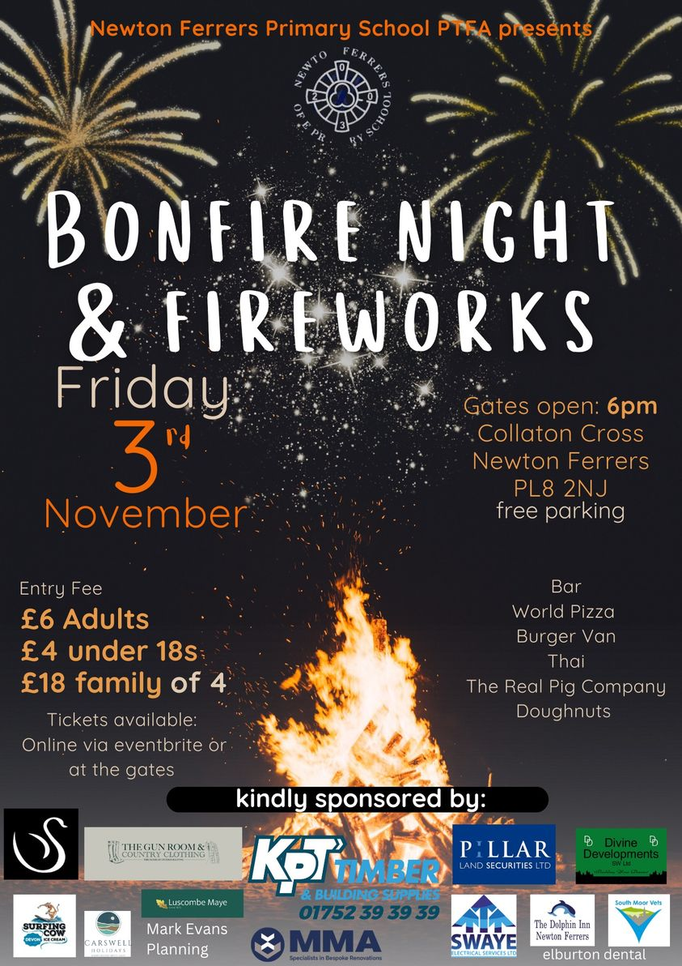

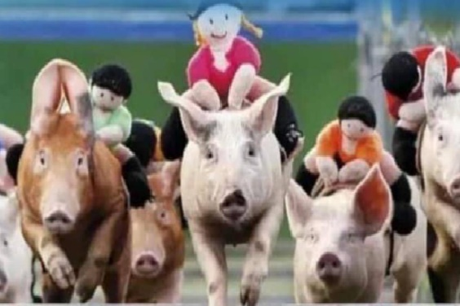
Pig Race Night
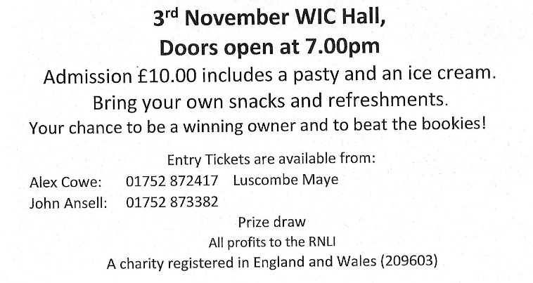

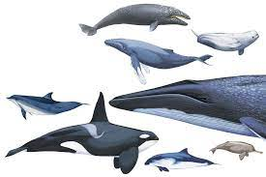

Identification of whales, dolphins and seabirds
Saturday 4 November 2023 10:00am - 4:30pm Wembury Marine Centre,
Learn how to identify UK and European seabirds and cetaceans with this one day course!

1st Tuesday Lunch Club 7th November @12.00 £6 for 2 course meal plus tea or coffee. Newton Ferrers Community Hall. @ 12.00noon £6 for two courses plus tea/coffee. Allergies can be catered for. Please contact either Jeanne (872442) or Jane (872627) New members welcome
If you wish to come to the Christmas Lunch on Tuesday 5th December please book at the November lunch
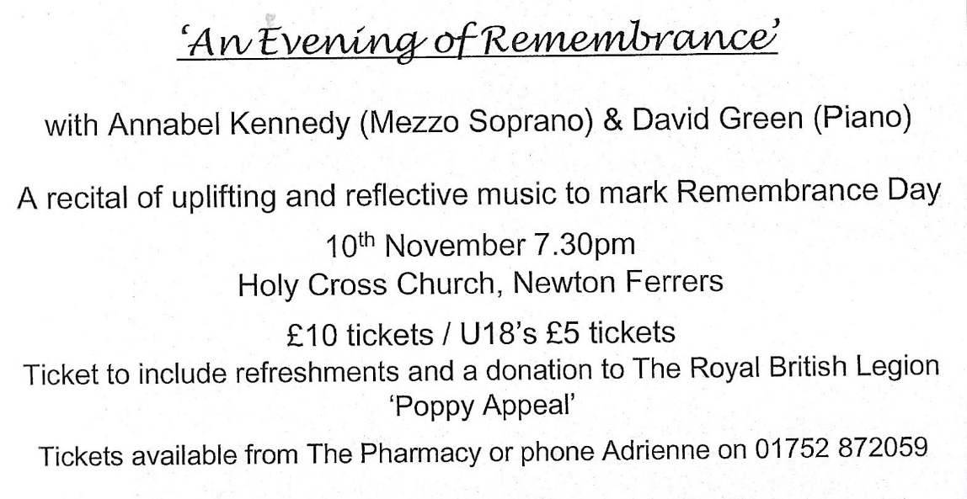

Yealm Art Society Open meeting 10th November Jo Beer talks about her work (Portrait artist of the year twice)6.30. Wine and nibbles on arrival. Tickets on the door £7.50 WI Community Hall

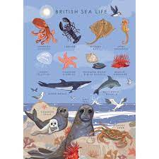
Sea Watch Saturday! 11 November
Saturday 11 November 2023 8:30am - 10:30am
Wembury Point National Trust Car Park
Come and join us for a monthly sea watch at Wembury Point!

Shoresearch Volunteer Survey - 15 November
Wednesday 15 November 2023 11:00am - 1:00pm
Wembury Marine Centre, Wembury, Devon
Join Devon Wildlife Trust’s Wembury Marine Centre and the Green Minds Project for a Shoresearch Survey at Wembury Beach.

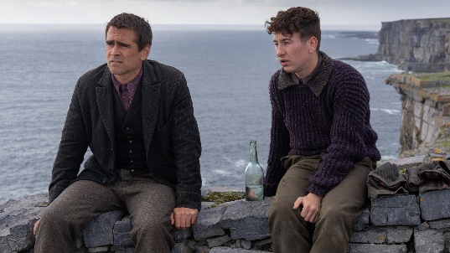
11th November Holbeton Film Club are showing The Banshees of Inisherin @7.00pm

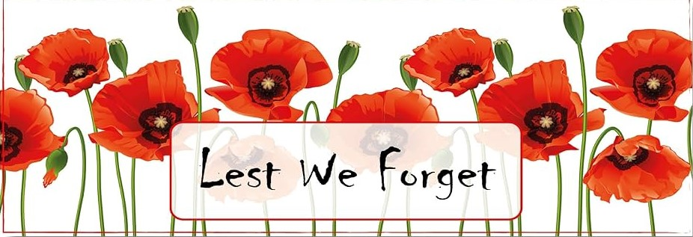
Remembrance Day Service is at St Peters Church Noss Mayo at 10.45. 12th November The remembrance parade and ceremony will take place around the war memorial, followed by a service in the church

Neighbourhood Plan Review Noss Village Hall
17 November 12.00 noon – 18.00
18 November 9.30 – 12.30

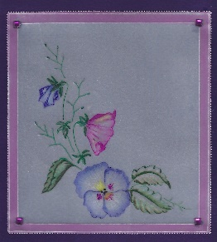
Yealm Parchment Group meet on 17th November at 2pm £8.00
We will be painting with watercolour on Parchment. Equipment supplied if you don’t have it. Tel Lesley 07838375449 for more information

22nd November 7.30pm Yealm Gig Rowing Club AGM Newton & Noss Village Hall

Thursday Lunch Club 23rd November @12.15 £6 Newton and Noss Village hall 12.15. The tide will be coming in Please contact mrandmrsbarnett@gmail.com Allergies can be catered for. New members welcome

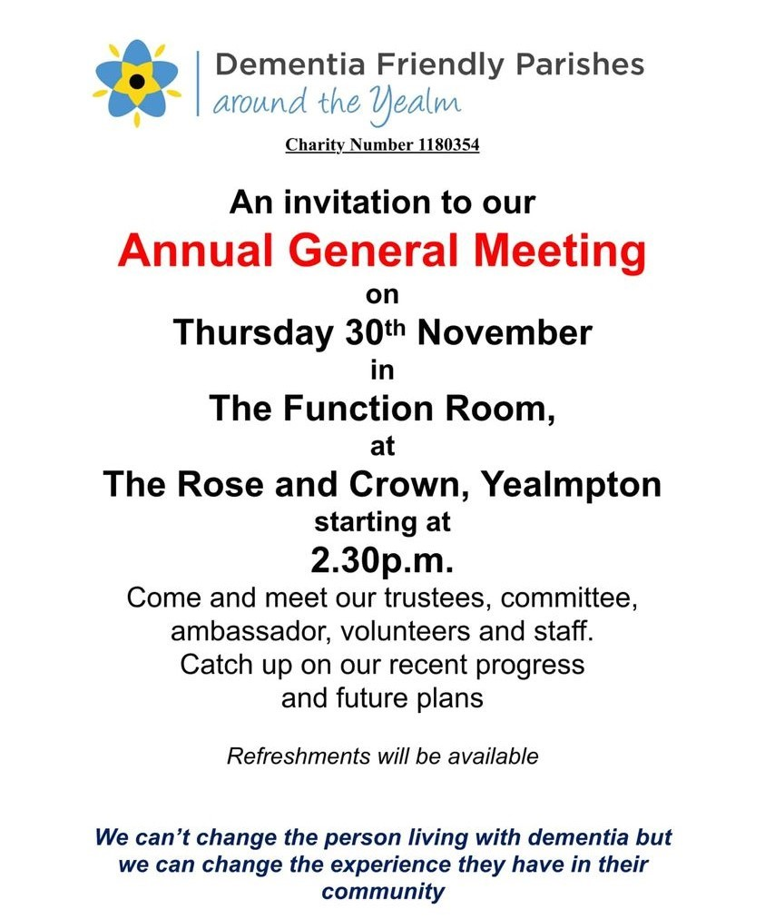

Wildcat, Woodcat, Bad Cat, Good Cat?
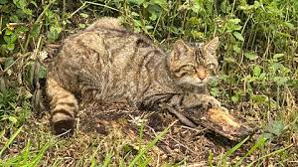
Thursday 23 November 2023 6:00pm - 7:00pm
Online
Hear about Britain's rarest mammal and investigating the feasibility of reintroducing them to South West England.

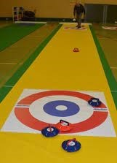

An evening of Dinner & Kurling at Newton & Noss Village Hall
25th November at 7pm
£15 including 2 course meal. Bring your own bottle. Tickets from Jean Ellis 873144 or Louise Holman 873050

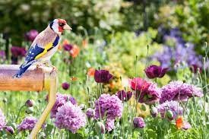

28th November Yealm Gardening Society Talk by Howard Wills on “Gardening for Wildlife” WI Community Hall 7.00. Non-members welcome.

29th November U3A talk “All at Sea & Up the Creek” WIC Hall 2.00-4.00pm Non-members welcome.
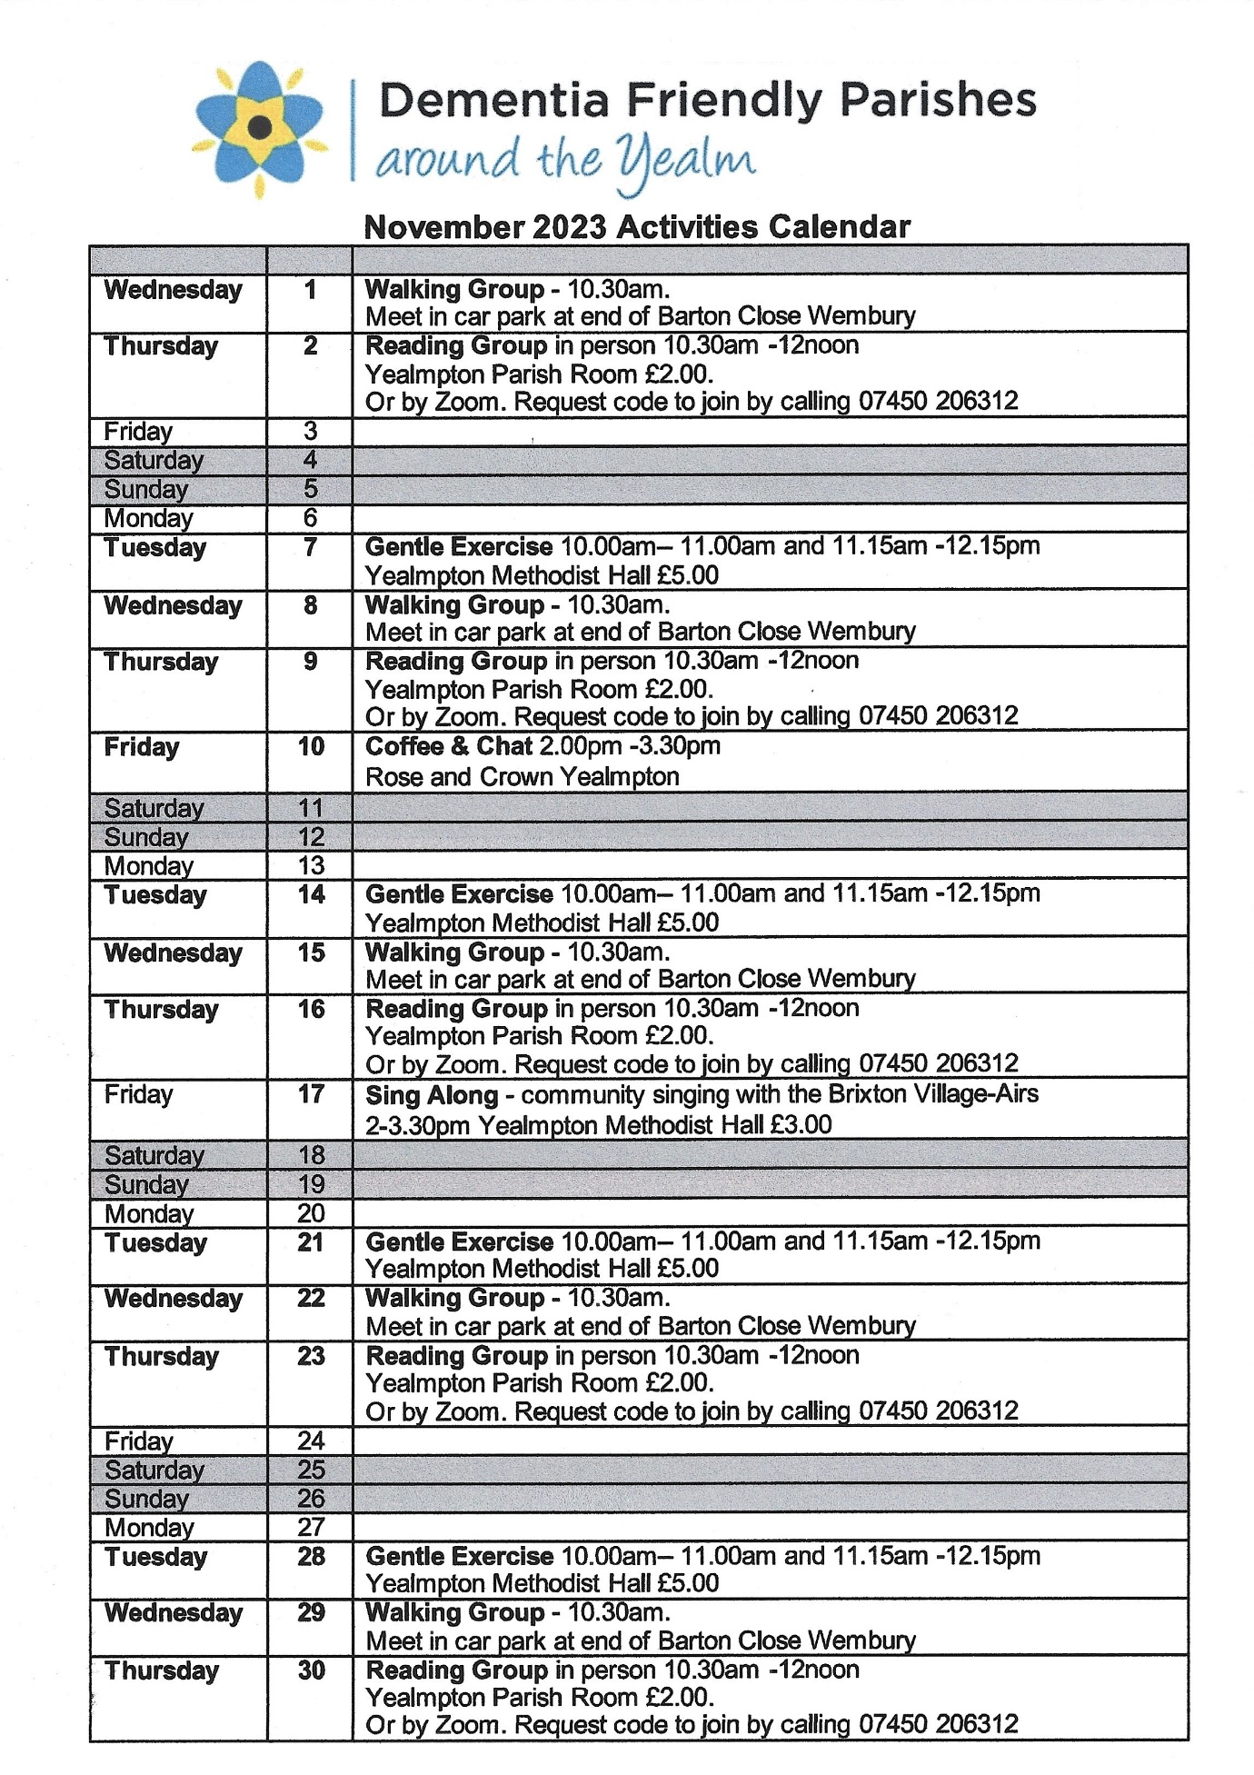

Save the Date
Charity Bridge Drive 1st December 2-5pm WI community Hall
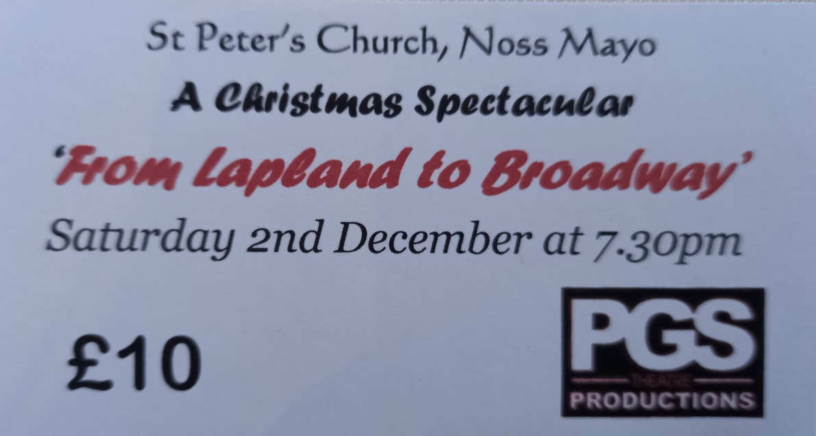

Tickets from Jean Ellis 873144; Jane Barnett 872663 & Tubbs Pharmacy

Sea Watch Saturday! 2 December
Saturday 2 December 2023 8:30am - 10:30am
Wembury Point National Trust Car Park
Come and join us for a monthly sea watch at Wembury Point!

2nd December Christmas Fair at Holy Cross Church 2pm
Stalls & fun for all the family.
(Savouries & Preserves; Homemade cakes; mulled wine; mince pies; bottle tombola; books; toys; games & Crafts etc) If you can offer contributions to the stalls please contact Judy Davis 872891 or Sandy Hignett 07469 775363
3rd December 10.30-4pm Pop-up Art sale with Yealm Art Society free entry WI Hall
8th December 7.00pm Holbeton film club present Elvis
9th December 10-12.00 noon St Peters Christmas coffee morning in Newton & Noss Village Hall
The tide is favourable for parking!
Seasonal floral decorations; books; toys; cakes & bottle stall
Donations, collections or queries please contact Val Sharples 872433

14th December 12.15 Thursday Lunch Club Christmas Lunch Newton & Noss Village Hall

19th December Newton & Noss WI Christmas Lunch

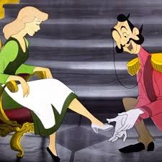
CINDERELLA
To be Performed at Noss Village Hall 7th, 8^{th,} and 9th March 2024

