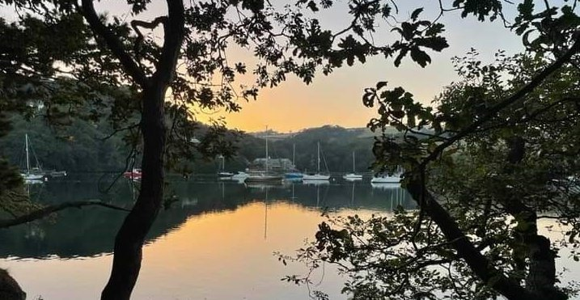
RYDA Newsletter 12/2022
Christmas through the Ages
The Origins of Christmas stretch back thousands of years to prehistoric celebrations around the midwinter solstice. Many of the traditions we cherish today have been shaped by centuries of changing beliefs, politics, technology, taste and of course commerce.
The Romans
The Romans celebrated midwinter with at least 5 days of feasting & partying, called Saturnalia. Honouring Saturn, Chief of the Roman Gods, it was a time when all the usual rules about rank and etiquette were overturned. Slaves were served meals by their masters, and everyone wore a pileus, the conical cap of liberty presented to slaves when they were freed. Public feasts were followed by celebrations at home, and people exchanged small gifts, especially Sigillaria, little figures made of wax or pottery.
During Saturnalia, soldiers would have been served by their officers, as still happens today in all of our forces. They would have varied their everyday diet of bread & beef with some of the luxury foods the Romans introduced to Britain, such as figs, dates, pine nuts, snails fattened up dormice and garum, a strong-tasting sauce made from fermented fish. Instead of the usual beer, they would have drunk imported wine.
Medieval Times
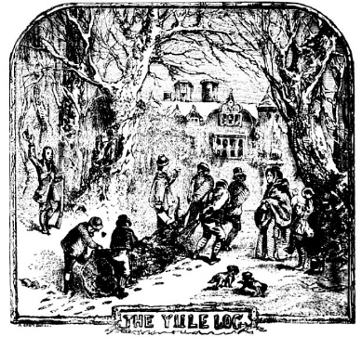
Medieval people really let rip with 12 full days of Christmas festivities, reaching a crescendo on 6th January, “Twelfth Night”, when presents were exchanged. These celebrations commemorated Christ’s birth & the name Christmas (Christ’s Mass) is first recorded in England in 1038. Medieval celebrations included the servants-as-masters antics, and gift giving of Roman Saturnalia, and the pagan midwinter feast of Yule. These included the Yule Log (kept burning throughout the season); decorating with Holly and evergreens, & eating richly decorated Boar’s Heads, sometime washed down with mulled extra strong ale with honey & cinnamon, spiked with Brandy.
The Tudor Times
During Advent it was traditional to eat no meat, eggs or cheese. This was done for religious reasons, - but it also saved up more food for the 12 days of Christmas, which were a time of big celebrations, especially for the upper classes.
December 21st is St Thomas Day & poor people often went “Thomasing” around their richer neighbours asking for help over Christmas. They were normally given real items like flour and oats rather than money. Poor people could also have been given some money on “Boxing Day” when the “poor boxes” were opened in churches.
During the 12 days of Christmas everyone was meant to stop work. Including farmers. Celebrations by the upper classes were very extravagant – so the servants and kitchen staff certainly had to work over Christmas!
However, it was traditional to invite all those who worked on farms belonging to the land owners to the main Christmas meal; although they had to eat with the servants.
The main decoration for large houses was a “Christmas Crown” made by weaving small branches of ash or hazel together (skills the farmers had from making fences). It was a kind of giant Christmas wreath which was filled with holly, ivy and other greenery, and was hung from a high ceiling on Christmas Eve.
Their feasts were huge. They normally consisted of pottage/frumenty (a watery kind of porridge) or soup – to line the stomach; lots of meat (only the rich could afford meat); different kinds of suet or pastry puddings filled with meat & expensive dried fruit; and the meal was finished with cheese. – Similar to today, but often all the dishes were on the table at the same time.
Frumenty is cracked wheat boiled in milk and was eaten all year round. But for Christmas they added dried fruit & spices like cinnamon, nutmeg & ginger. This is the origin of what has become Christmas Pudding.
The traditional centre piece was a boar’s head. This went back to Saxon times, and there is an early carol called “the Boars Head Carol” which was written in the 15th century & is still sung in many places of the UK today.
The “Banning” of Christmas
From the mid 1640’s until 1660, Christmas was banned by the puritans. They thought Christmas was wasteful, and that it led to people eating & drinking too much (they may have a point).
In 1650 the feast of Christmas was banned, and shops were ordered to stay open and people were penalised if they went to a church service on that day. Soldiers were posted on the streets to confiscate any food they thought would be used for celebrations.
When King Charles was restored to the throne in 1660, all the laws made between 1642 & 1660 were thrown out, & so Christmas was celebrated again.
The Georgian Times
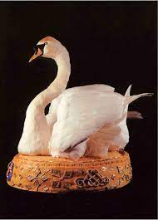
Popular Christmas food (for the wealthy) included brawn & multi-bird pies. In Georgian times, all the food, savoury & sweet, was served at once.
Roast Beef, Christmas Pudding and mince pies were introduced, as were sweet jellies with lots of alcohol in them. Rich people would hire very expensive chefs who could make jellies into large and spectacular shapes.
The Georgians also popularised the twelfth night cake, which is still eaten in many countries at Epiphany.
The Victorian Times
Books such as “A Christmas Carol” by Charles Dickens, put together new feelings about Christmas & helped to shape the Christmas traditions and celebrations we have today.
Christmas cards were invented in 1843, and Christmas crackers a few years later, as did the Christmas tree.
During the Victorian period, there was a renaissance of singing carols, with people collecting old folk tunes and adding new words to them.
Christmas Cakes & puddings became what we know today, with more cook books being published and dried fruit and spices becoming available to more people.
With advent of trains, foods from the countryside became popular, introducing Turkey & Goose to the cities. Many people belonged to “goose clubs”, where they put money aside for the Christmas goose. The bird was often spit roasted over a fire.
It was during the Victorian period that the 12 days of Christmas became less important due to people living in cities and having to work. So, twelfth night parties and Twelfth night cake became Christmas parties and Christmas Cake.
World War II
The Christmases during WWII in the UK were very different. Many people were not in their own homes. Lots of men were away fighting, & most children were evacuated to the countryside.
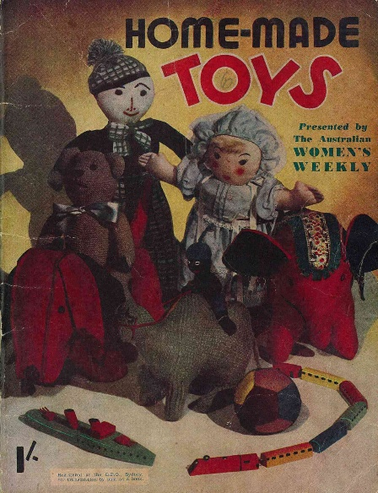
Decorations could be hard to get as most things were scarce &/or rationed. Trees were rare as the wood was used for construction. There weren’t many Balloons, as the rubber plantations were in the war zone in the far East.
The Women’s Voluntary Service published instructions for home made decorations made from scraps and leftovers. Paper Lanterns/chains were made from old magazines/wallpaper etc. Paper was strictly rationed so every bit was used and reused. Greenery was still available. German planes released “chaff”, (strips of metal foil to try and confuse radar), and they were used to make shiny decorations.
Toys were made from what you found lying around. Pipe cleaners, wire, matchboxes & cigarette packets were used to make furniture for dolls houses. 4 lids from cocoa tins and a tin could make a model car.
During the war, going to church became more popular again as people were looking for hope and comfort.
Christmas cards were popular as a way of families keeping in touch. The military forces used “air graphs”, where letters were photographed & then developed/printed at their destination. This saved lots of space taking things to & from the front line as you could get 1500 letters on 1 roll of film.
Food was rationed, but everybody grew their own vegetables. Stuffed rabbit was an alternative meat, goose & turkey was scarce. Cakes became eggless and even fatless, with vegetables such as carrots taking their place.
The Elf on the Shelf
The Elf on the Shelf is a very new Christmas Tradition, from a book written by Carol Aebersold, and is based on a family tradition. Carol had an elf doll that would “magically” appear in a different part of the house every morning running up to Christmas, and was told that the Elf was watching, and it would tell Santa if they had been naughty. There are 2 rules with the Elf: You can’t touch the Elf or it will lose its magic, & the Elf moves around the house when the children are asleep.
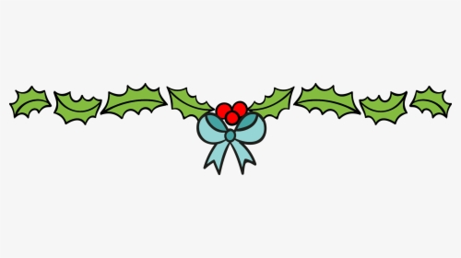

There is a good video of bringing the new electric ferry round to Plymouth from the Yealm on You tube, https://www.youtube.com/watch?v=nl5fKf-Kbj4 It was taken by Steve, our skipper, when he took the boat around to be over-wintered in Plymouth.

Brookings Down Wood & Eastern Hill Wood
Despite two cancelled working party dates at the beginning of September and through the efforts of our growing volunteer group, we have still managed to achieve a number of key tasks. This has included clearing a significant amount of broken branches and debris created by the huge Ash tree (southern edge of BDW) brought down by storms earlier this year. The trunk will stay where it has fallen to allow nature to take its course however the clearance work has created space for a mixed variety of new plantings which are due to be delivered from The Woodland Trust during November.
During November our annual Nest Box survey will have been completed in both BDW and EHW. Early signs are very encouraging with a high percentage of boxes having evidences of nesting materials, including moss, sheep wool and even some tennis ball fluff! Several boxes require maintenance such as new roofs and walls and these will be added to our work plan.
Other tasks have included strimming the edges of paths along with checking steps and rails. Clearing bramble at the top of BDW has revealed a large number of Foxglove seedlings and so we look forward to a good display next year.
Through a grant from Yealm Community Energy, we are considering the location of a replacement tool shed following the attempted break-in and damage to our current shed. The shed primarily contains hand tools and therefore are of little monetary value however the shed and these items are very important to our conservation efforts in both woods.
2023 Working Party dates are as follows:
January 7th 21st February 4th 18th March 4th 18th April 1st 15th
We meet at 10am at the shed in BDW near the play park where tools and tasks will be allocated. Coffee and biscuits are also included!!
If you would like to know more about becoming a Friend of the woods or joining a future working party please contact:
Paul Francombe (thefrancombes@btinternet.com) or
Val Lomax (val@lomcroft.plus.com)

The RYDA Village Directory is in the process of being collated for 2023.
The following may apply to you:-
• You are already in the Directory, but need to confirm a correct entry, or amend or delete the entry and have not already done so.
• You would like to be in the Directory, but are not sure how to go about it
• You are a Village Organisation who would like to have information about yourselves in the Directory
• You would like to join the RYDA to get a free entry for the next Directory
If so, please contact rydavillagedirectory@outlook.com in the first instance.

SIMON BROWNINGS Report to Sustainable South Hams CIC
Westcountry Rivers Trust’s Analysis of the Environment Agency’s published data reveals alarming facts. The frequency and scope of the sampling undertaken is scientifically inadequate to measure or even indicate the real impact of pollution. The, once, annual reports on the health of our rivers from the Environment Agency as required under the EU Water Framework Directive (WFD) have faltered. The last report in 2019 showed that many of our rivers in the South Hams, such as the River Erme, are ‘failing’ and we are not expecting to see another report until 2025. The monitoring work required by the EA was expected to lead to improvements in water quality by 2027 but we are headed in the wrong direction for that to be a realistic outcome. It is a widely-held view that sewage pollution of our rivers is only a risk after heavy rainfall. This is not true. Reports from water companies can be easily misinterpreted because of their focus on ‘sectors’ rather than individual ‘activities’. Water companies point to “Agriculture’ as being the most damaging ‘sector’ but the impact of Agriculture is divided across a number of ‘activities’. When the data is reviewed only using the information about individual types of ‘activity’ (across all ‘sectors’) – the percentage for treated effluent sewage discharge is 48%. Nationally, the single ‘activity’ causing the highest percentage of water bodies to fail the WFD requirements, according to data from the Environment Agency itself, is the discharge of treated sewage effluent directly into our rivers.
There are 55 sewage treatment plants in the South Hams of various sizes, depending on the nearby populations. But size of a sewage treatment plant is not necessarily an indication of risk of pollution of our waterways. The small parish of Holbeton with tributaries into the Erme, recorded 112 spillages of raw sewage over 961 hours in 2020. These spillages have to be recorded by the water companies which self-monitor the impact of their direct discharges into the waterways. The level of monitoring by water companies is superficial and the data is not effectively publicised because the data provided at the SSH Water is Life meeting shocked all attendees. Simon presented data from the Environment Agency and South West Water which is already in the public domain. He and colleagues at the Rivers Trust simply downloaded it and analysed it.
Torbay sewage treatment works effluent, dealing with a population equivalent of 175,000 people is only monitored 24 times per year, for a very limited number of pollutants. In addition to specific monitoring of waterways near sewage outlets, some rivers are only monitored 4 times per year but most are not monitored at all. To add insult to injury, the water companies have decided no longer to monitor coastal ria estuaries and they have not been required to reinstate this survey. Reporting of data does not uniformly cover all rivers, with disproportionally more samples form the Yealm leading to an unscientific skewing of the averages. It is an unequivocal fact that the number of samples taken by the EA are now too low to even indicate the general health of our waterways and as a result the public are systematically poorly informed. Something needs to be done.
To address this failure, The Westcountry Rivers Trust has provided technical support and a reporting platform for citizen scientists to routinely survey the health of our rivers. To date they have undertaken 477 surveys in 33 of the 90 areas in the South Hams catchment. With more citizen scientists, the aim is to cover 100% of the South Hams Catchment. To enrol, contact the Westcountry Rivers Trust https://wrt.org.uk/ and bring our rivers to life.
Forwarded from PETER BROWN

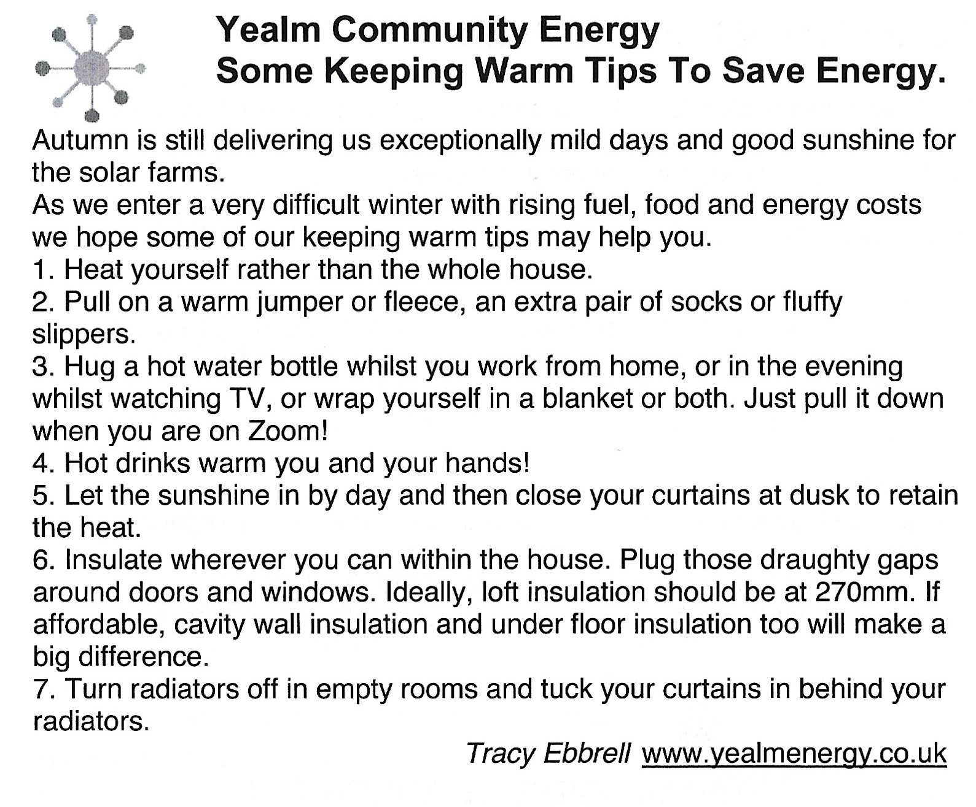

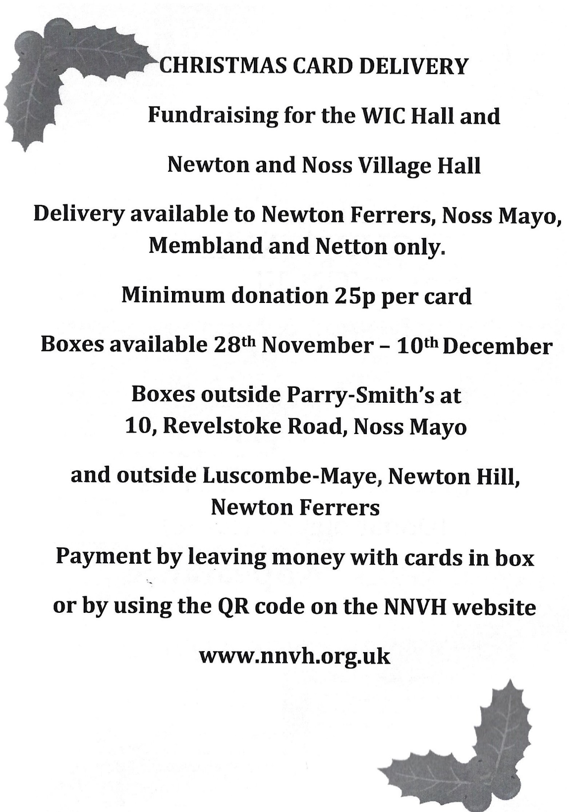

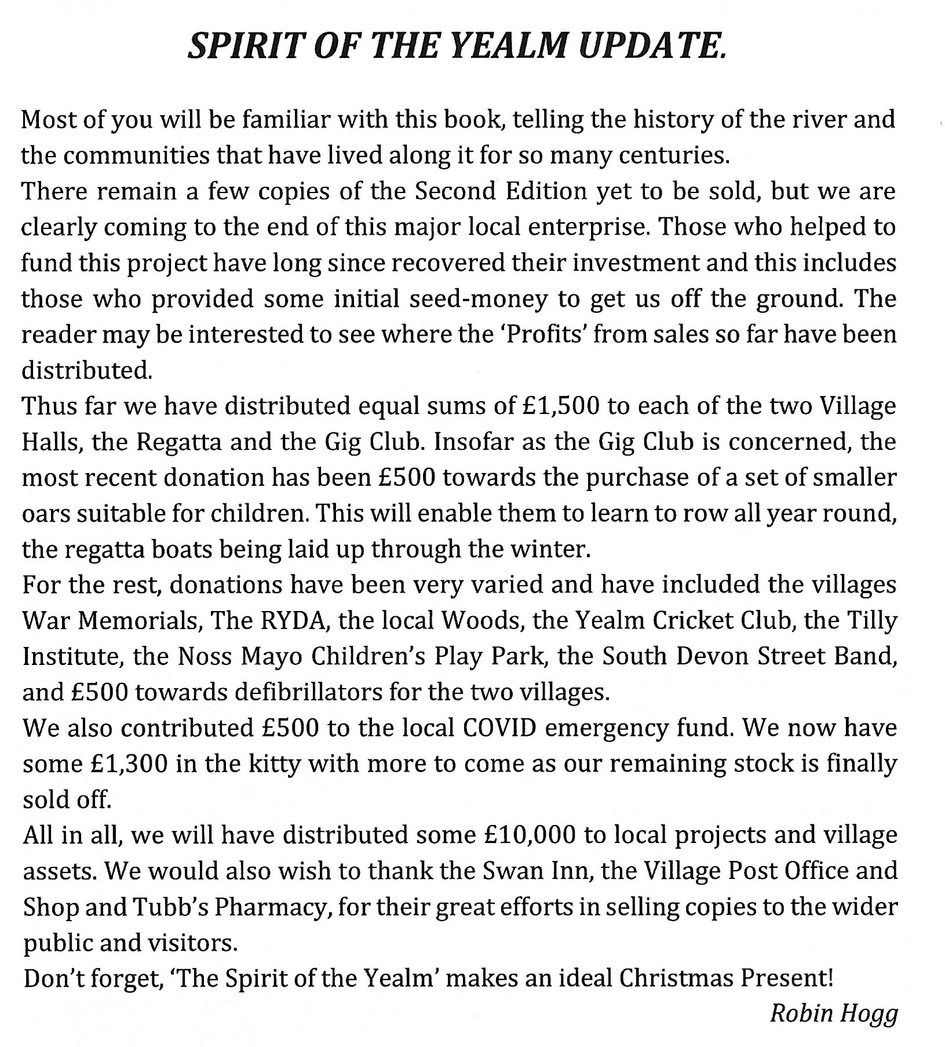

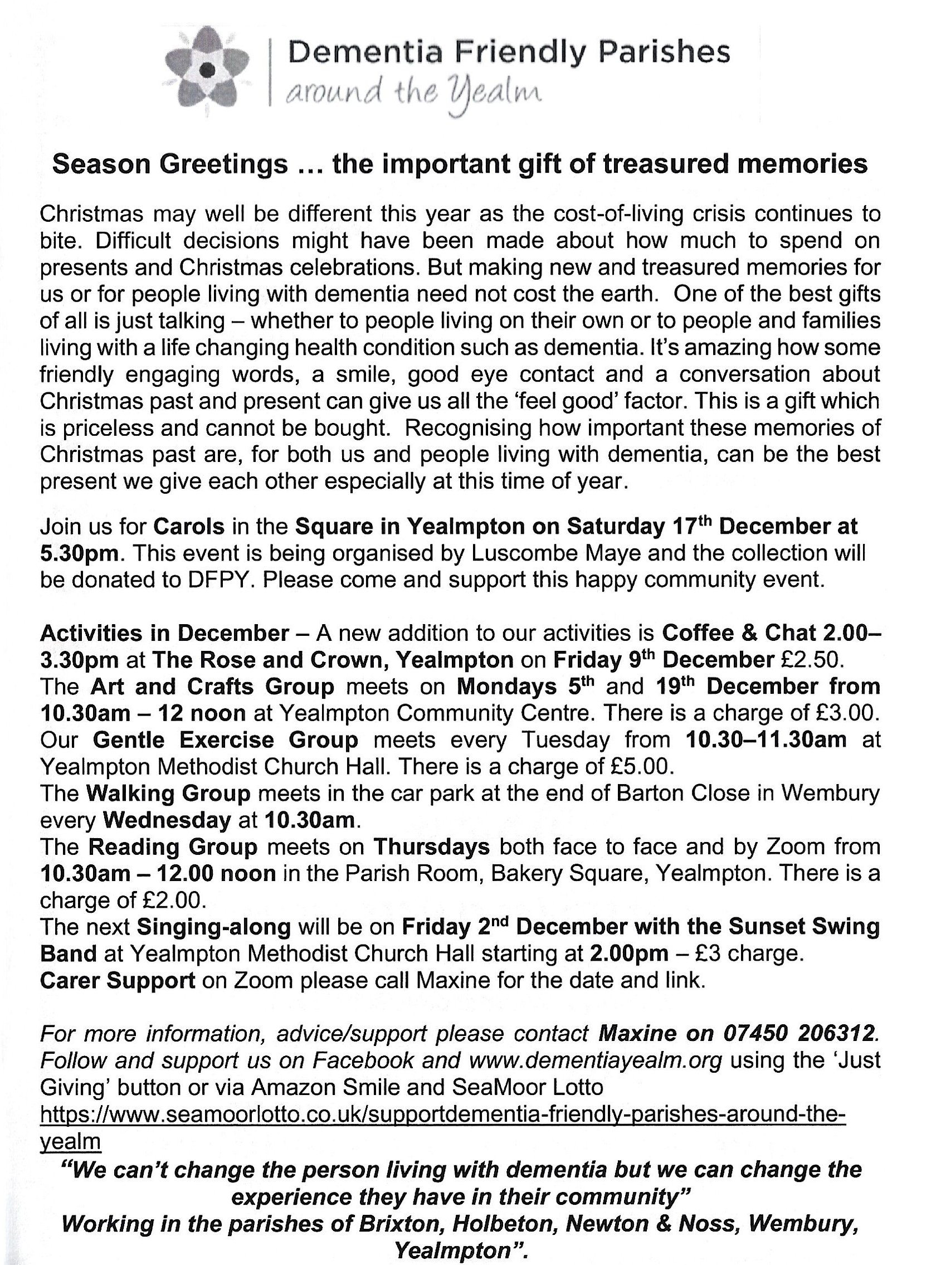

Planning
59 Yealm Road
Following concerns raised by Members, RYDA initiated a query with South Hams Planning on the permissibility of a large caravan placed on the old “Westerly” site at 59 Yealm Road. Their reply is included below:
Re: Alleged unauthorised Caravan
At: 59 Yealm Road, Newton Ferrers, Devon, PL8 1BJ
Further to our investigations, the Council hereby advise you that the following decision regarding the alleged Breach of Planning has been made.
As you are aware the Council was investigating this matter to establish whether or not a breach of planning regulations has occurred. I can advise you that the Local Planning Authority has concluded that there is no breach of planning regulations.
The home owners have an approved planning application 3117/17/FUL and the use of a caravan on a temporary basis during the build is permitted. The home owner plans to remove the caravan after the build is complete.
We will now close the enforcement file and update the Councils’ records. Please do not hesitate to contact me if you wish to discuss this matter further.
Kind regards.
We hope that this reply will reassure members and wish the home owners success in the construction of their new home. RYDA will continue to monitor the situation.

Planning items for December 2022
Tylecroft, Stoke Road - Extension to existing parking area (3994/22/HHO)
This is currently a cramped parking area where Stoke Road is quite narrow. Although the proposed design will provide more pace for parking, it is difficult to see how it will be possible for cars to turn on the site.
Membland House - Construction of a large store & workshop with ancillary facilities in an existing stables area (3618/22/HHO).
This is well designed to complement the Membland Revelstoke buildings. Any approval should ensure that the new store and workshop are clearly “incidental” to the main house and could not become additional accommodation. As this a workshop there also needs to be a restriction on potential nuisance to nearby residences.
Highbank, 5 Yealm View Road – Expansion of bedroom 3, extending kitchen to form dining room, new integral study & garden room & upgrading of services (4062/22/HHO - Re-submission of 2821/22/HHO).
A modest extension where the new pitched roof instead of the earlier proposed flat roof should obviate any potential overlooking issues, though potential loss of light to the property to the east may be an issue.
10, Munro Avenue, Collaton Park – Replacement of an existing single storey side extension with enlarged two storey side extension (4058/22/HHO).
This is a modest side extension on the existing footprint of a single storey lean-to extension.
1 Pillory Hill - Proposed fold-down awning to home studio street window/door with fold down de-mountable bench (not permanently fixed) below window (3798/22/HHO, Resubmission of 0908/22/HHO).
This has been resubmitted after withdrawal of the earlier application for which the PC raised an objection due to concerns over compatibility with the Conservation Area. The only discernible change is the removal of the advertising name from the front of the awning.

Wyndcroft, 6 Church Park - Remodelling existing garage to provide a study, photographic studio & store (4011/22/HHO) – A modest increase in the size of the garage (many 20c garages cannot accommodate modern cars).

Whats On?

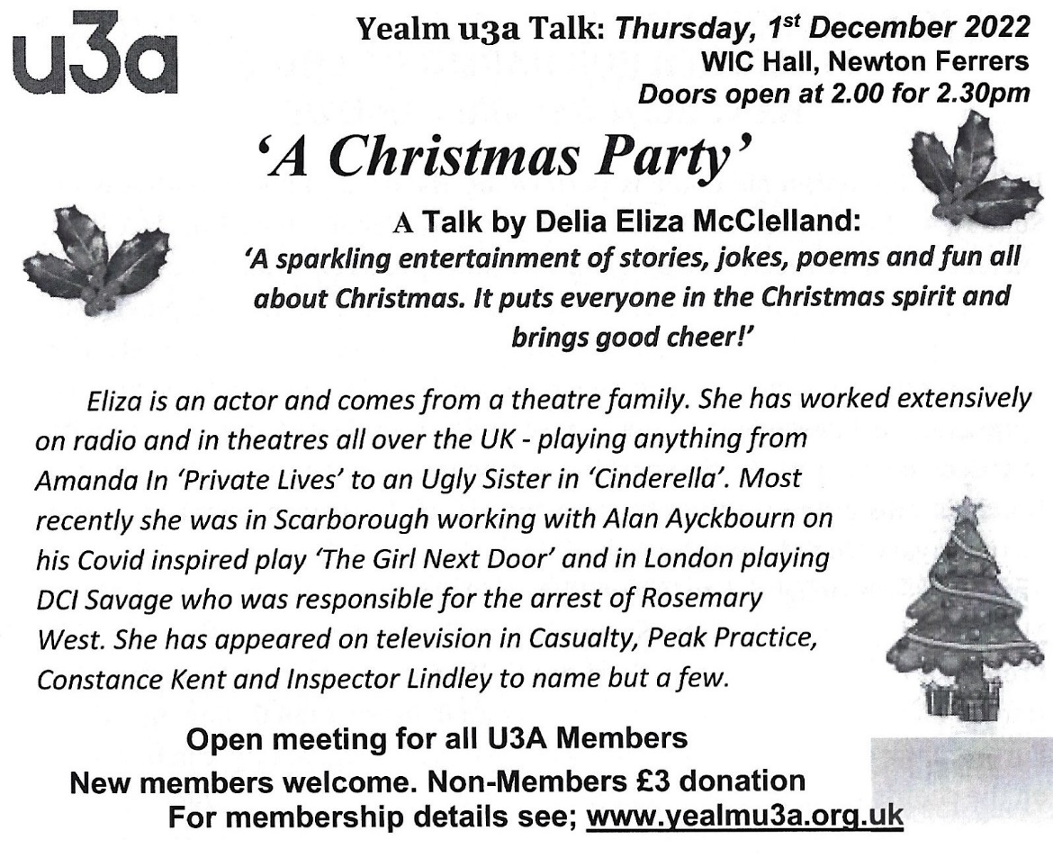

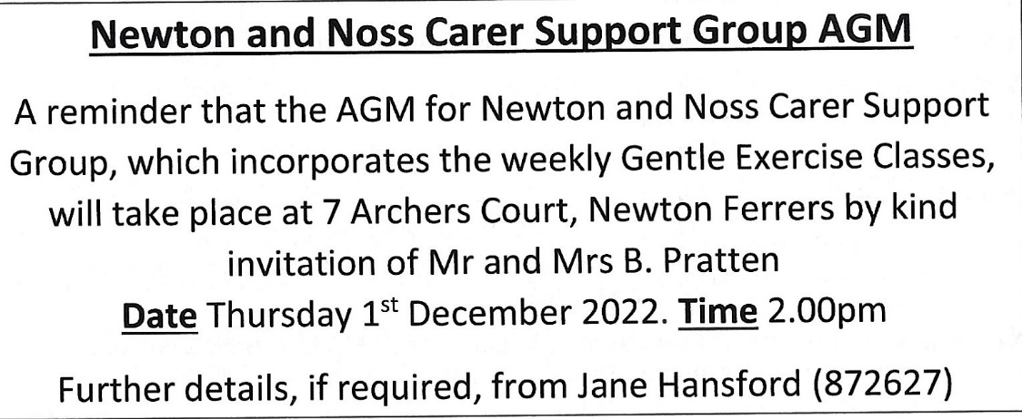

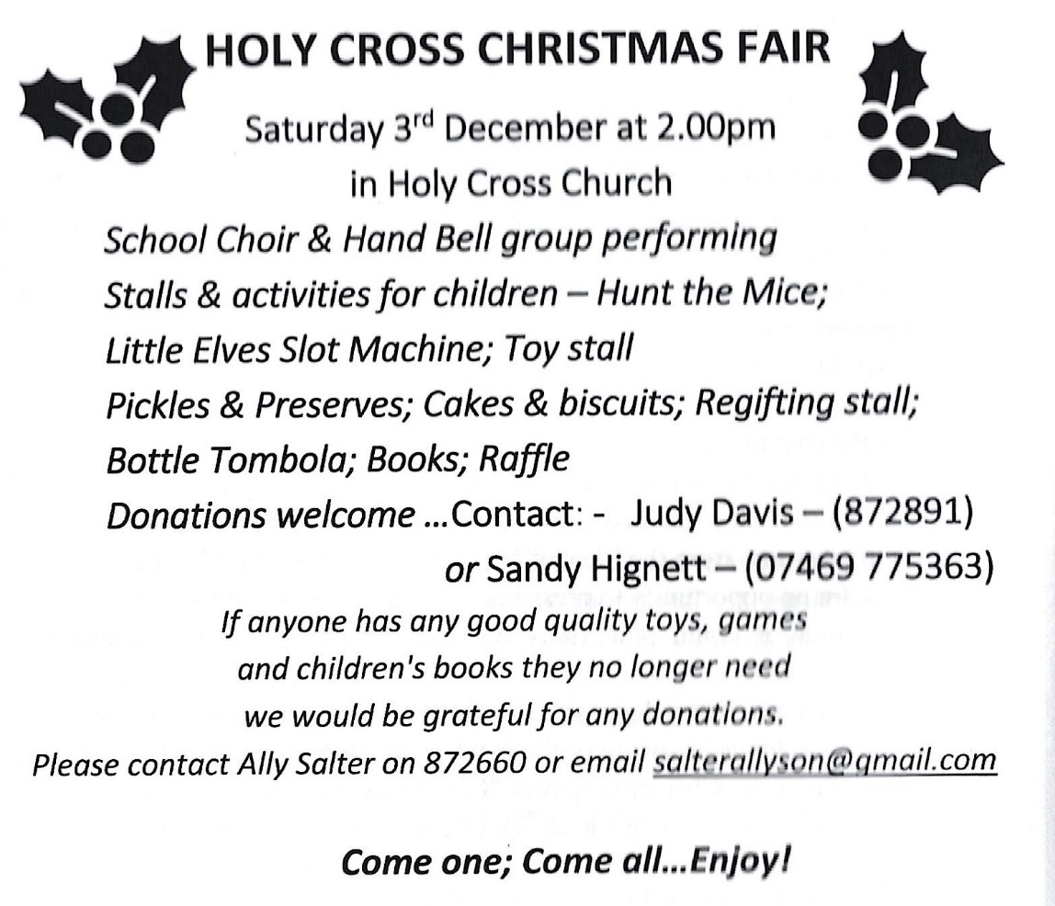

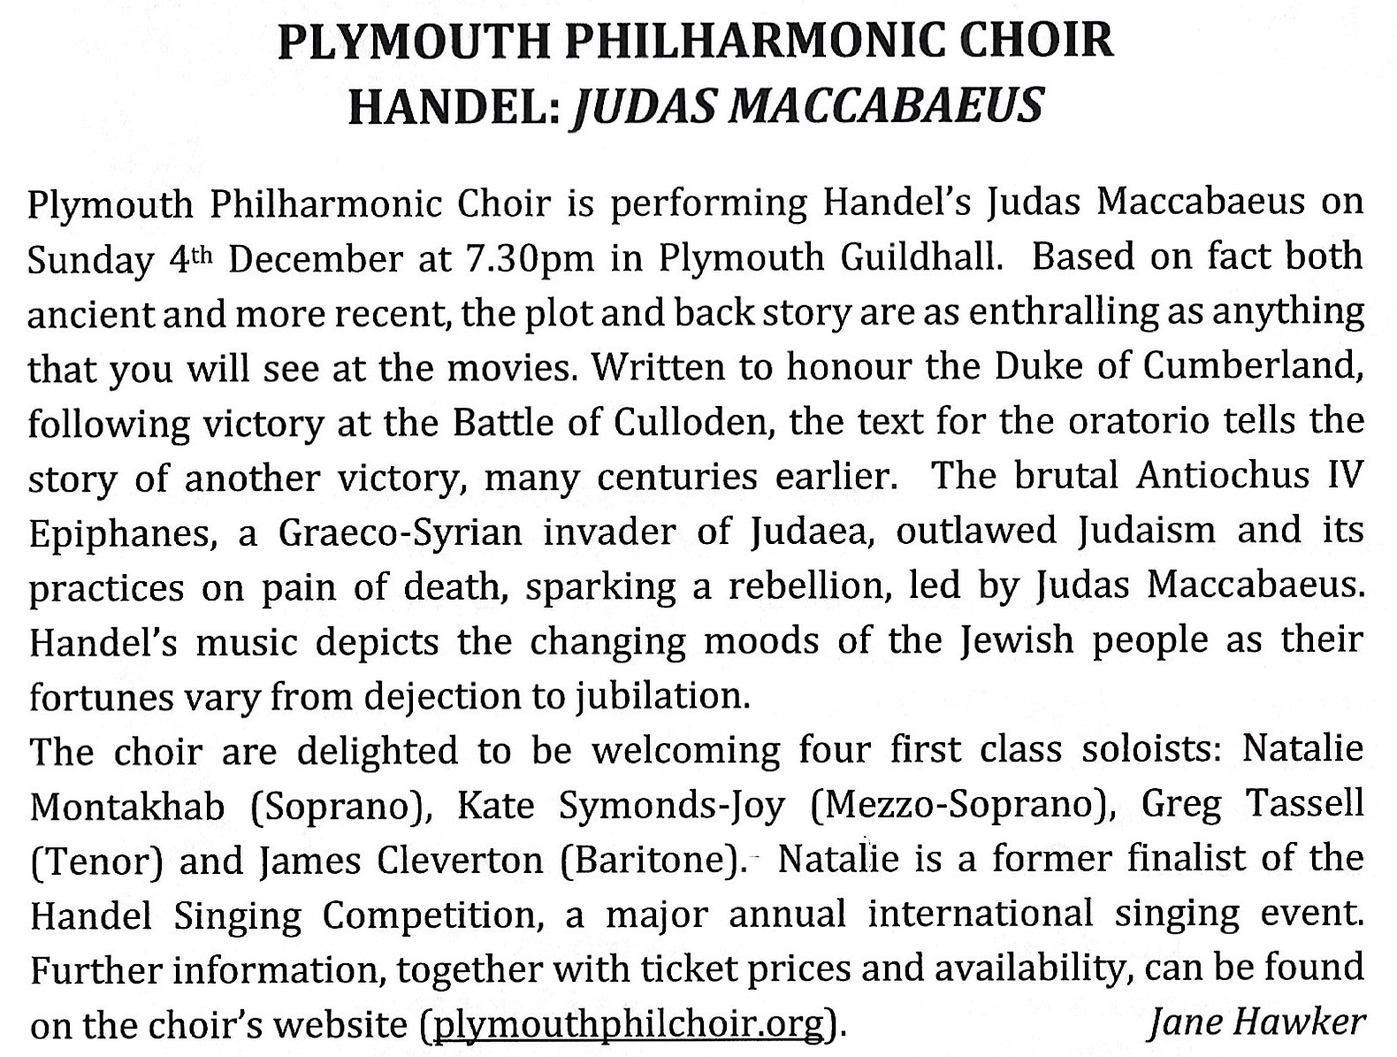

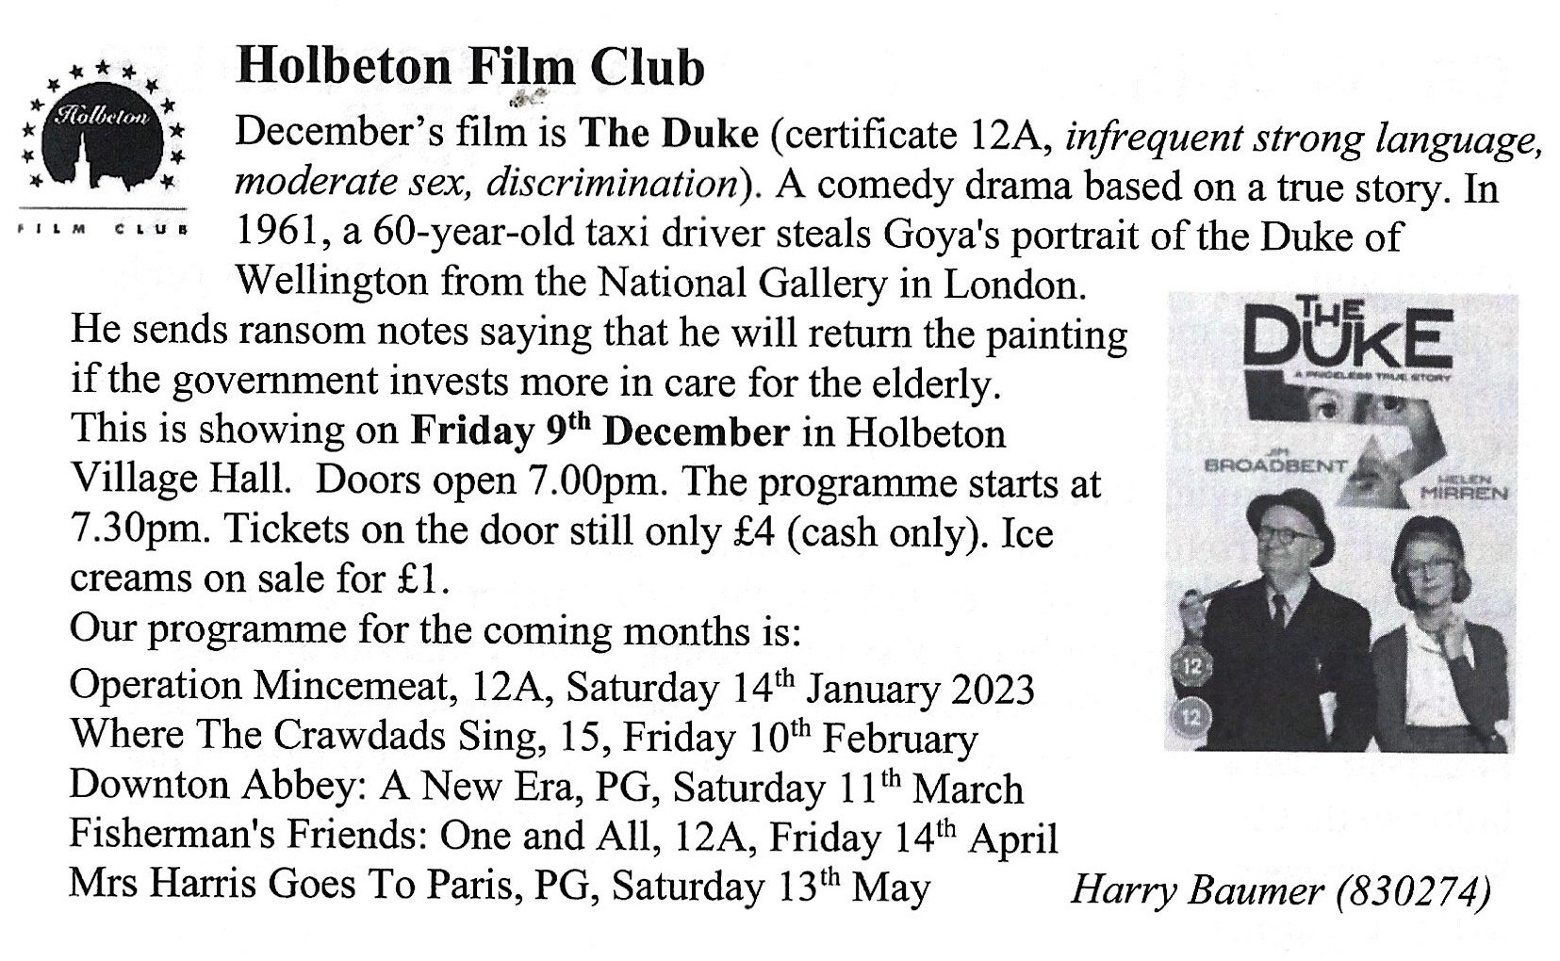

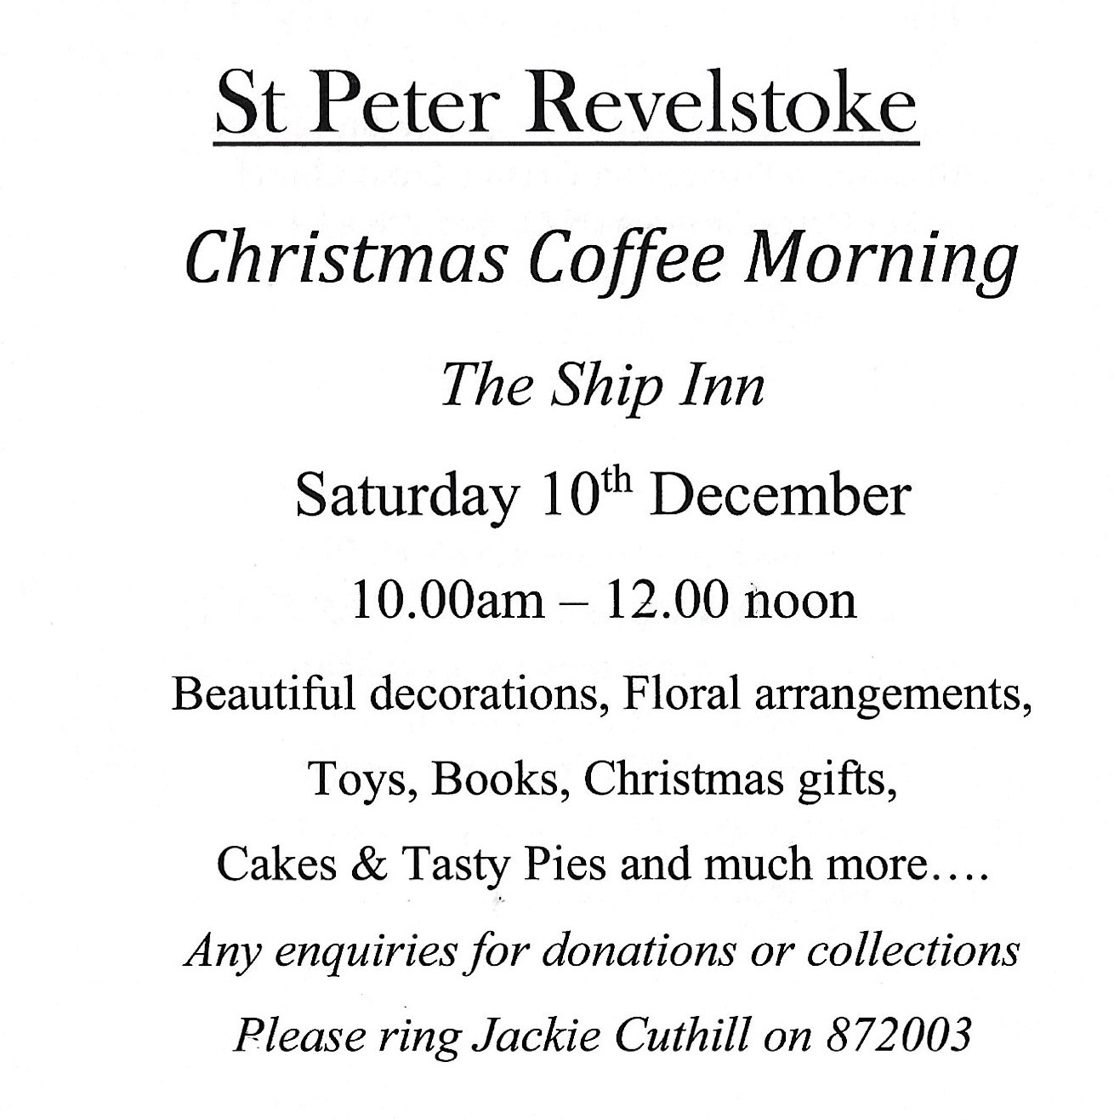

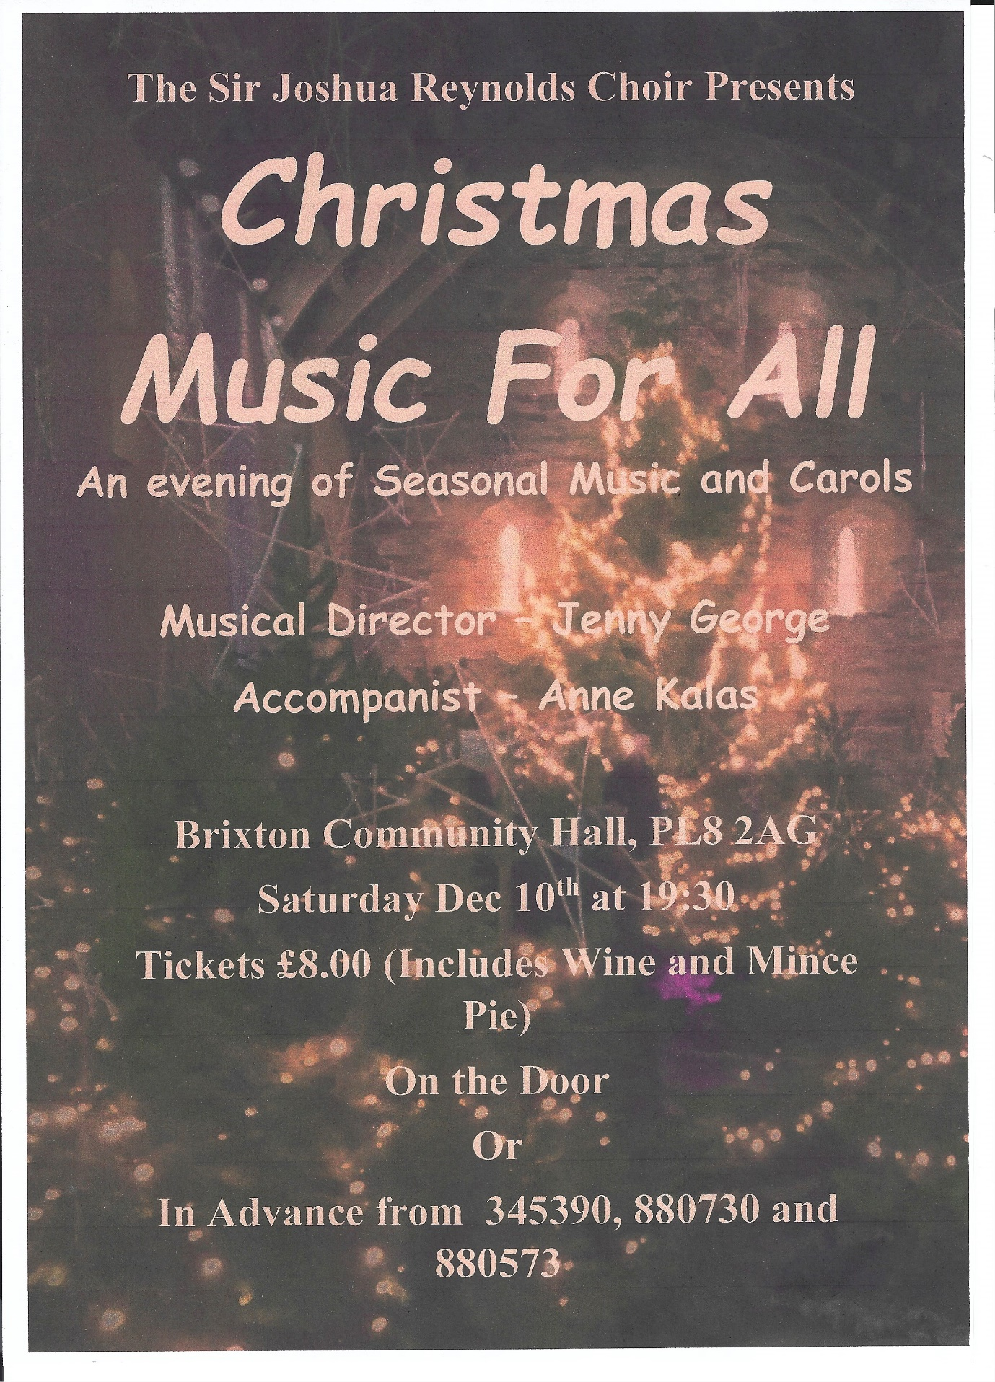

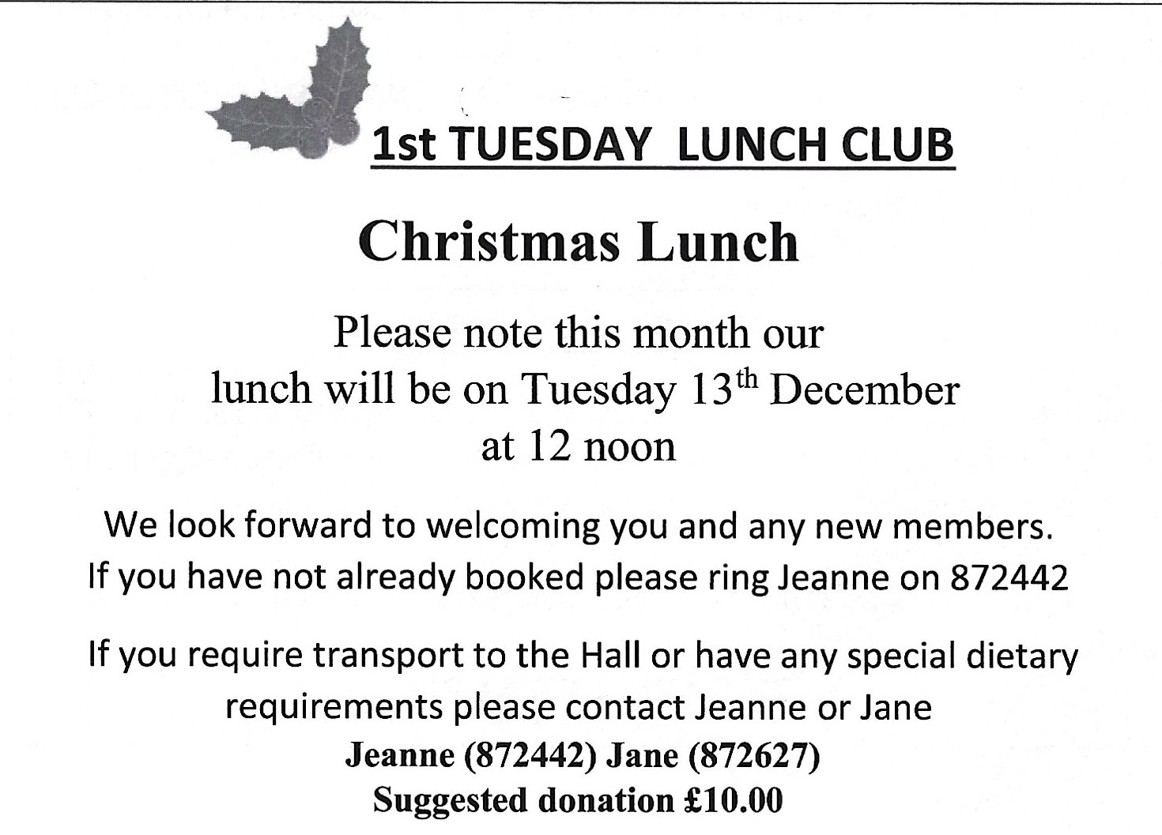

Carols around the tree on the green,
Newton Ferrers, with a Lantern procession to Holy Cross Church
refreshments of Mulled wine; Hot Chocolate; Marshmallows & Mince Pies
15th December 6.00pm
Featuring the School Street Band & Brass section
There will also be a short carol service in the church after refreshments at 7.30pm for those who wish to stay.
If the weather is bad, then the carols by lantern light will be held in the Church.
Bring a torch or lantern if you have one.
For more information contact Pat Parkes 872193

