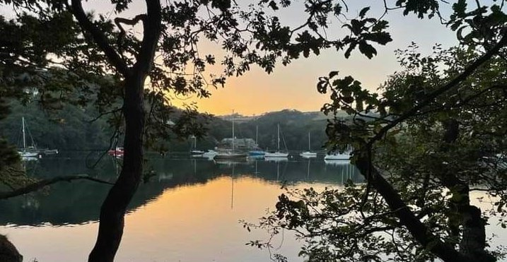
RYDA Newsletter 06/2023

June was most likely named for the goddess Juno, the patroness of marriage; and the month of June is still a popular month for weddings today! As a natural extension of marriage, Juno was also the goddess of childbirth. This month brings beauty in all forms, from flowers to sunlight. Another interpretation of the origins of “June” says that the name came from the Latin juvenis, “young people,” who were celebrated at this time.
Juno, in Roman religion, was the chief goddess and female counterpart of Jupiter, similar to the relationship between the Greek Hera and Zeus. Perhaps not surprisingly given her role of protector of women and children, this powerful queen of the gods was also considered the fierce protector and special counsellor of the state and a guardian angel warning those in times of danger.
Father’s Day is June 18th; & is a day of honouring fatherhood and paternal bonds, as well as the influence of fathers in society. In Catholic countries of Europe, it has been celebrated on 19 March as Saint Joseph's Day since the Middle Ages. In the United States, Father's Day was founded by Sonora Smart Dodd, and celebrated on the third Sunday of June for the first time in 1910. The day is held on various dates across the world, and different regions maintain their own traditions of honouring fatherhood.

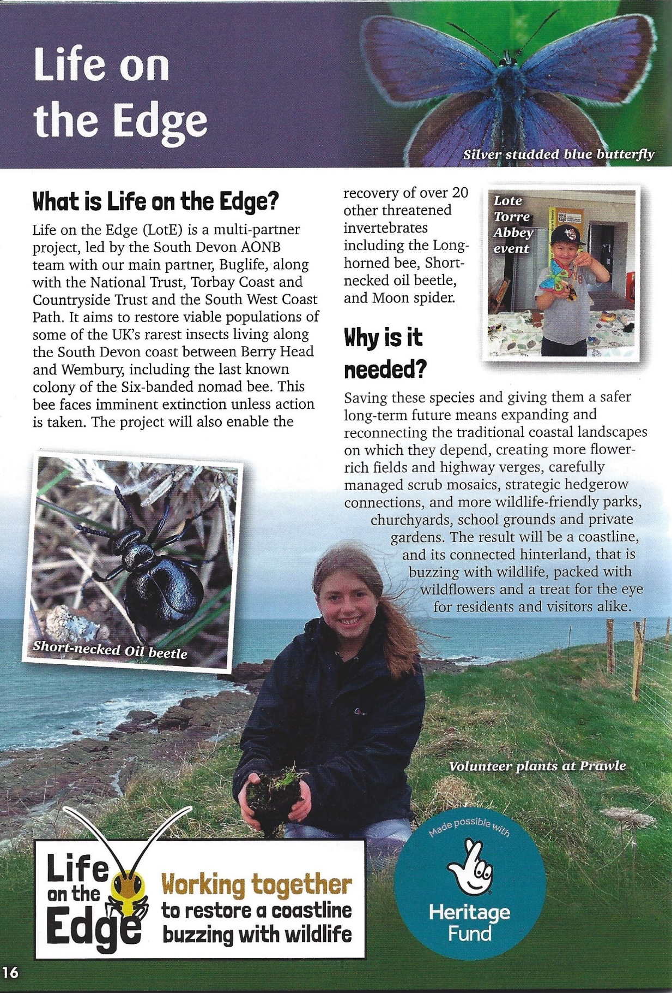
There are many other activities planned, including canoe tours; pond dipping; walks; rockpool safari’s; Wild food Foraging; Seashore Arts; Bat Walks & reptile rambles.
For details of lots of planned events please visit https://www.southdevonaonb.org.uk/events/

The WI craft group have been working on projects through “Life on the Edge” & “Doorstep Arts”
Our 1st project was making bees from Pine Cones, wool & Tissue paper.
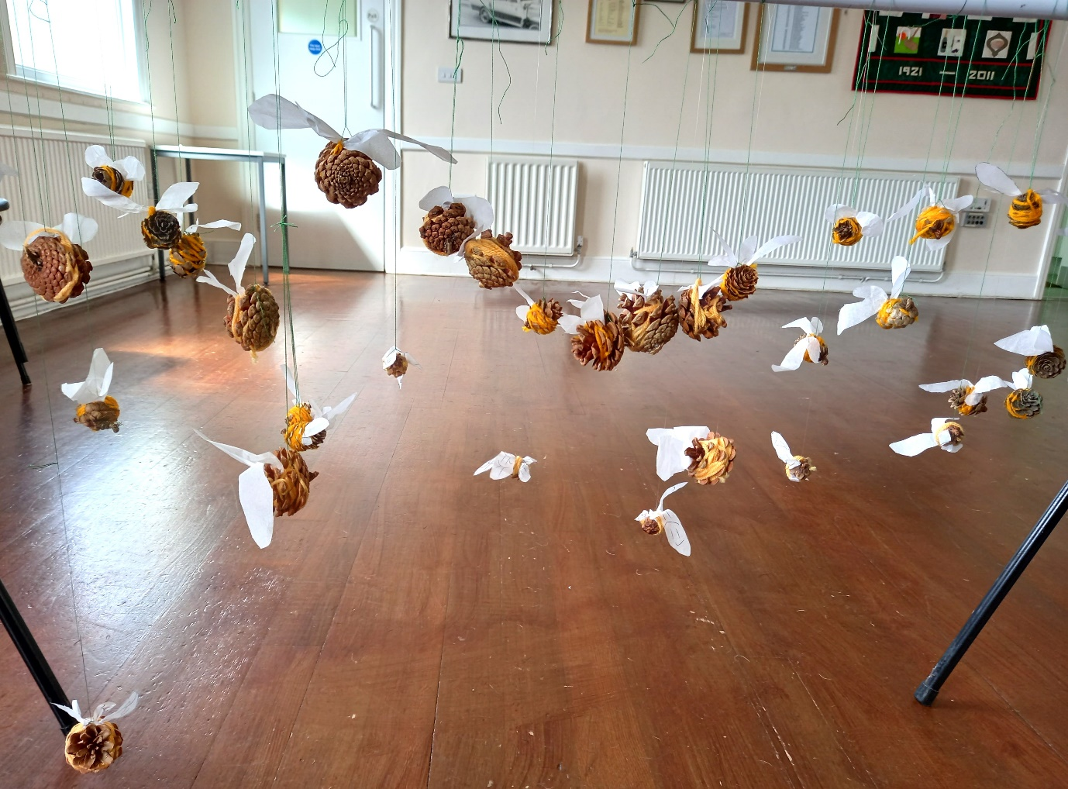
The 2nd project was Wet Felting, which was very tactile and messy but also great fun to do. We made landscape pictures from fine strands of merino wool with the guidance of Angela MacPhearson.
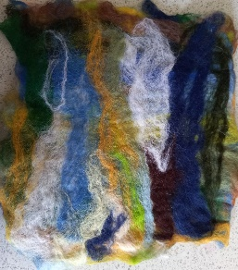

Angela MacPherson Gill Tune Jane Uglow Jackie Ross
These will all go on display at a celebration tea party in Mothercombe in June

One of Learn Devon’s (adult education) free courses is Digital Nature. We would like to bring this online course to the attention of members who might be interested in attending on Zoom. Enrolment will close just under a week prior.

The course enables learners who are interested in nature, to develop their digital skills and confidence. To know more about using Apps and digital tools to explore natural themes such as the environment, birdsong, trees and parklands.

“Choose your own creative project and start making art, craft, or design to improve your connection to the natural world.
Build your confidence in using digital technology to explore your nature theme. You will practise sharing and communicating your own research findings online. You will learn about the creative process: how to record, create and edit information for your chosen nature project.

You need to be able to take part in an online Zoom class with other learners, working in a group and independently. You will need a basic knowledge of digital skills.”

More details can be seen on the attachments and at: Digital Nature - Learn Devon

If adult education course information is not something you are able to disseminate, or you would like the information in a different format, please let us know and we will provide this.

Tel: 01392 384094
Email: newtonabbot@learndevon.co.uk
Website: www.learndevon.co.uk
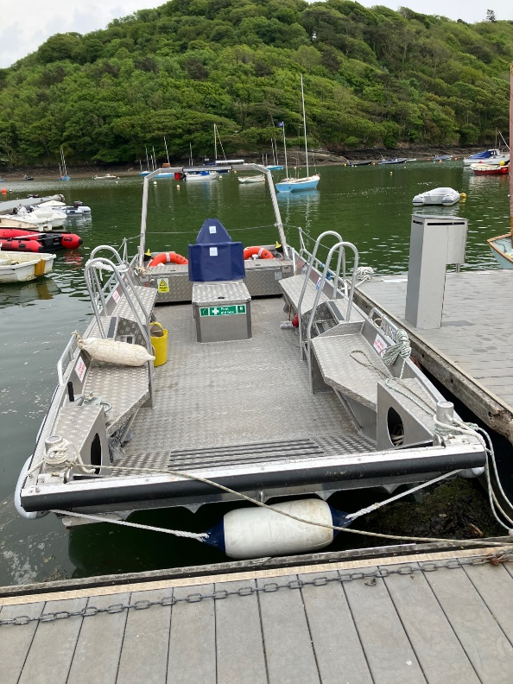

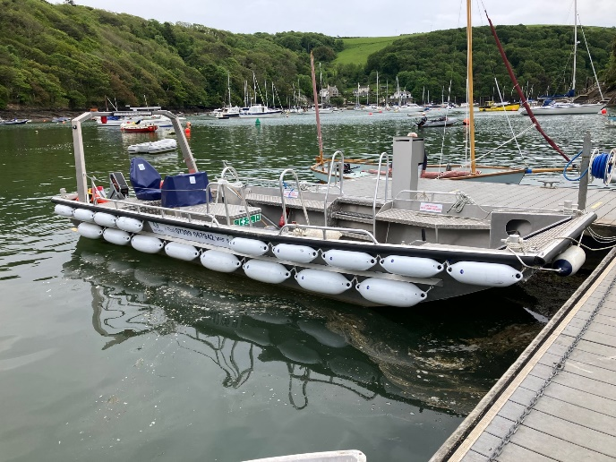
The New Electric Water Taxi
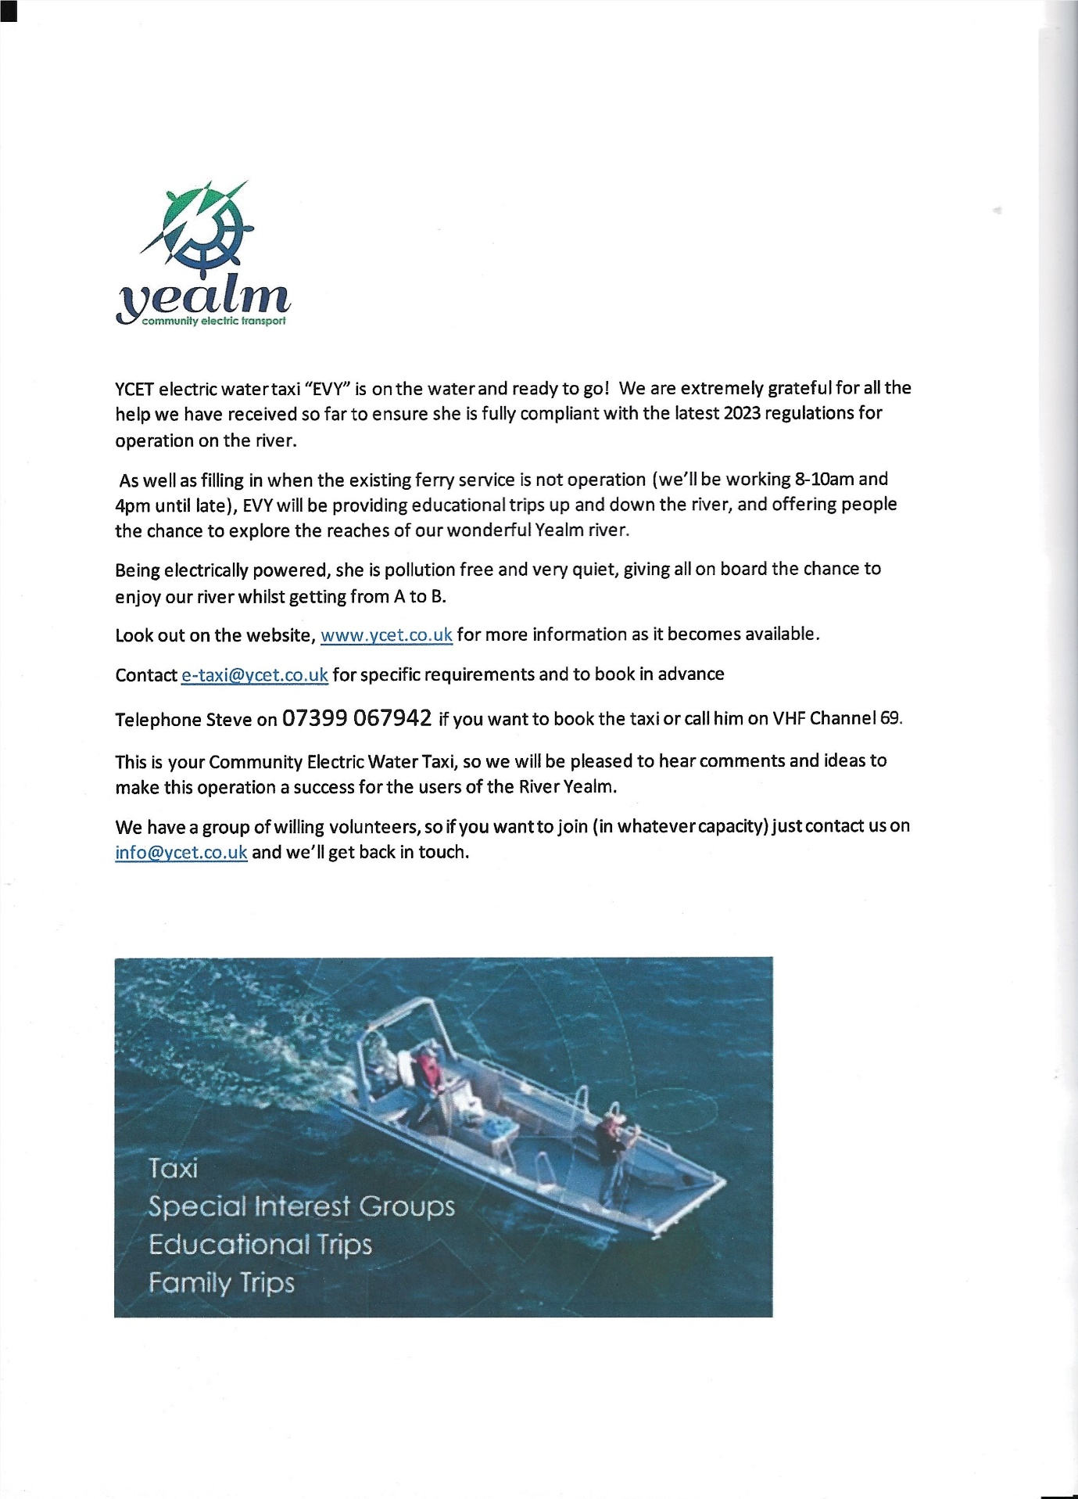
The Parish Council has agreed to a new U13s football club, Ivybridge Rangers, using Butts Park as their home ground. They have already held their first trials in May and have two more events in June and all U13s are welcome. Matches will be played on Saturdays.

POST OFFICE SHOP APPEAL
Following the circular delivered to most households (copy available in shop) we would like to remind the village of the need for your financial support so maintain the Post Office service.
It operates at a loss because Post Office Ltd only pay us £12,000 p/a. The shortfall needs to be covered as far as possible by the shop.
Newton & Noss Community Stores is registered as a Community Interest Company operated entirely for the benefit of the community. It now owns the property which involves maintenance costs.
The energy crisis has driven us into a loss of at least £5,000 this year.
The new wages rate is now costing an extra £3,000 p/a.
Your directors, in giving their time to oversee the village enterprise, do ask you to consider the benefit of having a Post Office Shop and what you would lose if it disappeared.
Our thanks go to those who have already contributed.
Donations can be deposited in the shop or by direct payment or Standing Order to
Lloyds Bank, Uttoxeter Branch,
Account: Post Office Action Group Sort Code: 30-98-90 Account Number: 15734060
On behalf of the Board,
David Stembridge dhs@dhstembridge.co.uk

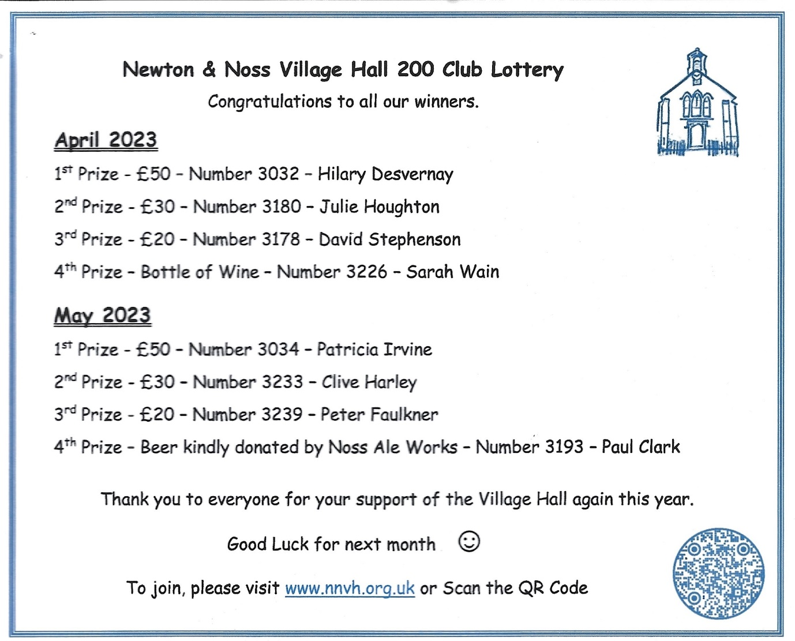

Planning
Only one Planning item of significant interest this month:
Planning Application Ref: 1421/23/PIP – Highfield, Parsonage Road (opposite St Catherine’s Park).
This is an application for permission in principle to demolish the existing bungalow and construct a replacement dwelling and an additional 3-4 further dwellings.
There has been much local concern over this proposal, with 6 objections plus an objection from Devon County Highways. The Parish Council’s comment to SHDC implied support subject to the preference for several smaller houses with Principal Residence requirement. Unfortunately an objection from RYDA was submitted too late to be considered. Concerns covered issues such as traffic safety, wildlife and habitat, drainage and the need for more housing. SHDC have, surprisingly quickly, approved the Permission in Principle application, making the important point that the above concerns can only be considered when the detailed designs are submitted. We will need to consider this carefully when the details are known.

What’s on
1st Tuesday Lunch club 6th June 12.00 noon £6 for 2 courses plus tea/coffee New members of any age welcome. Please contact either Jeanne (872442) or Jane (872627) Allergies can be catered for
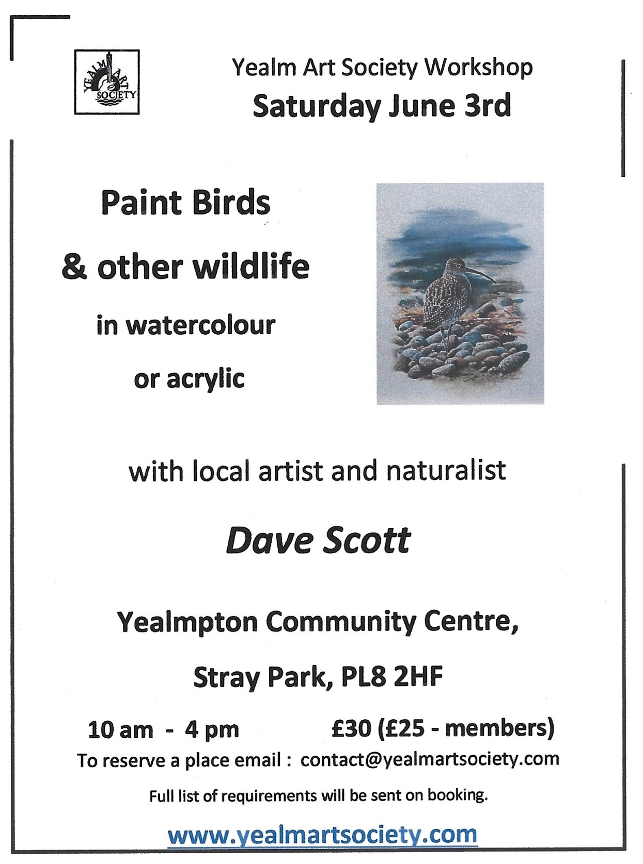

WI meet at 7pm on 6th June. With a talk by Richard Haigh about Canaletto..
New members welcome

Parish Council Meeting in the WI Community Hall 8th June @ 7.00pm
***
Holbeton Film Club,
June's film is See How They Run (certificate 12A). A ‘whodunit’ film with added satire and comedy. In 1950s London, plans for a film version of a smash-hit play come to an abrupt halt after a pivotal member of the crew is murdered.
A world-weary inspector and an eager novice constable find themselves thrown into a glamorously sordid world, investigating the mysterious homicide at their own peril.
This is showing on Friday the 9th June 2023 in Holbeton Village Hall. Doors open 7pm. The programme starts at 7:30pm. Tickets on the door still only £4, or £2 for accompanied children under 12 (cash only). Ice creams will be on sale for £1.
Our programme for the coming months is:
Empire Of Light, 15, Saturday 8th July
Living, 12A, Friday 11th August
A Man Called Otto, 15, Saturday 9th September

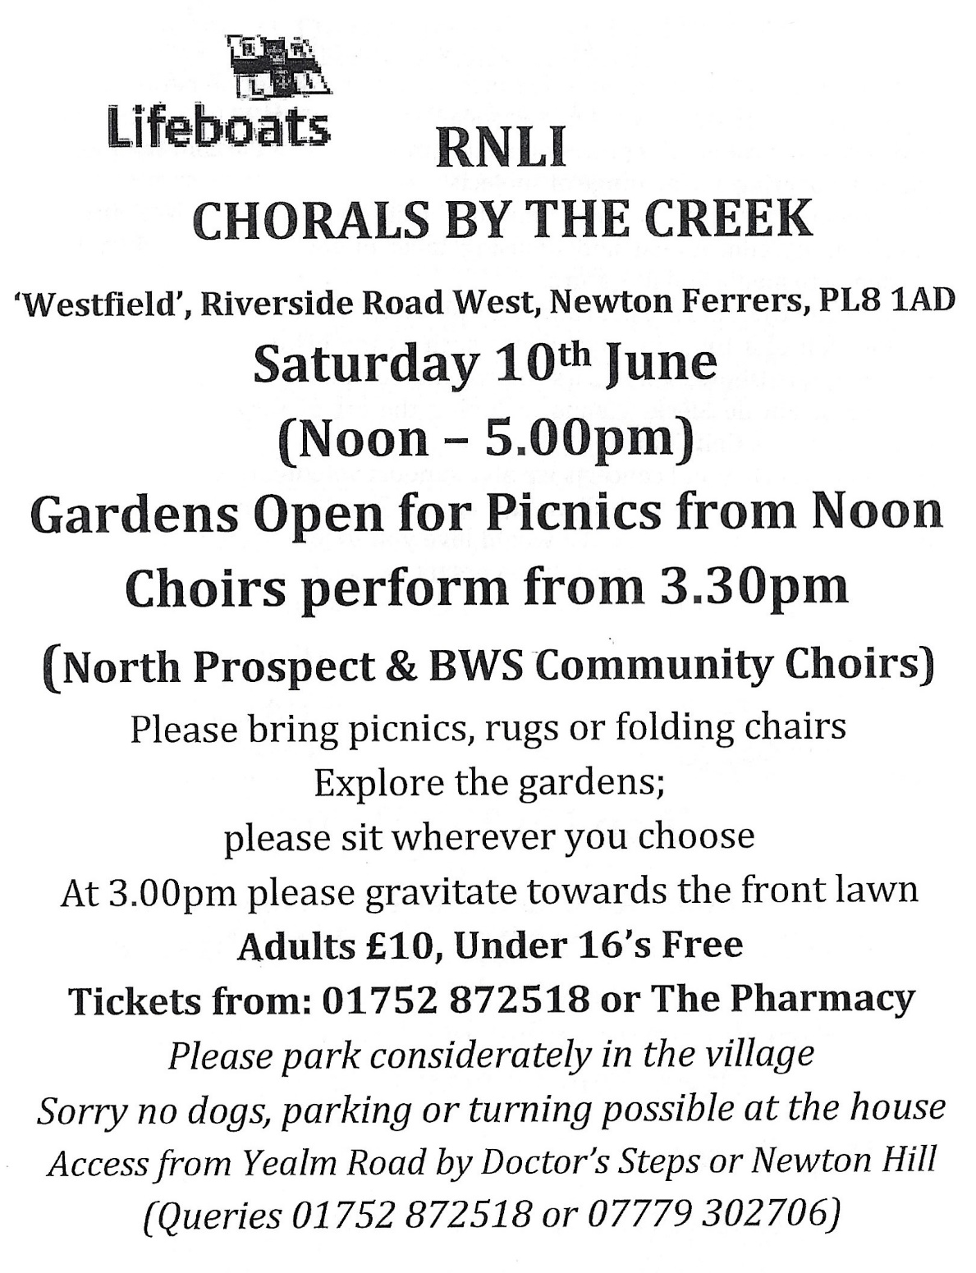

WI Craft Group Meet @14.00 on 13th June – This week Knit & Natter £1.50

Mevagissy Male voice choir are at St Peter’s Church Noss Mayo on 10th June @ 7.30 £10.00

Yealm Parchment group meet on 16th June @ 14.00 in the WI Community Hall.
This month we will be doing white work.
Full instruction will be given, and equipment may be supplied if needed. £8 New members welcome.
Tel Lesley 07838375449

Snorkel Safari SATURDAY, 17 JUNE 2023 FROM 10:00-12:30
Wembury Marine Centre
Our fully qualified BSAC Snorkel Instructors will cover basic snorkelling techniques, followed by a guided snorkel around Wembury Bay's famous rocky reefs, searching for and identifying underwater marine life as we go! We always follow our Seashore Code ethos of enjoying and respecting marine life through observation without disturbing.
Our snorkel safaris are suitable for children and adults, including beginners who would like to learn how to snorkel or more advanced snorkellers who would enjoy the company of a group. Full kit can be provided and is included in the cost, but we do require a £20 cash deposit per person on the day, which will be returned provided no kit is lost or damaged. If you plan to bring your own gear, then we reccommend a 5mm full length wetsuit and separate snorkel and mask (not a full face snorkel).

Children must be 8 years or over to take part and all participants must be competent swimmers. Parents/guardians do not need to accompany their child(ren) in the water but must stay on the shore to meet them when they exit the water. If you would like to join your child in the water and experience our stunning underwater world, then you will also need to purchase a ticket:
Book here: https://www.eventbrite.co.uk/.../snorkel-safari-tickets...
Please note, changing time and an introductory talk in the Marine Centre is included in the 2.5 hour event time - we are usually in the water for around 1 hour.
Snorkelling in open water is an activity which requires general physical fitness and good health. Please contact us before booking if you/your child has a history of diabetes, epilepsy (blackouts), perforated eardrums, high blood pressure, or any lung/respiratory disorder, including previously testing positive for COVID-19.
Rockpool Safari SUNDAY, 18 JUNE 2023 FROM 12:00-13:30
Wembury Marine Centre
Our expert team will take you on a guided rockpool safari to meet and learn about some of Wembury's most famous inhabitants, from crabs to starfish and everything in between!
All children must be accompanied by a paying adult and we suggest this event is most suitable for children aged 4 years+.
Book here: https://www.eventbrite.co.uk/.../rockpool-safari-tickets...
Please wear wellington boots or other suitable sturdy shoes which can get wet and please leave your rockpool nets at home, as we follow the Seashore Code and use our hands and buckets instead (tubs provided).
Please note, National Trust car parking charges apply at Wembury Beach car park. The beach car park can fill up very quickly on hot, sunny days so please leave plenty of time to park and aim to arrive at the Centre 10mins before the event starts.
Cancellation Policy – requested refunds will be issued up to 1 day before the event starts, minus the Eventbrite booking fee. If the event is cancelled by us due to poor weather, you will receive a full refund.
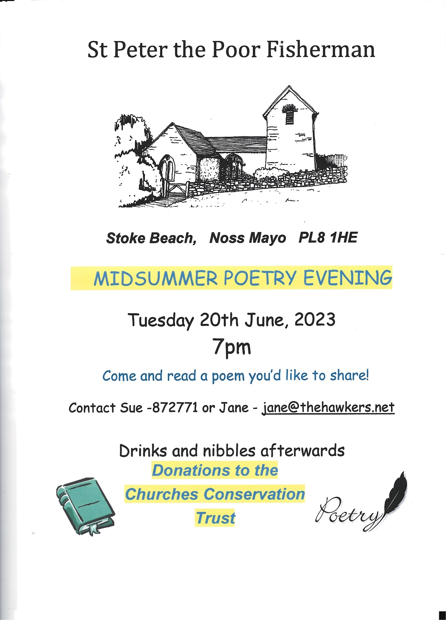

Thursday Lunch Club NNVH 22nd June @ 12.15 £6.00 for 2 courses plus tea/coffee New members of any age welcome. Please contact mrandmrsbarnett@gmail.com Allergies can be catered for. The tide will be going out
YCE will be holding its AGM for members on Sat 24th June at 2pm. If you are an existing member, or would like to join up on the day, we would be delighted to see you at Newton Ferrers Community Hall. To join YCE as a member it costs just £1. This allows you to gain voting rights and to invest in our forthcoming share offer, which will bring the local solar farms into community ownership. So much work is currently being undertaken, and negotiations are being had by the YCE team, we are in the most pivotal time for the project.
Further news – YCE had a great number of quality of projects apply for the latest round of grant funding from the Community Benefit Fund. The applicants will be informed of the panel decisions by mid June.
To date, £100,000 of financial support has been granted by YCE to local projects and causes in our 5 parishes. YCE continues to harness the power of the sun to empower our local communities.
WI Craft Group meet on 27th June @14.00 and will be painting with flowers as paint £2.00 (£1 hall; 50p refreshments). New members welcome.
Please bring a small hammer, and a few small flowers (colourful pansies work best, but also greenery). This turns out as an abstract watercolour, which resembles your choice of flowers
****************
Not in “our patch”, but on our doorstep:-
Friday June 16 at 7.30 pm at Plympton St Maurice Guildhall.
Sir Joshua Reynolds Choir, Musical Director Jenny George, Accompanist Anne Kalas
'Colour My World' Painting Pictures with Music
Opening event of the Plympton St Maurice midsummer festival weekend
Tickets £7, refreshments available
In aid of Friends of the Guildhall
Wednesday June 21 at 7.30 pm at The Minster Church of St Andrew, Plymouth
Plymouth Symphony Orchestra, conductor Anne Kimber, Elin Pritchard -Soprano and Peter Van Hulle - Tenor
'A Night at the Opera' to include:
Puccini : Nessun Dorma
Verdi: Triumphal March from Aida
Puccini: O Mio Babbino Caro
Puccini: Excerpts from La Boheme
Bizet : Excerpts from Carmen
and much more.....
Tickets £14.00 or £16.00 on the door from Mannamead News, 6 Eggbuckland Road, Plymouth PL3 5HF, 01752 661451 or wegottickets.com or on the door
Saturday June 24 at at 3.30 pm at the Minster Church of St Andrew
Plymouth Philharmonic Choir, Conductor Christopher Fletcher, together with children from the Fletewood School, Plymouth
Andrew Carter: Benedicite
John Rutter: The Sprig Of Thyme
Ticket prices (which include a cream tea) £20 in advance, £22 on the door. Students and U16s £5.
Choir ticket manager 07949 311030
Tickets online https://www.wegottickets.com
Further details are available on the choir’s website https://plymouthphilchoir.org

Save the date.

SATURDAY, 8 JULY 2023 FROM 13:00-15:30 Snorkel Safari Wembury Marine Centre £30
SAT, 15 JUL AT 10:30 Tots & Toddlers Rockpool Safari Wembury Marine Centre ·
SAT, 29 JUL AT 10:30 Coastal Wildlife Walk Wembury Marine Centre ·
FRIDAY, 4 AUGUST 2023 FROM 13:30-15:30 Extreme Rockpool & Shoresearch Survey
Wembury Marine Centre

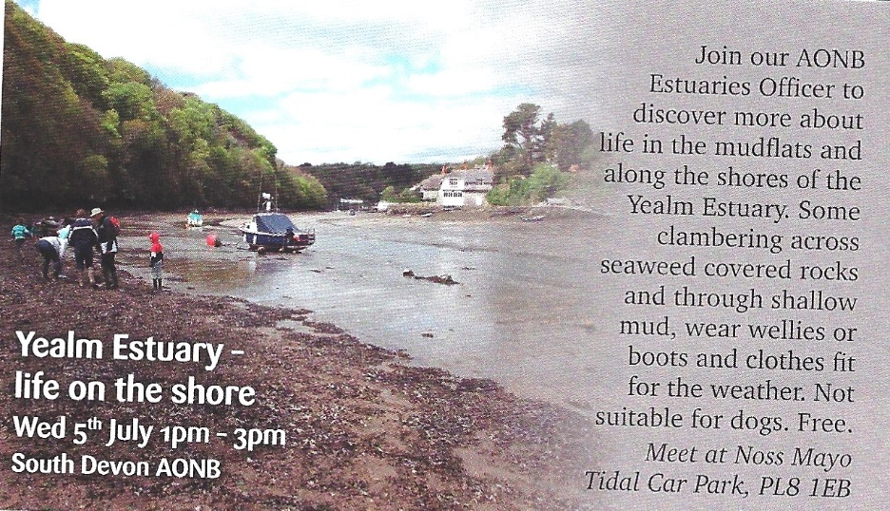

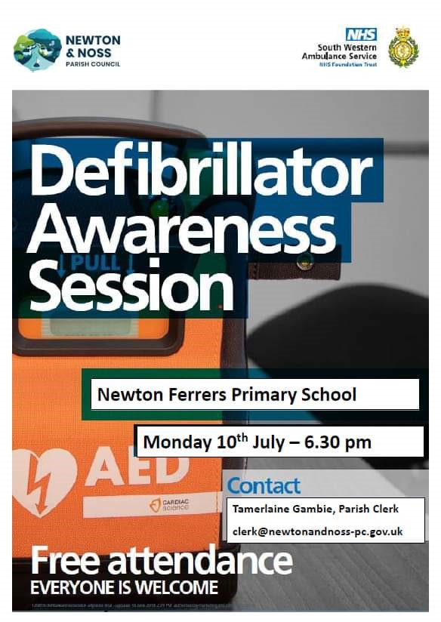
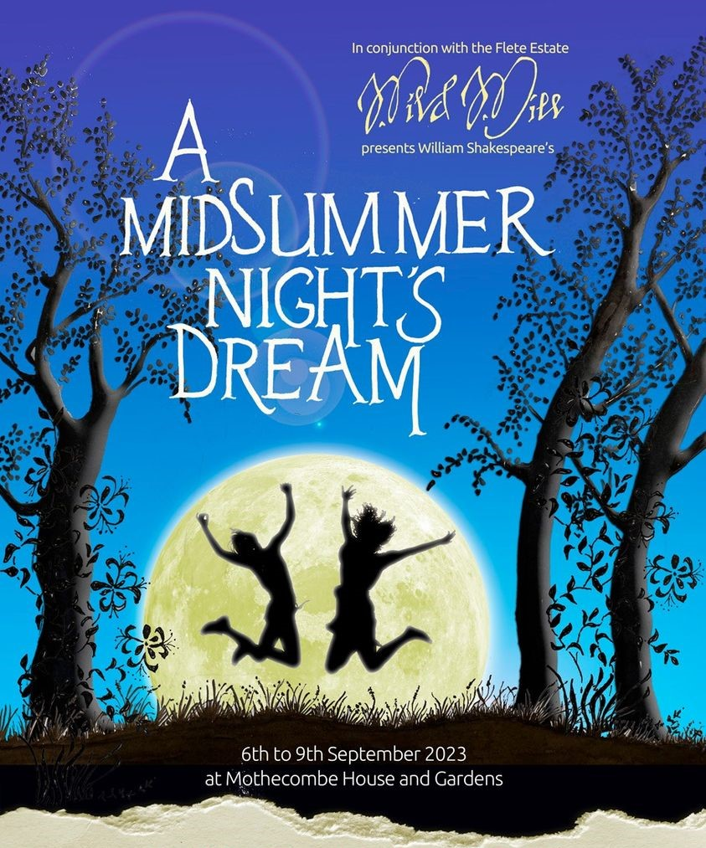
Kris Harris – Magician: Has been booked for 18th November 2023, in the WIC hall. There will also be a Cabaret.
This is a WI fund raising event open to all.
More details nearer the time

