RYDA Newsletter 02/2021
Unintentionally this has become a GREEN edition of your newsletter, mainly because Its nearly spring, a time of hope and renewal.

This year we have a bumper crop of hope in the form of the COVID-19 vaccine, the return to “normal”, holidays and sunshine.

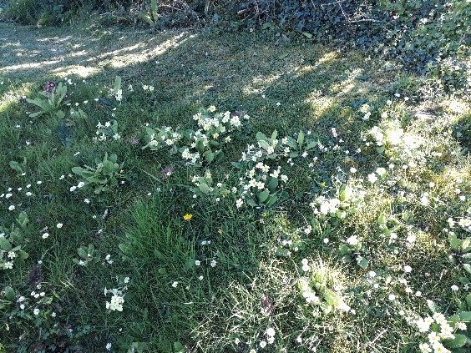
Spring is also a time for the first snowdrops, primroses, followed closely by bluebell and new shoots.

The Yealm estuary, with its relatively smaller freshwater rivers input, is more saltwater dominated and supports a rich diversity of habitats with their animal, seaweed, and plant communities. Quietly sheltered from the open coast, the depths and waters of this beautiful estuary can boast, among others, seagrass jungles of marine life and prolific mudflat communities.
These natural riches are recognised by most of the estuary being designated as both a Site of Special Scientific Interest and a Special Area of Conservation; and all within the South Devon Area of Natural Beauty.
Please respect and protect our native flora, fauna and foreshore when enjoying your exercise in the countryside. Remember, it is against the law to pick wildflowers or damage trees and woodlands.

Respect - Protect – Enjoy

- Respect other people & Property:
- consider the local community and other people enjoying the outdoors
- leave gates and property as you find them and follow paths unless wider access is available
- Respect the needs of local people and visitors alike - for example, don’t block gateways, driveways or other paths with your vehicle.
- When riding a bike or driving a vehicle, slow down or stop for horses, walkers and farm animals and give them plenty of room. By law, cyclists must give way to walkers and horse- riders on bridleways.

- Protect the natural environment:
- leave no trace of your visit and take your litter home
- Protecting the natural environment means taking special care not to damage, destroy or remove features such as rocks, plants and trees. They provide homes and food for wildlife and add to everybody’s enjoyment of the countryside.
- Litter and leftover food doesn’t just spoil the beauty of the countryside, it can be dangerous to wildlife and farm animals - so take your litter home with you. Dropping litter and dumping rubbish are criminal offences.
- keep dogs under effective control. When you take your dog into the outdoors, always ensure it does not disturb wildlife, farm animals, horses or other people by keeping it under effective control.
- Everyone knows how unpleasant dog mess is and it can cause infections, so always clean up after your dog and get rid of the mess responsibly - ‘bag it and bin it’. Make sure your dog is wormed regularly to protect it, other animals and people.
- Leave gates and property as you find them and follow paths unless wider access is available

Enjoy the outdoors:
- plan ahead and be prepared. For example, your rights to go onto some areas of open access land and coastal land may be restricted in particular places at particular times.
- follow advice and local signs & don’t forget the tide times

With the nation still in lockdown, many people are finding solace in taking a walk in the countryside; but farmers across the country are reporting increasing damage to crops and wildlife habitats caused by walkers not following the Countryside Code.
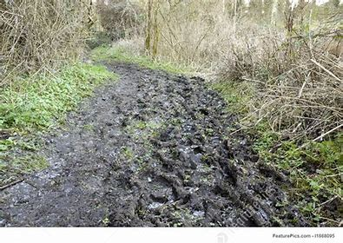
Mark Bridgeman, President of the CLA, said:
“It is perfectly natural, in times such as these, for people to want to enjoy the countryside. They are genuinely welcome, and we encourage people to enjoy the thousands of miles of footpaths available to them. But we need to work together to ensure the public can have an enjoyable time while also protecting farmland, animals and wildlife.
“Land is very wet at the moment and likely to get worse before the Spring, with heavy rain forecast, and with so many walkers enjoying the countryside, public footpaths have become very muddy. Unfortunately, that means many are circumnavigating the mud and walking over and damaging wildflowers, trees, planted crops and impacting farmers’ businesses. Our advice is to use a decent pair of wellies - or walking boots - and stick to the route of the footpath.
You can use:
- footpaths - for walking, running, mobility scooters or powered wheelchairs
- bridleways - for walking, horse riding, bicycles, mobility scooters or powered wheelchairs
- restricted byways - for any transport without a motor and mobility scooters or powered wheelchairs

Celebrate what’s on your doorstep and #ExploreFromYourDoor
We live in a beautiful part of the world and now is a good time to view your local area from a different perspective and enjoy what is right on your front doorstep.
Alongside our public sector partners, we're encouraging everyone in Devon to stay local for their daily exercise and #ExploreFromYourDoor. Whether you live in a city, town or village, take time to appreciate the things you wouldn’t notice in the car and maybe discover something new about where you live.
We offer some useful resources to help you get outside in your local area:
- Where will you discover? Use the public rights of way website and interactive map to plan a route.
- The Explore Devon website is filled with some amazing walks, trails and sites to visit during lockdown on foot, bike or horseback; just remember to stay local for exercise.
- If you live within walking or cycling distance of the seaside, why not discover the South West Coastal Path.
- Get outside safely and search by activity and location using GetOutside from Ordnance Survey. Their website brings together current advice from the government, local authorities and other outdoor organisations to help you decide where to go and what to do.
- Discover a great new way to get outside with your family with a treasure trail.
- You can also find more cycle routes and trails, as well as other useful travel information at Travel Devon.

How to raise your property value

At a recent committee meeting a member remarked on the unkempt appearance our beautiful villages were accruing. Do not forget the kerbside appeal of your property raises the value of it, so why not take care of that little bit of verge outside your house or remove the weeds from the gutter. If your neighbour is elderly or infirm, offer to do theirs too. It takes minutes, and forges friendships.

Brixton, we have noticed, have regular cleans of the gutters and verges by their villagers and it shows. Can’t we do the same? Its time (and we have more of that at the moment thanks to COVID-19) to take pride in our surroundings and enjoy is beauty.

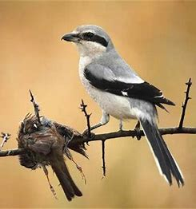
The great grey shrike (a large songbird - the larger ones are carnivores, - birds of prey) impale its prey on sharp thorns, then present the "kebab" to potential mates!!!!!

Birds that live in the city start tweeting earlier to avoid the rush hour!
- In the 17th century, they thought migrating birds went to the moon for the winter.

Wembury Marine Centre Update - Paul Martin, Devon Wildlife Trust

Well, we took a big sigh of relief when 2020 drew to its conclusion! The Marine Centre has never had a quieter time in its 26-year history with the doors closing in first lockdown and remaining that way for the rest of the year. However, appearances can be deceiving and, with the continued support of funders like Devon CPRE, the business of marine education has not ended, just adapted to a different way of being. DWT staff at the centre have been working hard to create resources online which families and schools could access, and during the Autumn term, when schools were open but not welcoming visitors, Coral was able to deliver sessions through Zoom and has recently been developing subject specific video talks for schools studying the sea. Lots of new skills learned and support offered to teachers.
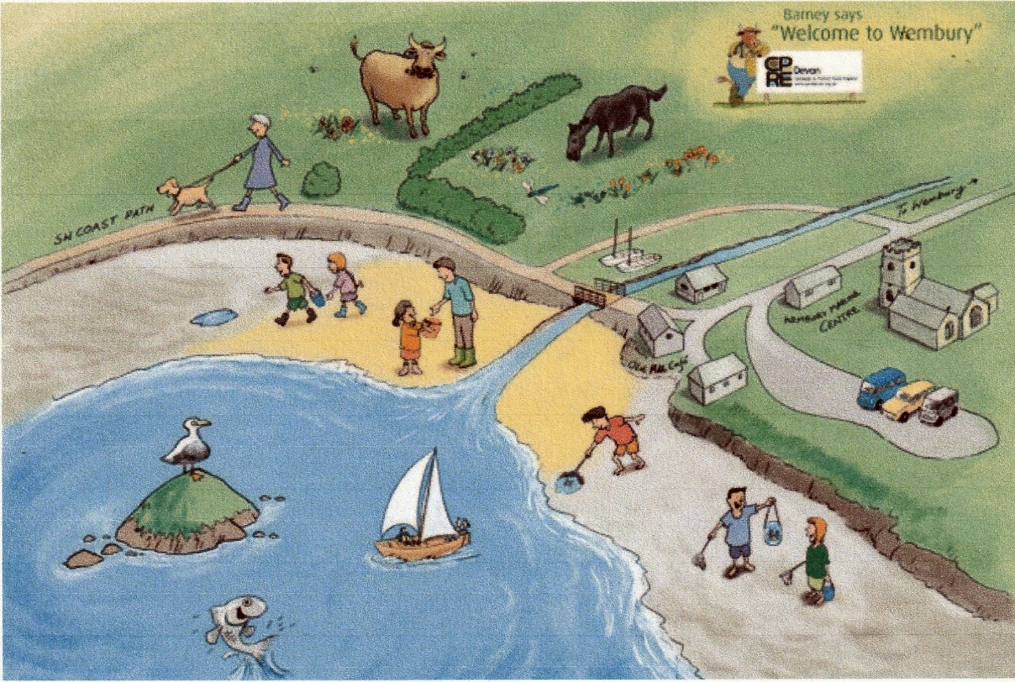

The centre is having a total overhaul with a brand-new interpretation being installed in preparation for, what we hope will be a re-opening at Easter (COVID-19 permitting) or early in the summer. This will be an exciting time for us as we welcome back schools and families who may have missed the shore experiences in the last year. We, of course, have plans in place to adjust and adapt as the situation develops but are confident that we will be able to deliver sessions this coming season. Devon CPRE support is invaluable to us as it supports our staff costs, the most valuable asset we have. Without them, nothing could be achieved! So, thank you! We look forward to welcoming you to Wembury as soon as we are allowed to this summer.

Pounds, shillings & pence
50 years ago (How time has flown), on 15 February 1971, otherwise known as "D Day “, for Decimal Day, the United Kingdom adopted a decimal currency.
This replaced the £. s.d. – (pound shilling and pence system) - in which there were 20 shillings in each pound and 12 pence in each shilling. The existence of 240 pence in each pound was a legacy from Anglo-Saxon times when a Roman pound in weight of silver was divided into 240 silver pennies.
Who remembers the farthing? 960 of those to £1. How much easier is it to divide or multiply by ten!

Dog Fouling (Again)

The Anti-Social Behaviour Crime and Policing Act 2014, Public Spaces Protection Order 2017; Control of Dogs states that ALL dogs must be on a lead in the following locations: • All areas covered by Rule 56 of the Highway Code (NB - Rule 56. Dogs.

Do not let a dog out on the road on its own.

Keep it on a short lead when walking on the pavement, road or path shared with cyclists or horse riders.)

Under the Act, “Control of Dogs”, the person in charge of a dog whether they are the owner or not, must clean up after the dog has fouled in any area that the Act applies to It is an offence not to clean up after your dog, punishable by a maximum fine of £1000 or a fixed penalty of £100. • A person registered as blind in a register compiled under Section 29 of the National Assistance Act 1948 or assistance on a dog trained by a prescribed charity, shall not be guilty of an offence if they are alone with the dog and unable to remove the faeces. If you witness an incident contrary to this Act please report it using the following link to SHDC https://apps.southhams.gov.uk/WebReportIt/. It would help if you had photographic evidence and address details of the perpetrator.

You might not have heard of Bjarne Stroustrup, but he’s a very clever chap. A computer programmer. He came up with a new way of writing programs back in the 80s that’s still used today. .
And a favourite quote of his is this: “I have always wished for my computer to be as easy to use as my telephone; my wish has come true because I can no longer figure out how to use my telephone.” – if even he found his phone… er… challenging, what chance do we mere mortals have!

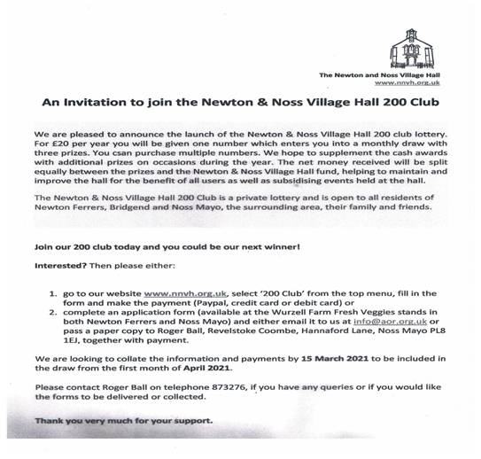

http://www.nnvh.org.uk/lottery.php
It is the quiet season for planning applications, but if you want to know what is/was and maybe happening, check out their web site
Application Details South West Devon Planning Search (southhams.gov.uk)

We will continue to let you know of anything we think may be of interest or concern.

