RYDA Newsletter 02/2023

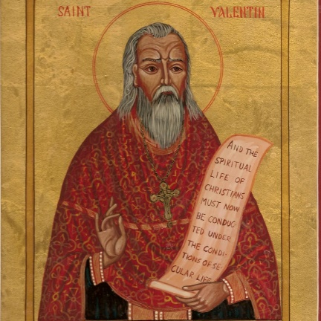
Where did Valentine's Day originate from? The history of the holiday—and the story of its patron saint—is shrouded in mystery. We do know that February has long been celebrated as a month of romance, and that St. Valentine’s Day, as we know it today, contains vestiges of both Christian and ancient Roman tradition. But who was Saint Valentine, and how did he become associated with this ancient rite?
The Catholic Church recognizes at least three different saints named Valentine or Valentinus, all of whom were martyred. One legend contends that Valentine was a priest who served during the third century in Rome. Emperor Claudius II decided that single men made better soldiers than those with wives and families, & he outlawed marriage for young men. Valentine, realizing the injustice of the decree, defied Claudius and continued to perform marriages for young lovers in secret. When Valentine’s actions were discovered, Claudius ordered that he be put to death.
Other stories suggest that Valentine may have been killed for attempting to help Christians escape harsh Roman prisons, where they were often beaten and tortured. According to one legend, an imprisoned Valentine actually sent the first “valentine” greeting himself after he fell in love with a young girl—possibly his jailor’s daughter—who visited him during his confinement. Before his death, it is alleged that he wrote her a letter signed “From your Valentine,” an expression that is still in use today.
While some believe that Valentine’s Day is celebrated in the middle of February to commemorate the anniversary of Valentine’s death or burial—which probably occurred around A.D. 270—others claim that the Christian church may have decided to place St. Valentine’s feast day in the middle of February in an effort to “Christianize” the pagan celebration of Lupercalia. Celebrated at the ides of February, or February 15, Lupercalia was a fertility festival dedicated to Faunus, the Roman god of agriculture, as well as to the Roman founders Romulus and Remus.
To begin the festival, members of the Luperci, an order of Roman priests, would gather at a sacred cave where the infants Romulus and Remus, the founders of Rome, were believed to have been cared for by a she-wolf or lupa. The priests would sacrifice a goat, for fertility, and a dog, for purification. They would then strip the goat’s hide into strips, dip them into the sacrificial blood and take to the streets, gently slapping both women and crop fields with the goat hide. Far from being fearful, Roman women welcomed the touch of the hides because it was believed to make them more fertile in the coming year. Later in the day, according to legend, all the young women in the city would place their names in a big urn. The city’s bachelors would each choose a name and become paired for the year with his chosen woman. These matches often ended in marriage.
Lupercalia survived the initial rise of Christianity but was outlawed—as it was deemed “un-Christian”—at the end of the 5th century, when Pope Gelasius declared February 14 St. Valentine’s Day During the Middle Ages, it was commonly believed in France and England that February 14 was the beginning of birds’ mating season, which added to the idea that the middle of Valentine’s Day should be a day for romance. The English poet Geoffrey Chaucer was the first to record St. Valentine’s Day as a day of romantic celebration in his 1375 poem “Parliament of Foules,” writing, ““For this was sent on Seynt Valentyne’s day / Whan every foul cometh ther to choose his mate.”

So, Who Is Cupid or Eros?
Cupid is often portrayed on Valentine’s Day cards as a naked cherub launching arrows of love at unsuspecting lovers. But the Roman God Cupid has his roots in Greek mythology as the Greek god of love, Eros.
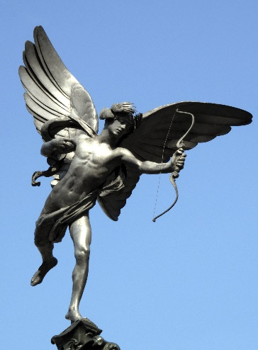
According to the Greek Archaic poets, Eros was a handsome immortal played with the emotions of Gods and men, using golden arrows to incite love and leaden ones to sow aversion. It wasn’t until the Hellenistic period that he began to be portrayed as the mischievous, chubby child he’d become on Valentine’s Day cards.
By the middle of the 18th century, it was common for friends and lovers of all social classes to exchange small tokens of affection or handwritten notes, and by 1900 printed cards began to replace written letters due to improvements in printing technology. Ready-made cards were an easy way for people to express their emotions in a time when direct expression of one’s feelings was discouraged.
The statue shown in the photograph in Piccadilly Circus is always referred to as ‘Eros’. In fact this is incorrect. It is not Eros but his brother Anteros! The statue is officially known as the Shaftesbury Memorial in memory of the 7th Earl of Shaftesbury who was a nineteenth century philanthropist, politician and reformer.
Shaftesbury Avenue which runs off Piccadilly Circus is similarly named for the same reason. The Earl was a deeply religious man and so the sculptor considered it would be inappropriate to represent Eros (Cupid in Roman mythology) as he was the Greek god of passionate or romantic love. He therefore chose Anteros to represent Shaftesbury’s selfless, fraternal love. In the end it was decided that it would be inappropriate for such a Christian man as Shaftesbury to be represented by a pagan deity – Eros or Anteros – and so the figure was dubbed ‘The Angel of Christian Charity’. The figure was the first public statue to be made of aluminium, and the sculptor was apparently able to carry it across his studio as it was so light.
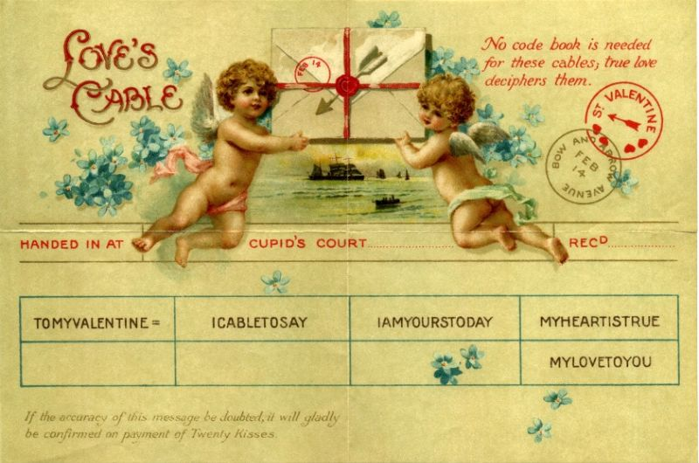

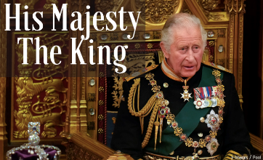
Ring for the King!

Calling all past, present and future bell ringers! You may have seen recently on the local news that there is a shortage of bell ringers to ring in every tower in Devon for the King’s coronation on May 6th. Here in Newton and Noss, we have two magnificent peals of bells and we are always on the lookout for new ringers to come and join us.
We are having an Open Day on Saturday 11th March 2023 at Holy Cross church, Newton Ferrers, for people to come and see what we do, have a go at ringing a bell and consider joining the team to play the loudest instrument in the village! If you are aged 16+ (sorry we can’t take under 16s due to current legislation) and looking to learn a new skill, or maybe to revisit a skill you developed in the past, please come along any time between 11am and 4pm on 11th March, when you can find out more about learning to ring.
Refreshments and a light lunch will be available so please come and have a go! If you would like more information or to let us know that you will be coming, please phone me on 830344 or email me at nene_carr@hotmail.com. We look forward to seeing you.
Chris Lock

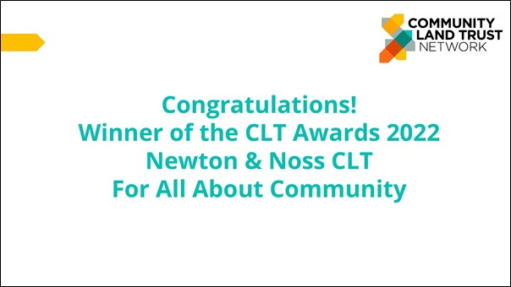
In recognition of our achievements in the last year, we are delighted to say that the small team responsible for Newton and Noss Community Land Trust was nominated for and won the prestigious ‘All About Community’ Award from the National Community Land Trust Network; beating CLT’s from Bristol, Waltham Forest, and Kensington Fields
The ‘All About the Community’ award celebrates how CLTs involve, engage with, and are deeply rooted in their community. People power is at the heart of the CLT and NNCLT were recognised for building on the years of work by the Parish and the Neighbourhood Plan to provide desperately needed, social rented homes for people with a Strong Local Connection.
Gaining approval for our own Allocations Policy was key to any proposed development, as we needed to ensure that the houses are only allocated to people with a ‘Strong Local Connection’;
Criteria established through consultation.

The team has worked hard to develop relationships with key partners, engage in community consultation events, site meetings and planning meetings leading to Permission for our first 18 Social Rent homes, on gifted, serviced land as part of the ground breaking development at Collaton and a pending Application for a further 17 Social Rent homes opposite Butts Park.
Notably, the Collaton Team have also worked very hard to engage with the Community; providing a further 39 Affordable Rent or Self Build homes, all of which will use the Newton and Noss ‘Strong Local Connection’ criteria for allocation in Bands A- E, and all of the homes will be covered by the Primary Residence Requirement as stipulated in the Neighbourhood Plan.

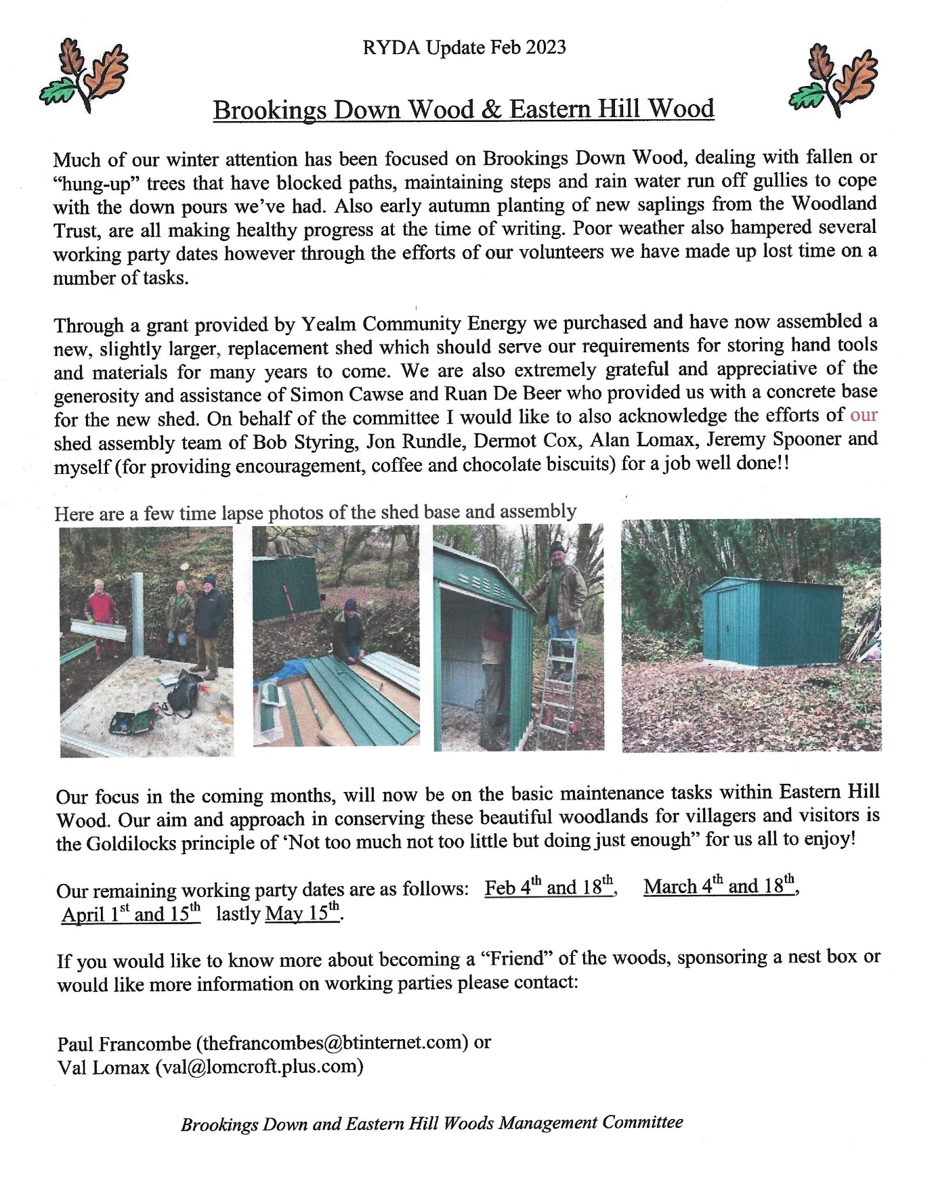

IMPORTANT
It is time for updating the village directory.
Please let us know if you no longer wish to be included.
Please confirm that your current details ARE correct
If you do wish to be included, and are not yet listed, please send:-
1) the name/s you wish listed
2) your address
3) your phone number along with a completed GDP form
to
rydavillagedirectory@outlook.com

Cut off date the end of Febraury

"Parish Council Roads and Highways Committee update.

The Committee has played a big part in the development of the Parish Council consultation which has just closed for comment. Once the results have been analysed, they will help determine where Parish Council resources need to be deployed particularly on the pressing matter of parking in our villages. The Committee has been working on trying to find a volunteer to take on the role of Parish Lengthsman and we hope to report some success with this in the coming weeks. A successful outcome will result in a general improvement in the upkeep of our village roads. South Hams District Council has been requested to sweep the local roads and to scrape Yealm Road gutters and Coach Road."

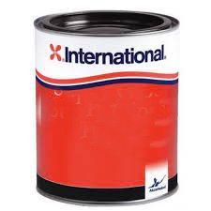
International Paint Ltd has been fined £650,000 and ordered to pay costs of £145,000 after a highly toxic banned chemical was washed out from a holding tank into a “pristine” river in south-west England.
International Paint Ltd “utterly failed” to control a substance called TBT that it had stored at its mothballed plant on the banks of the Yealm in Devon, a judge concluded.
An expert who tested water in the Yealm, a site of special scientific interest renowned for its oysters and cockles, found that one sample close to the plant contained 80,000 times the safe level of TBT.
The company has agreed to cover costs of remediation works, likely to be at least £500,000.
For the full report click here.
“Because of local concern about the pollution from this site, your Committee has written to the Parish Council: Following the publication of the Judgement against Akzo Nobel the RYDA have received enquiries regarding the safety of the water whether ingesting, entering or encountering water derived from the river, from Kitley, seawards; and the Estuary and Creek is now advisable or safe, or dangerous. Are the PC in communication with the EA regarding this and the remediation of the river bed etc?
The response from the Parish Council has been: We have had an agenda item for the last couple of meetings for this and I am sure it will be on the agenda for February.

The next meeting of the Parish Council is on Thursday 9th February in the WI Hall.”

Are you passionate about our local area?
There is still one vacancy on the Parish Council so if you are passionate about your community and care about where you live, why not join the Parish Council. They have a number of committees that you might like to join along with attending Parish Council meetings once a month. More information can be found under the 'Council' tab on their website.
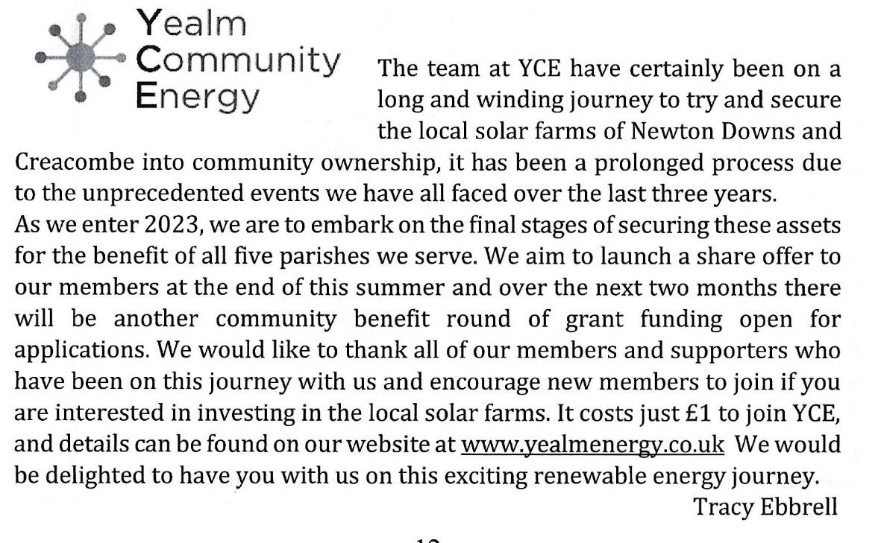

PLANNING

48 Yealm Road. Reference 3569/22/VAR. There is as yet no decision on this retrospective application, which is for variation of the approved drawings, on the original planning consent 0151/18/HHO. There are 6 objections currently lodged with SHDC, including Newton & Noss Parish Council and RYDA.

Linden Lea, Church Park. Reference 3401/22/HHO. This application for installation of a vehicle gate, parking area and removal of part of a stone boundary wall abutting Yealm Road, opposite Holy Cross Church, has been refused on the grounds of "likely to result in an increased risk to highways safety".

71, Yealm Road. Reference 2928/22/FUL. Proposed boatshed and reinstatment of landing. The decision on this application remains outstanding, but comments have been recieved from the Devon AONB concerning potential loss of natural foreshore.

Land opposite Butts Park. Reference 2982/21/FUL . This application from the Newton and Noss Community Land Trust for 20 new houses is listed for discussion at the SHDC Development Management Committe (DMC) and is shown on their website as "Comment – Discussions over viability ongoing between housing and land owner".

Land West of Collaton Park . Reference 3335/21/FUL. Construction of 125 homes, commercial business units, landscaped parkland, community boat storage/parking, allotments, improvements to existing permissive pathway and public footway, enhancement of vehicular access and associated infrastructure and landscaping.
Although approved by the SHDC Development Management Committee, this application has not yet been formally approved and is shown on the DMC website as "Approved by Members, subject to S106 agreement (now with legal)".

WHATS ON

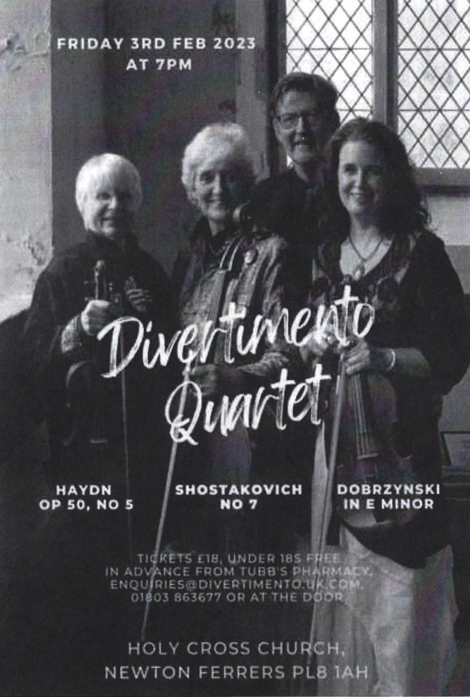

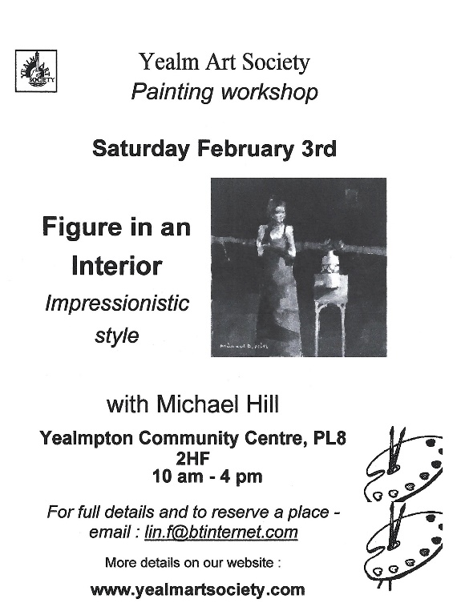
1st Tuesday Lunch Club
WI Hall Newton Ferrers
On 7th February @12.00
2 course lunch, plus coffee or tea £6
All welcome

WI speaker on February 7th is Poldark – Mining in Cornwall
WI Hall Newton Ferrers @ 7pm
New members and visitors welcome

WI Craft Group 14th February
WI Hall Newton Ferrers 2pm-4pm £1.50
Bring your current hobby and join us for a chat & coffee
New members and visitors welcome

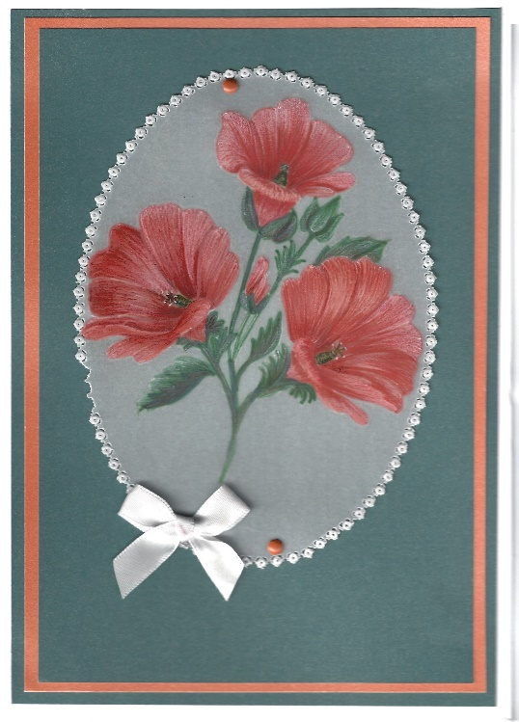
Yealm Parchment Craft
WI Hall, Newton Ferrers
17th February 2-4 pm
Next lesson : Dry on wet technique

Come along and learn a new absorbing hobby
Equipment supplied if you don’t have it £8 per session
Contact Lesley 873403

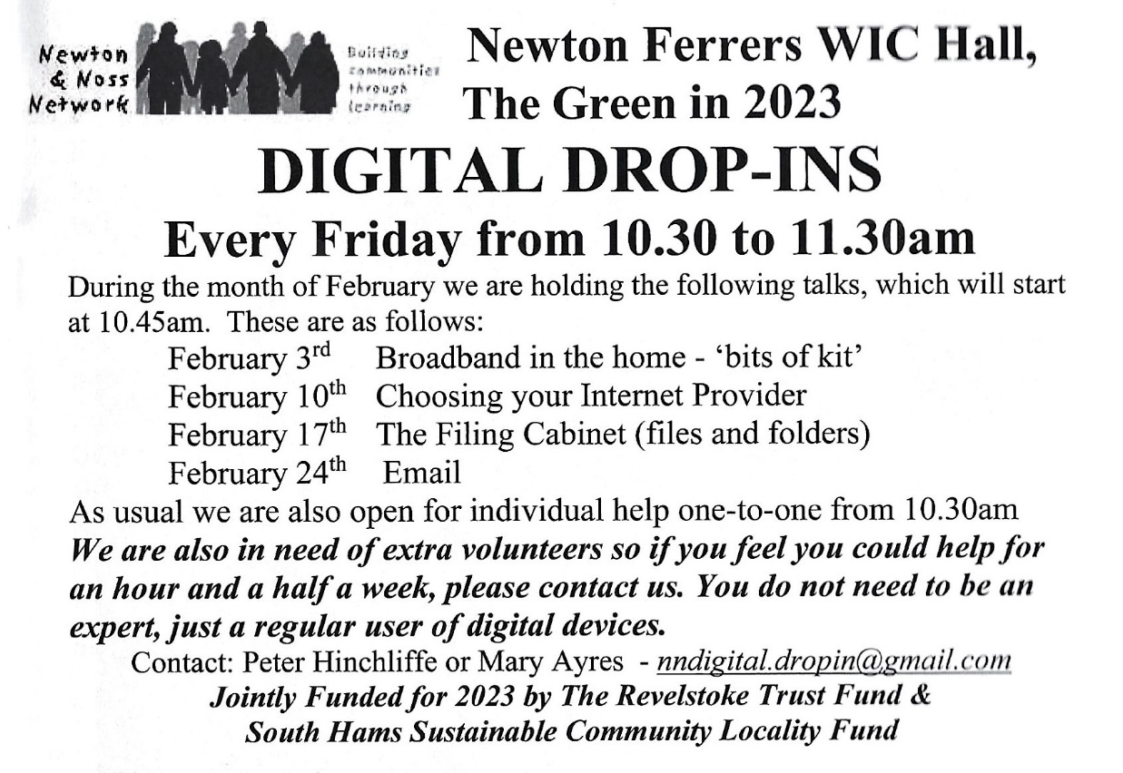

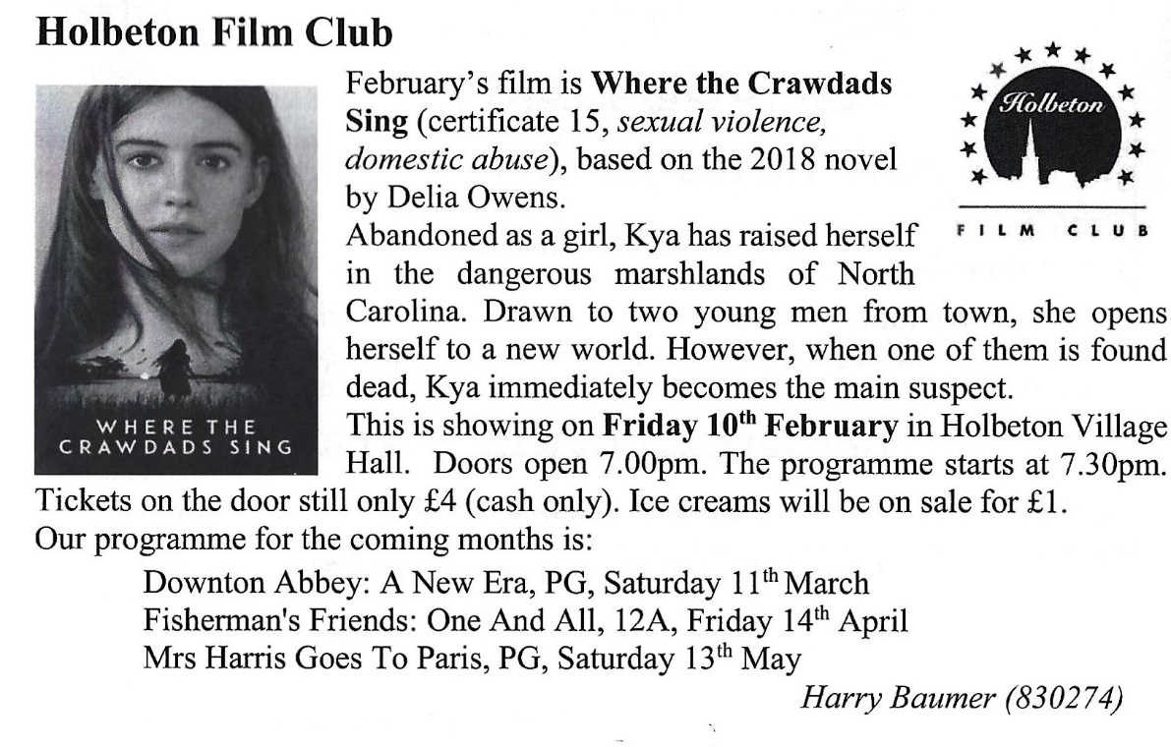

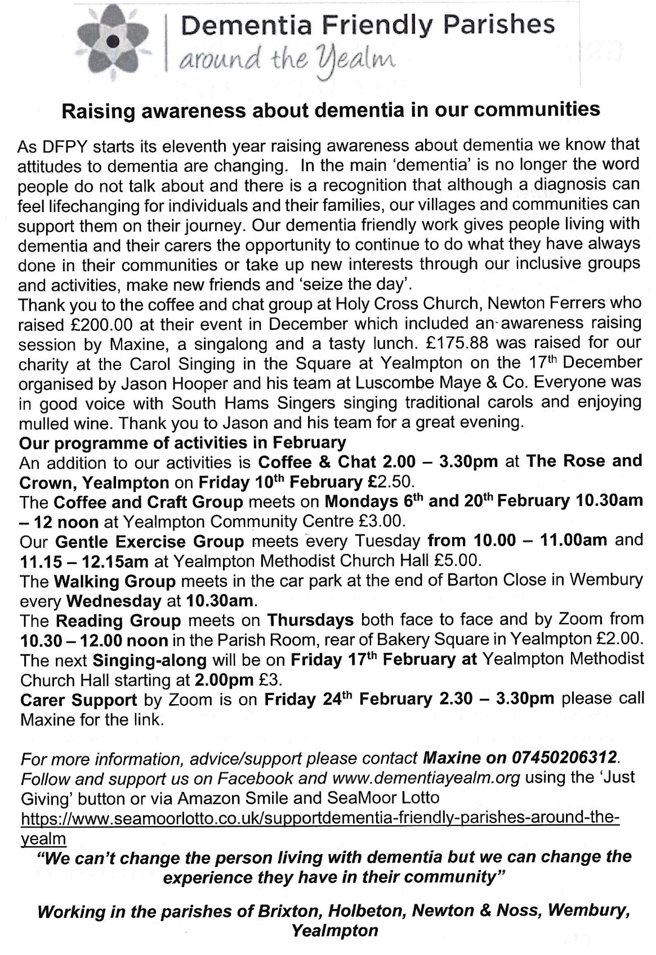

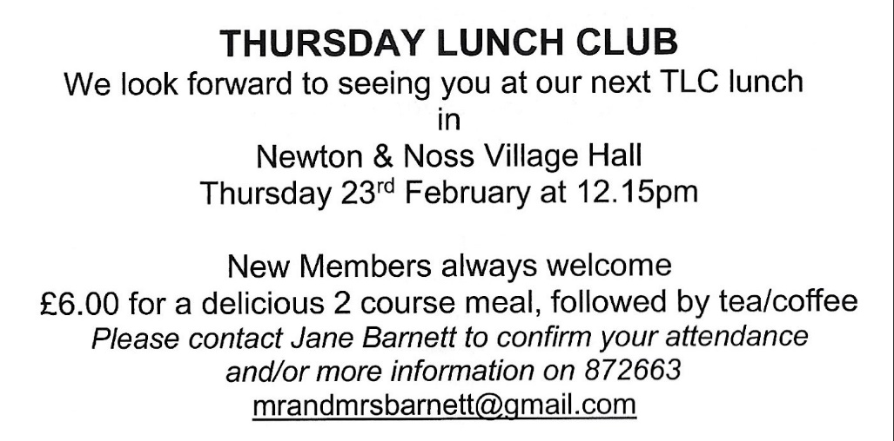

WI Craft Group 28th February
WI Hall 2-4pm “Sunrise” Yarn Art. £1.50 including tea & coffee,
Please bring glue (preferably PVA) Yarn, sewing cotton, crochet cotton, embroidery thread, knitting wool oddments, ribbon, lace offcuts, pencil & scissors.
A picture to inspire your design if you need it
(some yarn is available) New members and visitors welcome

