RYDA Newsletter 04/2021

Spring Newsletter
When is Spring?
A simple question – but the answer is … It depends!
According to the astronomical calendar, the first day of spring is 20th March, but for meteorologists, spring starts on 1st March and runs to the end of May. Then again, once crocus and daffodils start popping up all of a sudden in late February, we wouldn’t blame you for calling that the start of Spring either!
With more of us out and about, and with an accumulation of holiday makers & day trippers litter is becoming a big problem.
- Common litter items include fast-food packaging, sweet wrappers, drinks cans, bottles and cigarette butts. Litter does not clean itself away. It can take years to degrade, causing harm to wildlife and habitats.
- More than two million pieces of litter are dropped in the UK every day. The cost to the taxpayers for street cleaning is over £1 billion a year.
- Dropping litter is illegal. People who drop litter can be fined or face prosecution in court. Authorised officers have the power to issue a fixed penalty charge of up to £80 for a litter offence, as an alternative to prosecution.
- Please pick up your rubbish plus a bit more.
- Keep an eye on your tradespeople, they are often big offenders.
- Have more respect for where you live

Two local young people, Neve and Freya, have been raising funds for the Marine conservation society, by doing a paddle board litter pick. So far they have raised over £1,000. This is their story:

We are very lucky to live in an area of outstanding, natural beauty and love the waters around us. We are really keen on protecting our seas and environment and are actively involved in Newton Ferrers primary school’s eco committee. We try to inspire younger children to love and protect the ocean too.
To raise funds for the Marine conservation society, we have organised lots of fun activities at school on Friday 26th March. We have also done a sponsored paddle board from Bridgend to Wembury beach (4 miles). Wembury and the surrounding coastline form a marine conservation area (MCA) and a special area of conservation (SAC). On the way we removed rubbish from the water and did a litter pick at Wembury beach. Each bit of rubbish we collected will help save a sea creature. We hope to raise £100 to donate to the Marine conservation society.
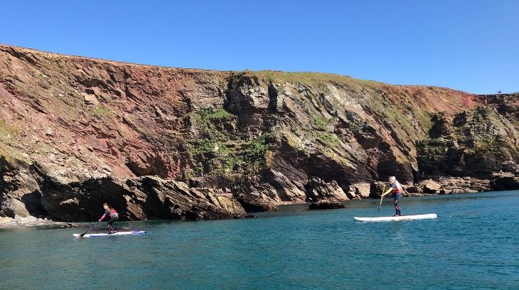
We did the paddle board on the 3rd of April. We paddle boarded from the pontoon to Wembury instead of from Bridgend because the water was really far out. The hardest part was coming up and around from Wembury to get past all of the rocks. I was wearing a Go pro, Kim (Freya’s dad) was taking pictures on his camera and Max (Neve’s dad) was on a speed boat in case we got into any trouble. We have loads of pictures and did a litter pick and found lots of rubbish.

Well done Neve & Freya, an example to us all. If you wish to contribute to their fund raising efforts, the funding page is Freya and Neve Paddleboardingfundraiser

If you’re keen to roll up your sleeves and get involved, there are ways to make handling other people’s discarded trash less of an irritating job…
1. Do a two minute clean whenever you arrive or leave somewhere
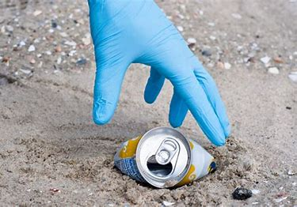
As the saying goes, every little helps. You don’t have to be on a mammoth litter pick to make a difference to your local area. Instead, set a two minute timer and speedily pick up any rogue bits of litter you see when you arrive at a beach or beauty spot. Make sure to carry thick gardening gloves with you, as they’ll protect your hands from dirty or sharp objects.
2. Make it a competition
Children love getting involved in litter picking, especially if you turn it into a game. You could set a challenge to see who can collect the most amount of litter in a short space of time. Or, send them out on a scavenger hunt to find a specific item, like a crisp packet or plastic bottle – the first person to collect it wins.
3. Start an Instagram account
You don’t need to share your good deeds on social media for them to count, but let’s face it, sharing a selfie or two can incentivise you to get out and do your bit. Plus, if your friends see you posting about all the plastic you’ve collected, it might just encourage them to do the same.
4. Make it part of your fitness training
‘Plogging’ is a Swedish lifestyle trend that involves jogging and picking up trash as you go. Whether you like to run in a park or on a street, picking up trash adds a full-body challenge for your muscles, as you need to bend, squat and reach to grab litter on your route.
As well as wearing gloves when you’re out litter picking, it’s important not to handle sharp needles or anything containing human waste or potentially dangerous chemicals. If you’re unsure what it is, it’s better to not pick it up. It has added benefits too. 30 minutes of “plogging” burns approx. 330 calories while 30 minutes of jogging the same terrain burns only 270 calories
5. Listen to something uplifting
A solo litter pick is the perfect excuse to put on your headphones, turn off your notifications and enjoy some quality ‘me’ time. How often do you really get the chance to listen to your favourite podcast without the distractions of other people around?
6. Treat yourself to something nice afterwards
A hot latte from the local coffee shop tastes so much better when you feel like you really deserve it. Just make sure to bring your reusable cup so you’re not adding to the single use plastic waste in your area. Or, now they are opening, a refreshing drink from your local pub.

A new, refreshed Countryside Code has been launched by Natural England and Natural Resources Wales, coinciding with the 70th anniversary of the creation of the founding booklet in 1951.
Key changes to the Countryside Code include:
- New advice for people to ‘be nice, say hello, share the space’ as well as ‘enjoy your visit, have fun, make a memory’.
- A reminder not to feed livestock, horses or wild animals.
- To stay on marked footpaths, even if they are muddy, to protect crops and wildlife.
- Information on permissions to do certain outdoor activities, such as wild swimming.
- Clearer rules for dog walkers to take home dog poo and use their own bin if a there are no public waste bins.
- A refreshed tone of voice, creating a guide for the public rather than a list of rules – recognising the significant health and wellbeing benefits of spending time in nature.
- New wording to make clear that the code applies to all our natural places, including parks and waterways, coast and countryside.

You can access the new code here

Proposed Collaton Development
Have you checked out the Proposed Collaton Development Presentation yet? Although the original proposal for 70 houses was approved before the N & N Neighbourhood Plan was "adopted", this new application is for 140 houses plus some small industrial units.
If you haven’t seen the proposal or commented yet, please do. It could have a big impact on the villages and waterways. Although the RYDA Committee has had a limited preview of the proposals, it is important that members take the opportunity to comment and make full use of the free text boxes. It would also be useful if members could inform the RYDA Committee of their views of the proposal. https://collatonpark.com/

Chris Phillipson, chairman of the community land trust says:
To date there have been 92 feedback forms submitted and so far the majority have been in favour of the development!
But there are still lots of folks who want/ need to be able to see the plans and ask the questions - eg. what about school places, what about traffic etc.
So, the Parish Council asked if it was possible to have a more public event now that it is possible.

The plan is for Friday 23rd and Sat 24th - afternoons, possibly 1-6pm. It will be held up at Collaton - there is a very large Barn on the site, and plenty of room for parking.
We can have all the doors open, so that its very airy and lay out a one-way-system. I do hope you all think that's a good idea.

The RYDA Committee recommend that Members familiarise themselves with the proposal, avail themselves of the invitation to attend the Presentation and comment as necessary, further details will be forwarded when known.
Water quality in the Yealm
For those curious about the water quality in the Yealm, you can now have a look here to see how many incidents there have been courtesy of The Rivers Trust. Is my river fit to play in? (arcgis.com) We are fortunate to live in such a lovely place. The problems are mostly after heavy rainstorms, so don't be put off from enjoying the creek and river. Also, after a hot day and a low tide causing the mud to bake, you will often see a slick of brown, organic matter floating on the water. A lot of people think it is sewage, but it hardly ever is. It's just the baked and dried surface floating up off the mud as the tide comes back in.

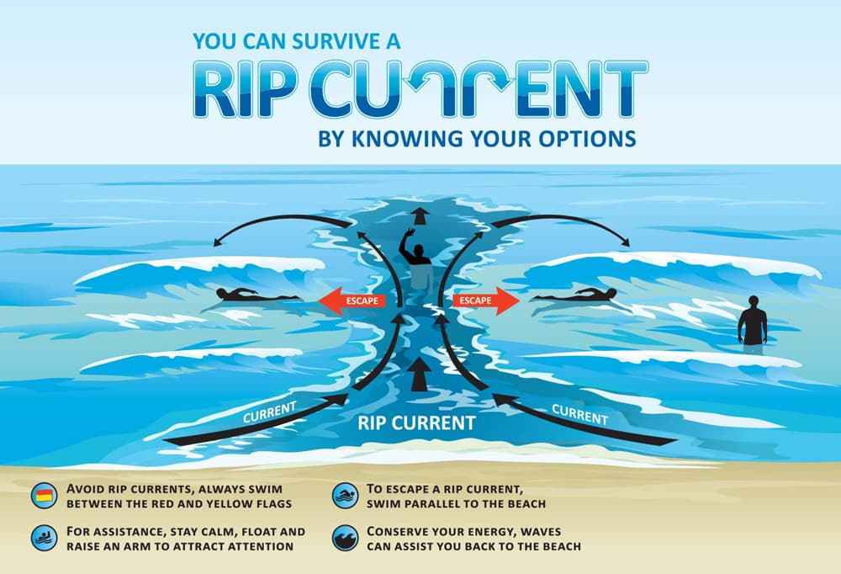
Rip tides
The sun is still shining in Britain which means many of us will be heading to the coast this Bank Holiday weekend to enjoy a day at the beach
But if you’re planning to take a dip in the sea, it’s important that you know how to stay safe in the water - particularly how to identify and stay out of rip tides.

What is a rip tide?
- Rip tides, also known as rip currents or undertows, are long, narrow bands of water that flow quickly away from the sea.
- Swimming in one of these seemingly calm stretches of water, which usually form in between crashing waves, can pull swimmers away from the shore rapidly.
How to identify a rip tide?
- Rip tides are hard to spot, but there are few tips to help you to identify them.
- Look for a gap in the waves
- Dangerous currents can occur anywhere there are breaking waves, including large lakes. One of the best visual identifiers of a rip current is to look out for gaps between the waves. A calmer body of water in an otherwise choppy sea might look safe to splash in, but these small breaks are often rip tides.
- Look for darker waters
- Look out for discoloured water near the shore. A strong current can also pick up sand and sediment, leaving a noticeable jet of darker water near the shore.
- Look for debris
- You might also be able to see the rip current picking up things like seaweed, forming a line of debris which moves steadily seaward.
- Be particularly careful around structures that have been built into the sea
- Finally rip currents are also common in areas with sand bars (both surface and submerged), piers, jetties, groins, and anything else that sticks out from the beach that could catch a longshore current and cause it to start flowing away from shore.

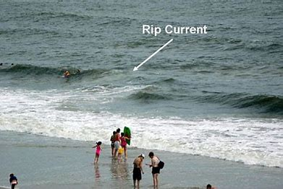
What should i do if I get caught in a rip tide?
It’s easy to panic when you get caught in a rip tide, and the natural reaction is to attempt to swim back towards shore.
Unfortunately, all this will do is tire you out and use up valuable energy. Even the strongest swimmer cannot swim against a rip tide, which at high speeds can pull you at 8-feet-per-second.
So here’s what to do to successfully escape:
Regain your footing if possible
If the current is relatively weak and you’re in shallow water, you may be able to grind your feet into the sea bed to prevent you from being dragged out further.
Call for help immediately
Get the attention of beachgoers and the lifeguard by waving your arms high in the air and yelling for help.
Swim parallel to the shore
Instead of swimming against the rip current, swim perpendicular to it, in either direction. Rip currents are usually narrow - they're rarely over 100 feet (30.5 m) wide -so you need only get to the side of the rip current to escape.
Rather than swim against the current toward shore, swim parallel to the shore until you are clear of the current.
Swim diagonally to the shore once you’ve escaped the current
Once you’re in calmer waters, you need to make your way back to shore.
Swim diagonally toward the shore and away from the current, to avoid getting caught in it again. If you’re feeling tired, stop and float periodically to regain your breath.
If help is on the way, lie on your back until the lifeguard team reach you.
And some final tips for sea safety...
- Never swim alone
- Identify where the nearest lifeguard is before swimming in the sea
- Supervise children at all times
- Don't swim in the sea after drinking alcohol
- Don't jump from heights into the sea

Annie Beighton says:- Our local hazards include:-
- Strong spring tides in the Pool
- Cold water at this time of year - especially for children!!
- Offshore winds in Cellars Bay - paddleboarders are particularly vulnerable.
- Be aware if you use an engine on your dinghy - they can break down so always take oars too!!
Believe me - I have local knowledge and experience!!

Continuing the watery theme …….Three new mooring holders were elected earlier this week to sit on the harbour board. Stephen & Maltby Nicky and Andrew Matthews

And Finally …..

Many people have been tracing their family tree’s during lockdown, but have you given this a thought?

It gets you thinking doesnt it!

Things to look forward to:
All events are subject to Covid restrictions at the time

Once lockdown is over, why not continue to enjoy and support our communities by joining in with one of our friendly groups and activities. These can be found on your web site www.RYDA.org.uk. From personal experience the support received from one of these groups during lockdown and bereavement has been amazing, and really appreciated.
The communities have something for everyone; lunch clubs; coffee mornings, out door activities, as well as indoor activities and hobbies.
Have you seen a “need” during lockdown for a new activity and want to start a group? Maybe we can help. Have your clubs details changed? Do you want new members? Let us know at rydamembers@yahoo.co.uk

Regatta Dance Saturday 10th July 2021

Regatta Heats 22nd - 25th July 2021

Regatta Finals 7th & 8th August 2021

Yealm Cricket club
2020 was the 40th year of Yealm Cricket club but because of COVID 19 we were unable to celebrate appropriately. On the 31st of July Yealm CC are planning to celebrate our 41st anniversary up at the Butts oval. The current Yealm Xl will be playing an all star ⭐️ Xl made up of X factor ex-players and friends of the club. We want as many people as possible to join us up at the playing field on the 31st to help us celebrate. The club has organised a bar and food trunks but picnic enthusiasts are welcome. We’d love ex-players, cricket fans, closet cricket fans and anyone who fancies a go or just a cool drink on a sunny afternoon to come along and share the day with us.
We’ll drop more details closer to the time.

The telephone number for the Dolphin Pub in the RYDA directory is incorrect it should be Plymouth 872007

There are no significant Planning Applications this month,
However, “The Newton Ferrers Paint Laboratory has been purchased by local businessman James Brent”.

