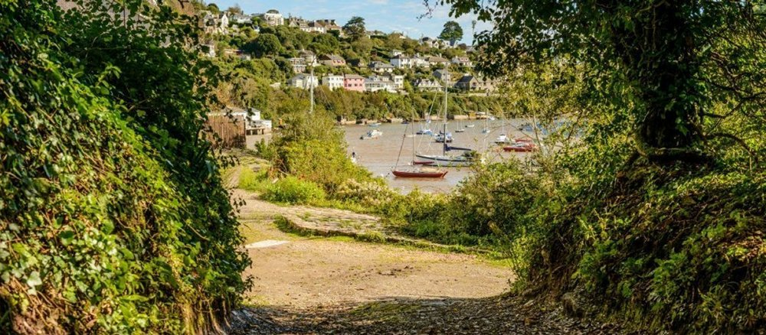
RYDA Newsletter 03/2021

Livestock Worrying

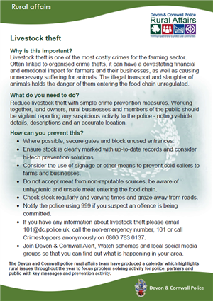
The Devon and Cornwall police rural affairs team have produced a calendar which highlights
rural issues throughout the year to focus problem solving activity for police, partners and
public with key messages and prevention activity. March theme is Livestock Worrying
Why is this important?
You are responsible for your dog. Livestock worrying is a crime and livestock that are
chased or attacked by dogs are frequently killed or injured. This has a financial and
emotional impact on all concerned and can affect the livestock long after the incident
has taken place. Action may be taken against you and your dog.
What do you need to do?
Ensure responsible dog ownership. Dogs should not be unaccompanied outside of the home and their behaviour should be managed at all times. On access land your dog MUST, be on a lead between the 1st of March and 31st July and at all times when livestock is present.
How can you prevent this?
• Enjoy the countryside but keep your dog on a lead if livestock is present. Release your dog if chased by cattle.
• Livestock worrying taking place at the time is considered an emergency dial 999
and explain there is a dog attacking livestock with a precise location.
• Livestock owners can advise dog walkers by giving clear notices advising of the
presence of livestock, Location of footpaths and appropriate fencing.
• Email 101@dc.police.uk if livestock has been chased or attacked and the dogs
have left the location.
• Farmers have the right to protect their livestock. Ensure you are aware of the
legislation and your legal responsibilities.
• Anyone able to offer information relating to livestock worrying is asked to email
101@dc.police.uk, call 101 or Crime stoppers anonymously on 08007 830137
• Join Devon & Cornwall Alert, Watch schemes and local social media groups so
that you can find out what is happening in your area

There have been some additions to the Postscript of “The Spirit of the Yealm” book.; namely the History of Newton Ferrers by the Rev Grimes 1946 & "George Hodge & the Kitley Ferries
If you have any further information that you think might be worthy of inclusion, please let Ron Furzeland, or Robin Hogg know by Email, preferably by submitting the information in Microsoft Word. Photographs should be submitted at a minimum of 300dpi.

Email addresses:

Robin Hogg. robstarflotilla@gmail.com

Ron Furzeland. ronald.furzeland@btinternet.com

This will be a gradual process, as any new information comes to light. We hope that this will enable a more complete history of this community to be built up over time.
Brookings Down and Eastern Hill Woods
Spring 2021 Update

Due to covid restrictions our maintenance programme this year meant we were unable to achieve our full maintenance target.
However individuals, observing social distance, have managed some essential tasks, pulling and strimming areas of bramble to keep paths clear and allow the bluebells and other flora to see the light of day!
With increased foot fall and wet weather, paths in both woods have been very slippery and this prompted us to install 5 new steps on a very slippery corner in EHW.
With the lifting of restriction we will have additional projects to complete this summer without disturbing the wildlife.
Following a kind financial donation we have purchased and planted a further 5 3ft bare root Hornbeam and replaced one bird box and added a further 3 in EHW . If you are interested in making a financial donation to our tree fund or would like to become a Friend of the woods please contact
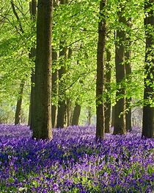
Paul Francombe - thefrancombes@btinternet.com
or Val Lomax - val.lomcroft@googlmail.com
Enjoy the Bluebells towards the end of April and early May.
Dog walkers we do have ground nesting birds so please keep your charges under control.
Thanks to our helpers and we look forward to seeing more of you in the near future.
Brookings Down Wood Committee

Protect your dog against theft key facts
- Think twice before leaving your dog tied up outside a shop
- Don’t leave your dog alone in the car, even for a few minutes
- Prevent your dog being stolen while out walking by varying your times of walks and routes, and keep your dog on a lead.
- Dont engage in conversation with strangers about your dog.
- Check your fences and access ways, and fit a bell to the gate so you hear if anyone opens it, and check on your dog while it is free in your garden
- Make sure your dog is microchipped and that you keep your contact details up-to-date, especially if you move house or change your telephone number. Dogs and puppies in the UK must be microchipped by eight weeks old, by law.
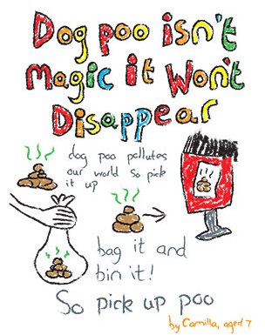
- Your dog should always wear a collar and ID tag with your name and address on it. This is a legal requirement when your dog is in a public place. A mobile number is also a good idea, but avoid putting your dog’s name on the disc.
- Take clear photographs of your dog from various angles, and update them regularly. Make a note of any distinguishing features.
- Have lots of photographs of yourself with your dog, to help you to prove ownership if needed.

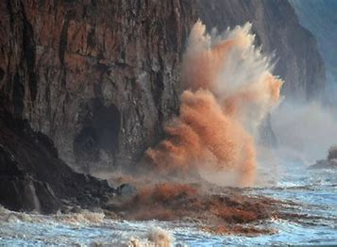

Be careful when out walking the beaches, cliffs and headlands.
Many of these are unstable at the edges due to recent storms and cliff falls
Sadly, Devon County Council have sent a 6 months’ closure notice in respect of Footpath No. 27 leading down to Cellars Beach. They have advised that the footpath is unsafe to use at present and will be closed until a safe alternative route can be arranged.
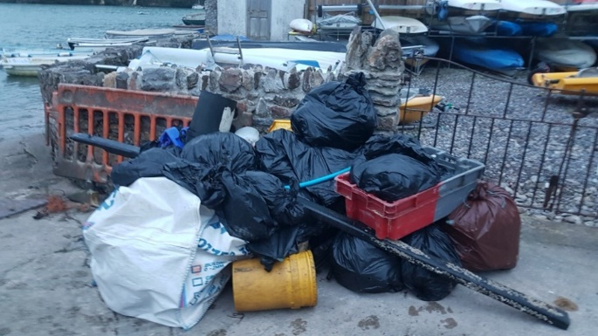
RYDA Harbour Cleanup March 13th 2021
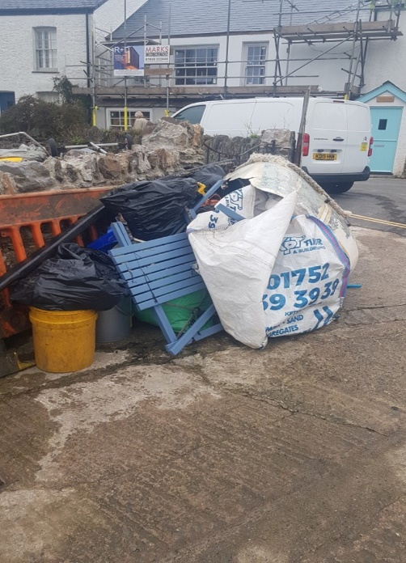
Despite the ongoing Covid restrictions we decided to go ahead with a socially distanced cleanup this year -having missed 2020’s entirely at the start of the first lockdown. The weekend of 13th/14th March was chosen but unluckily the weather turned really nasty with a westerly gale, showery rain and cold. Bob Cuthill decided to postpone the cleanup for the Spit, which is very exposed, for one of the next midday low tides - but about 30-35 people turned out either on the Saturday or Sunday to clean up the rest of the river which was much more sheltered. Many people reported that there was surprisingly not a lot of rubbish but there were exceptions particularly from Puslinch down river on the southern bank and we must have picked up over a tonne in all, mostly rope and fishing gear. Nothing like the 3 tonnes we picked up 3 years ago but nevertheless a worthwhile effort for which I and the RYDA would like to thank all the volunteers.
Andrew Beveridge

NEWTON AND NOSS VILLAGE HALL ANNUAL GENERAL MEETING
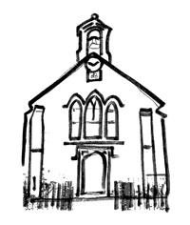
Notice is hereby given that the next AGM of the Newton and Noss Village Hall will be held on 27th April 2021 at 7pm
Due to Covid, the meeting will be over Zoom. Download the agenda here
Please email info@nnvh.org.uk for the link

A couple of things to look forward to
Yealm Cricket club
2020 was the 40th year of Yealm Cricket club but because of COVID 19 we were unable to celebrate appropriately. On the 31st of July Yealm CC are planning to celebrate our 41st anniversary up at the Butts oval. The current Yealm Xl will be playing an all star ⭐️ Xl made up of X factor ex-players and friends of the club. We want as many people as possible to join us up at the playing field on the 31st to help us celebrate. The club has organised a bar and food trunks but picnic enthusiasts are welcome. We’d love ex-players, cricket fans, closet cricket fans and anyone who fancies a go or just a cool drink on a sunny afternoon to come along and share the day with us.
We’ll drop more details closer to the time.

Wildflower Verges for Insects
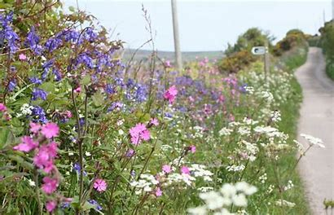
Newton and Noss WI have offered to fund some wildflower planting on the verges near the water tower. They had hoped to plant some trees, but there are cables and pipes for services in that area making tree planting unwise.
In order for the wildflowers to be successful it has been agreed that some turf will need to be removed before planting the seeds. Consequently they are looking for help working on this project.
The plan is to wait until the autumn for sowing as work parties during the lockdown are not possible.
Also planting at this time of year will mean that the seed will not need watering which would be difficult.
If anyone would like to help with this project please get in touch with Angela Macpherson. (angelamacpherson2@icloud.com)

Once lockdown is over, why not continue to enjoy and support our communities by joining in with one of our friendly groups and activities. These can be found on your web site www.RYDA.org.uk. From personal experience the support received from one of these groups during lockdown and bereavement has been amazing, and really appreciated.
The communities have something for everyone; lunch clubs; coffee mornings, out door activities, as well as indoor activities and hobbies.
Have you seen a “need” during lockdown for a new activity and want to start a group? Maybe we can help. Have your clubs details changed? Do you want new members? Let us know at rydamembers@yahoo.co.uk

Free things to do during the remainder of lock down

- Take a virtual tour of Buckingham Palace
Many UK tourist attractions offer virtual tours, so you can look around from the comfort of your own home.
The Buckingham Palace tour allows you to snoop around the Queen's house while learning about the history of the royal family.
- Look around London Zoo
London Zoo has launched a virtual zoo experience with zookeeper diaries, live streams of the animals, behind the scenes updates and more.
- Research future trips – travelling might be on hold for now, but that doesn’t mean you can’t start planning future trips. I’ve been! armchair travelling” with Virtual Trips. & have enjoyed Paris, Budapest, Split, Bled & Amsterdam to name just a few. All conducted by professional tour guides (all totally free), with the advantage of no crowds during global lockdown. My next is The Bolshoi Theatre. Your writer recommends these tours.
- You can access a myriad of virtual museums in the coming weeks.
Famed museums like the National Museum of Natural History in Washington, DC, and London's British Museum are offering online experiences, allowing viewers to learn about the exhibits in the museums from the comfort of their homes.
- Wildwatch Kenya virtually transports volunteers to Northern Kenya to identify types of wildlife in a conservation area.
- NASA's free Space Center Houston app offers a tour of its educational facility, as well as VR experiences and astronaut selfies.
- A quick search for #MuseumMomentsOfZen will lead you to dozens of relaxing exhibits that will keep you calm and entertained.
- Bob Ross' "The Joy of Painting" show is available in full on YouTube, so it's never been easier to learn how to paint from the master himself. You can watch Ross' video tutorials here.
- If you're interested in ancient architecture, you'll love Budget Direct's new series on renovated castles. The site spotlights gifs of what seven different ruins of castles might have looked like in their prime, such as the Poenari Castle in Romania. Follow this link
- Explore mars from the comfort of your Earth home. NASA's Curiosity Mars rover recorded some footage of the planet, and NASA worked with Google to turn the footage into a virtual tour of the Martian surface.
- David Attenborough's Great Barrier Reef virtual tour combines videos, photos, graphics, text, and interactive elements to transport viewers to the reef.

Although technically not part of our villages along the Yealm the following road works potentially affect most of us.

Flete, A3121/A379 Road works. Here's a snapshot of the new road layout at Flete/ A379 and A3121 junction. The link road between A379 and A3121 will be widened and become part of the A379 joining A3121 at a new roundabout. The existing A379 between Flete entrance and the existing junction will be removed. If you are driving a vehicle over 7m long and want to travel east from Modbury or Ermington, the diversion is via the Elburton Roundabout for you to turn round!

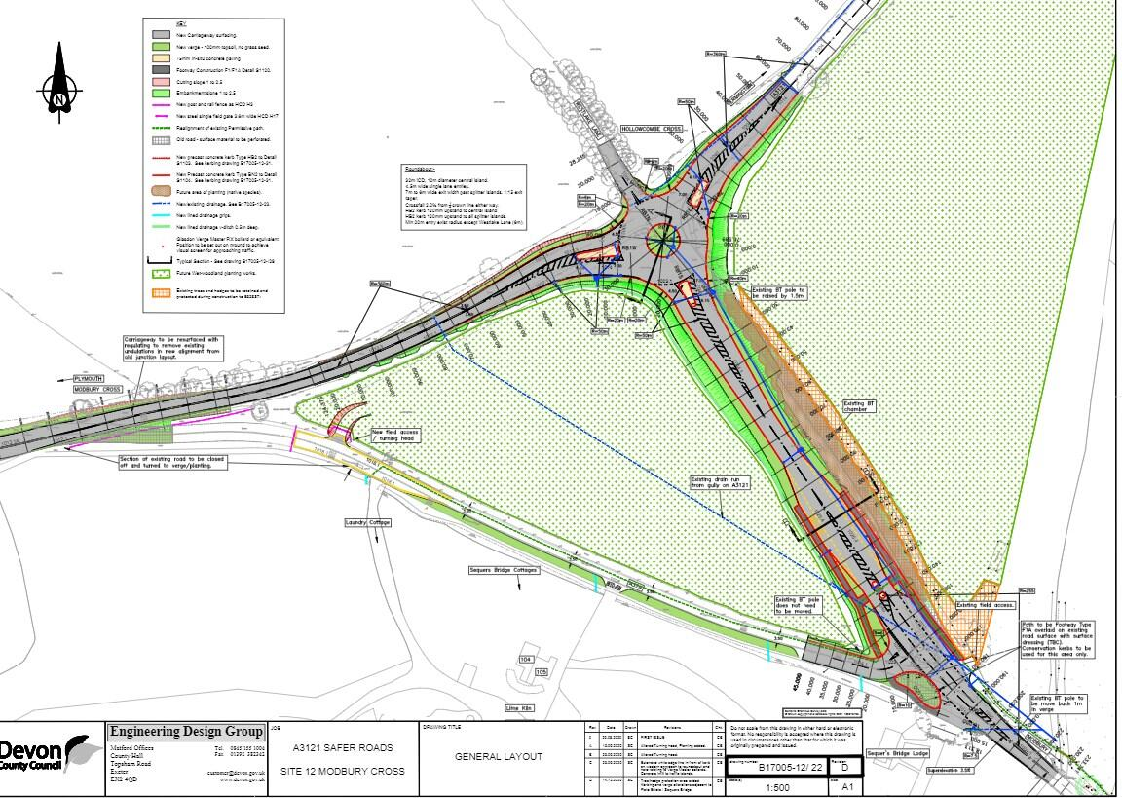

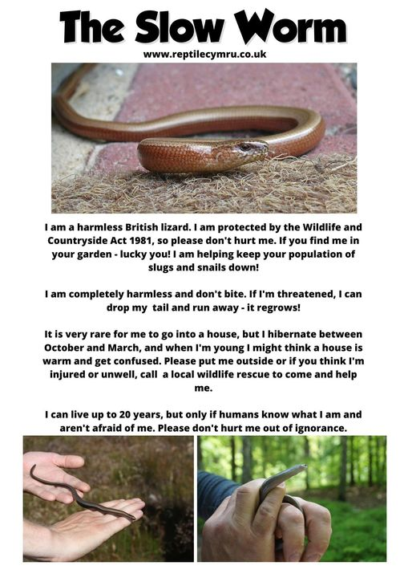

I heard that we are in the same boat.
But it's not that.
We are in the same storm, but not in the same boat.
Your ship can be shipwrecked and mine might not be.
Or vice versa.
For some, quarantine in optimal: a moment of reflection, or reconnection.
Easy, in flip flops, with a whiskey or tea.
For others, this is a desperate crisis.
For others, it is facing loneliness.
For some, peace, rest time, vacation.
Yet for others, Torture: How am I going to pay my bills?
Some were concerned about a brand of chocolate for Easter.
Others were concerned about the bread for the weekend, or if the noodles would last for a few more days.
Some were in their "home office".
Others are looking through trash to survive.
Some want to go back to work because they are running out of money.
Others want to kill those who break the quarantine.
Some need to break the quarantine to stand in line at the banks.
Others to escape.
Others criticize the government for the lines.
Some have experienced the near-death of the virus, some have already lost someone from it, and some believe they are infallible and will be blown away if or when this hits someone they know.
Some have faith in God and expect miracles during 2020. Others say the worse is yet to come. So, friends, we are not in the same boat.
We are going through a time when our perceptions and needs are completely different. And each one will emerge, in his own way, from that storm.
It is very important to see beyond what is seen at first glance. Not just looking, more than looking, seeing.
See beyond the political party, beyond biases, beyond the nose on your face. Do not judge the good life of the other, do not condemn the bad life of the other.
Don't be a judge.
Let us not judge the one who lacks, as well as the one who exceeds him. We are on different ships looking to survive.
Let everyone navigate their route with respect, empathy and responsibility.
Author – unknown

Did you know:
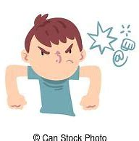
- Swearing on the bible is theologically problematic as the new Testament forbids the taking of oaths!!
- When we swear, we are using a different part of our brain!!
- In the 16th century, cancer was thought to be curable with tobacco. But, in the 17th century the Greek monks thought that tobacco was the excrement of Satan!
- In the 18th century gin was thought to cure sea sickness.
- in the 19th century, an Edinburgh doctor sold homeopathic snake excrement to treat chest problems. I wonder have we actually changed much since then, when you can think of so many weird things said to heal nowadays
- Pigeons can be trained to identify breast cancer - that is amazing x
- Rats can diagnose tuberculosis faster than the doctors..... the mind boggles.

Notable Planning Applications

14 Butts Park - proposed front and rear dormer extensions and single storey rear extension
0420/21/HHO

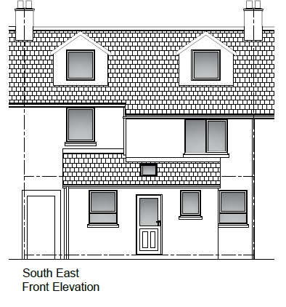
Although use of the roof is a standard method of increasing living space and may provide an efficient use of limited land, is this proposal suitable in this location? This application also includes removal of a rear conservatory and store with replacement by an enlarged kitchen and dining area. Together with the new garage a considerable portion of the rear garden is utilised.
3 Briar Hill Farm – Variation of design
0425/21/VAR
This development was originally approved as one of a terrace of three houses as a managers dwelling, subsequently amended to separate open market homes. The larger of these now seeks to add a Playroom on the north east side and projects beyond the common rear building line. This may impinge on views from the adjacent house. See plan below:

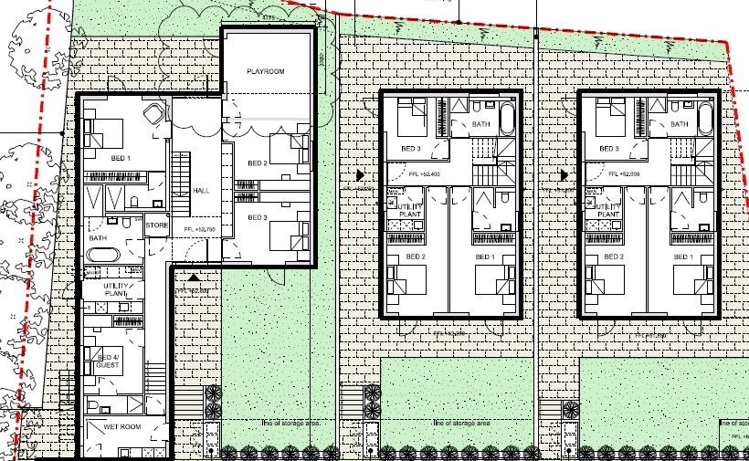
Mossgara, Pillory Hill, Slope stabilisation and associated works.
0464/21/FUL
In 2020 a landslip took about half of the Mossgara’s garden down to the foreshore of Newton Creek leaving both Mossgara and the neighbouring house potentially undermined. This proposal provides an engineering solution to stabilise the bank and garden. Extensive use is proposed of soil nails anchoring soil stabilization netting. Construction of a substantial reinforced concrete anchored structure along the foreshore adjacent to the existing gabions will support the lower bank whilst a reinforced concrete strip will stabilise the structure of the deck area. Planting is proposed to both add to the stabilisation and maintain the vegetated character of the local foreshore.

