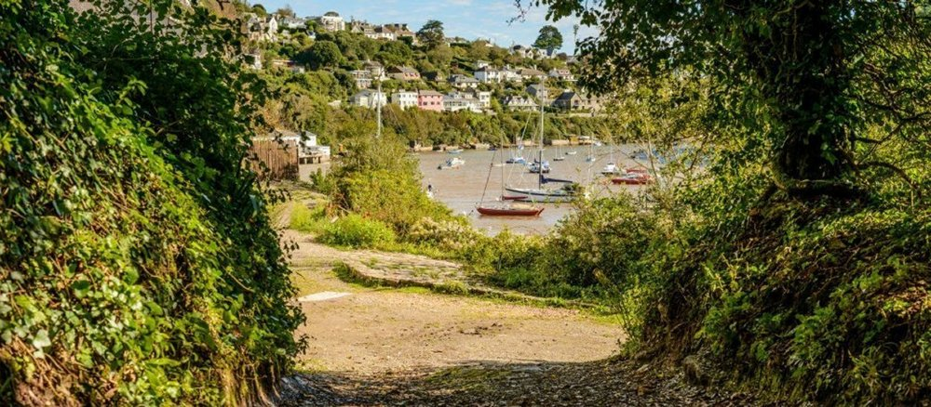
RYDA Newsletter 05/2021

GEORGE POLLEXFEN ARCHER
AND THE ARCHER FAMILY
If you have noticed the memorial drinking fountain by the bus stop on Parsonage Road near to The Green, you may have wondered who George Pollexfen Archer was and why there is such an impressive memorial to him in Newton Ferrers.
The straightforward answer is that he was the Reverend George Pollexfen Archer RN who was aged 33 when he died in 1887. His father was the Rector of Holy Cross at the time.

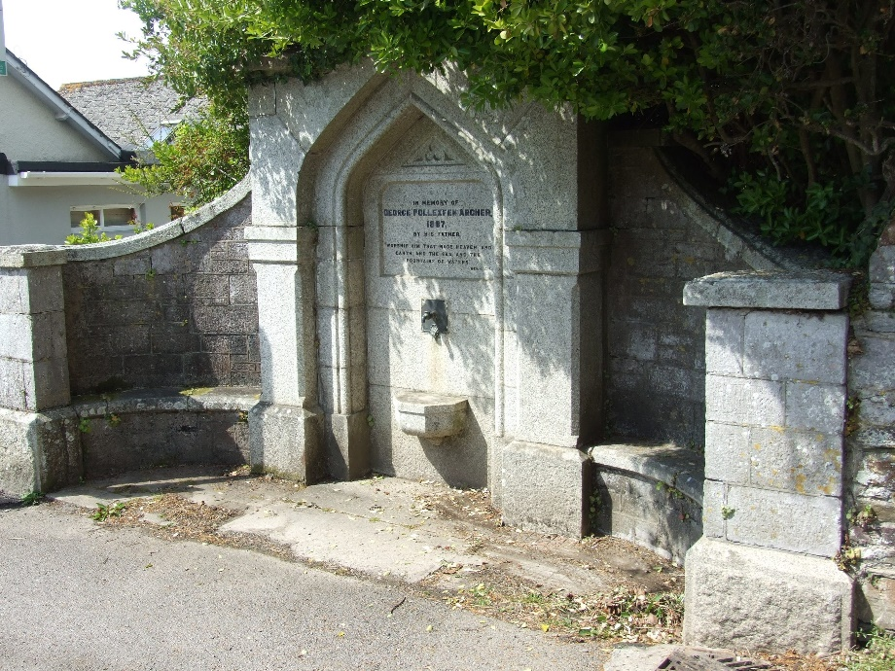
Following research by Christopher Lunn, there is much more to tell about the Archer story. The tale wanders over much of South Devon, reaches into Cornwall and even touches on a voyage to China. It inevitably also includes some sadness, but it dispels a local myth and draws out how entwined prominent families could be in times gone by.

If you are interested in finding out more, the full article is on the RYDA website. Just follow the link at https://ryda.org.uk/The Spirit of the yealm
We would be very interested to hear from you if you have any more information to add or even if you have any memories of drinking from the fountain.
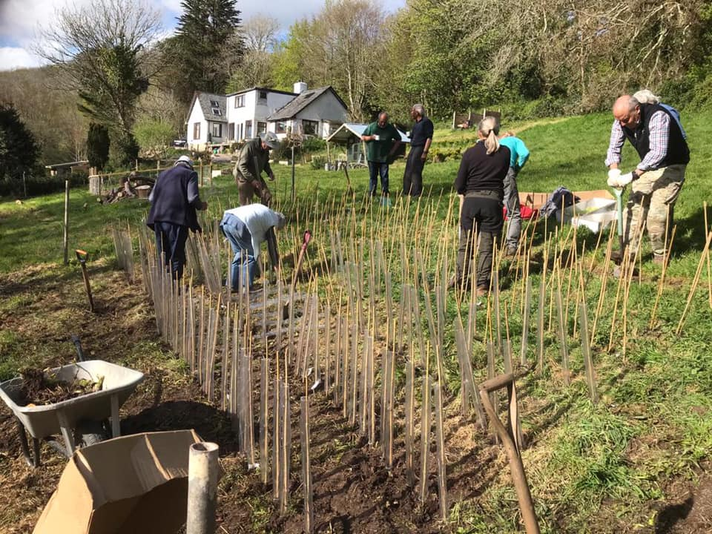
You may remember, a while ago, the Parish Council were asking for suggestions as to where to plant native trees donated by the woodland trust. The 350 trees arrived two weeks ago, and the Parish Council agreed that it was too late to plant them in the dry spring and so they have been temporarily put in the ground at Noss courtesy of Mark Steggles in damp ground to wait planting in November.

Hedgehog Awareness
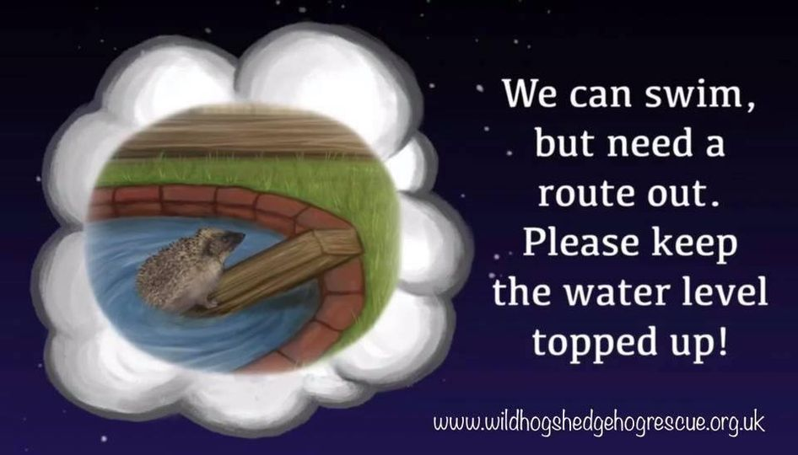
It’s often drier than we think. Always seems to be raining, but fresh standing water isn’t that easily available during the summer.
Ponds are often inviting, and hogs fall in and can’t climb out.
Ramps, not to slippery or steep, bricks or large stones make good exit routes. Chicken wire pegged into surrounding grass and draped over the sides will be great to climb, will become covered in plants quite quickly leaving a discreet way out.
One thing to keep an eye on is even with exit routes and summer progresses the water level can drop and make the exit routes inaccessible. So, keep ponds topped up

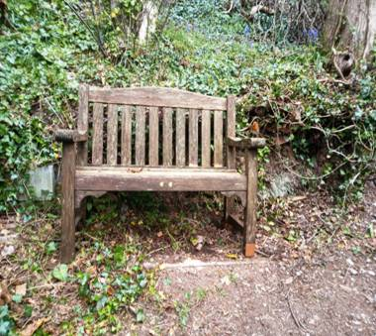
Brookings Down & Eastern Hill Woods Update
The path behind the tennis courts was getting a slightly overgrown and uneven so a small working party has worked on this area to improve it making the access much better.

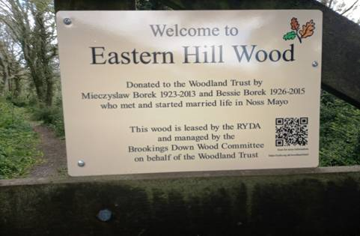
It was also felt that as EHW was donated to the WT we should create signs at the entrances to EHW giving a very brief history of its acquisition.
This spring there are wonderful displays of Bluebells and both woods offer walks through to suit a variety of tastes and distances as well as places for peace and tranquillity.
In EHW they can easily be seen from Middlecombe Road.

We have been kindly donated an old garden bench which has now been refurbished and resides at the top of the woods in EHW (the Robin gave it his seal of approval straight away !)
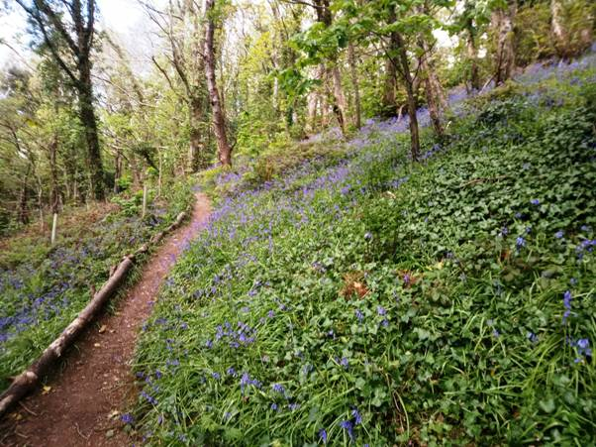
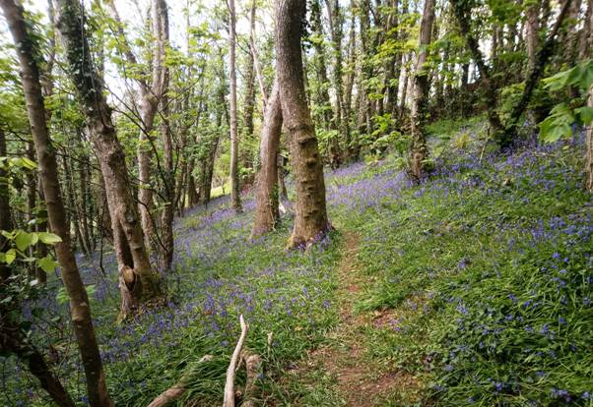

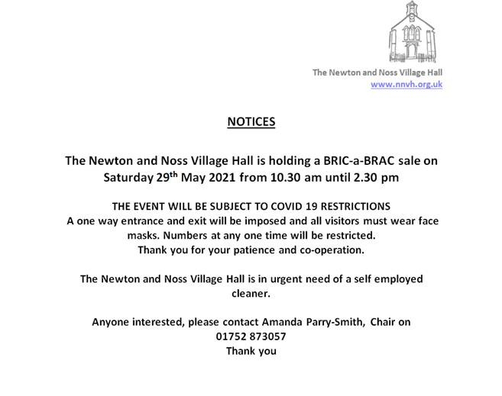

Illegal parking
The weather has been lovely recently, and with lockdown easing for walks in our lovely woods and coastal paths as well as bringing out visitors to the pubs parking is becoming a serious issue.
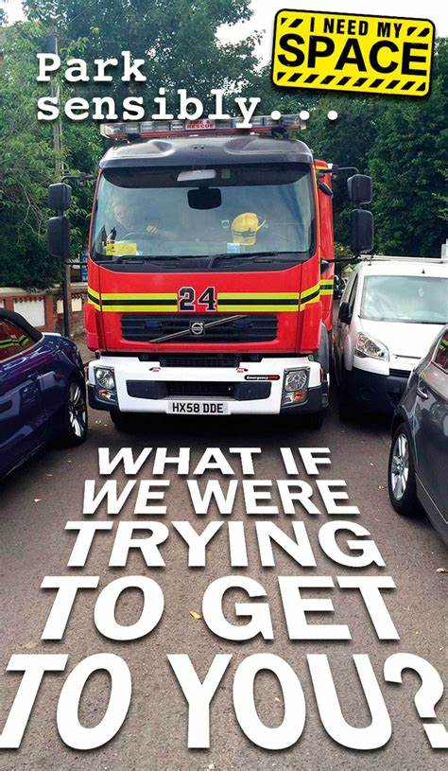
Noss, which is now nearly 50% Buy-to-let and second homes, has been completely overrun by vehicles celebrating the end of lock-down. Parking outside the Ship was so dense that some vehicles, parked earlier in the day, found themselves blocked in by later arrivals! For all of them the tide was fortunately in their favour.
However, Robin Hogg witnessed an incident on Wednesday morning on Pillory Hill outside his house that bodes ill for all of us.
The Bin Men could not get past a car, beautifully parked very close up to the wall, with its wing mirrors turned in. The driver decided that this car was “illegally Parked”, in that there would have been insufficient room for emergency vehicles, particularly Fire Engines and Ambulances to get through. Robin volunteered to get the owner to move the car, but the driver would have none of it. He jumped out of the vehicle and went to the owner’s front door and told him that he would be charged for illegal parking!
Robin asked him what this fine might be. He didn’t seem to know but thought it might be £100 - £200. More threateningly there might be the threat of deducting points on the driver’s license.!
The driver also made the point that his vehicle had 360 degree CCTV coverage around the vehicle, and there would be “No argument about the Facts” in any case!
On researching this, I found that it is indeed a criminal offence to cause a blockage to emergency vehicles. According to the circular guidance notes on the Emergency Workers (Obstruction) Act 2006, which are published on the government website, examples of obstruction may include parking where an emergency vehicle cannot get past.

What could happen if your parking obstructs an emergency vehicle
According to the Emergency Workers (Obstruction) Act 2006 it is an offence, without reasonable excuse, to obstruct or hinder certain emergency workers responding to emergency services.
A person found guilty of the level five offence could be handed an unlimited fine.
According to the Sentencing Council for England and Wales, the fine generally depends on a person's income.
But the council confirmed people generally don't get fined more than £5,000 as a general rule.

If the vehicle is parked:
- on zig zag lines
- dangerously
- in a way that would prevent emergency vehicles from accessing
You can report these to us (the Police) online

If the vehicle is parked:
- over a dropped kerb
- on a pedestrian crossing (including the area marked by the zig-zag lines)
- in spaces reserved for Blue Badge holders, residents or motorbikes (unless entitled to do so)
- in marked taxi bays, cycle lanes or red lines
- near a school entrance, bus or tram stop
- anywhere that would prevent access for Emergency Services
Please report it to your local council

Rule 243: of the highway code says: DO NOT Stop, or Park
- Near to the entrance of a school.
- Anywhere that would prevent access for the Emergency Services.
- Near to the brow of a hill or on a hump bridge.
- In front of an entrance to someone else's property.
- On a road bend.
- Near to bus stops and no stopping at a bus stop.
- Opposite a road junction or within 10 meters (32 ft) near junctions or corners (except in authorized spaces).
- Opposite a traffic island or another parked vehicle if it causes an obstruction.
- Anywhere the kerb got lowered. This is usually done to assist powered mobility vehicles and wheelchair users.
A lot of these parking “errors” happen in our villages, In particular by the co-op, the school, St Peter’s Church , near the pubs and down by the bus turning point

YEALM Medical Centre & Covid Vaccinations
Our group of GP practices, the Mewstone Primary Care Network (PCN), has been running the vaccination programme out of The Staddy Function Centre in Plymstock for patients in cohorts 1-9 since December 2020.
The team have vaccinated over 13,000 people and are now focusing on the second doses for those patients. We have been proud to be involved with the national programme and vaccinate the highest risk patients, however, we are now handing over the vaccination programme for cohorts 10-12 (those aged 18-49).
We will not be providing a vaccination service for people aged 18 to 49 when they become eligible. If you are in this cohort, you will be able to get your vaccination at other local vaccination services including hospital hubs, community pharmacies and larger vaccination centres.
If you are eligible please book using the link below. You can also call 119 to book.
https://www.nhs.uk/.../coro.../book-coronavirus-vaccination/
We are continuing to give the second dose of the Covid Vaccine to everyone who has had their first dose of the vaccine with us. You don’t need to do anything - we will contact you to make an appointment when this is due.
Thank you for your support and understanding.
Bee wild
Rewilding of our green spaces has begun, maybe you have joined the rewilding with leaving an area of your garden. So what might you see in the space left to rewild?
Here we have few wildflowers that you might see;
Oxeye daisy (Leucanthemum vulgare) is a small perennial and our largest native member of the daisy family. The yellow centre of the oxeye daisy is made up of many small flowers which hold nectar and are exploited by various pollinating insects.
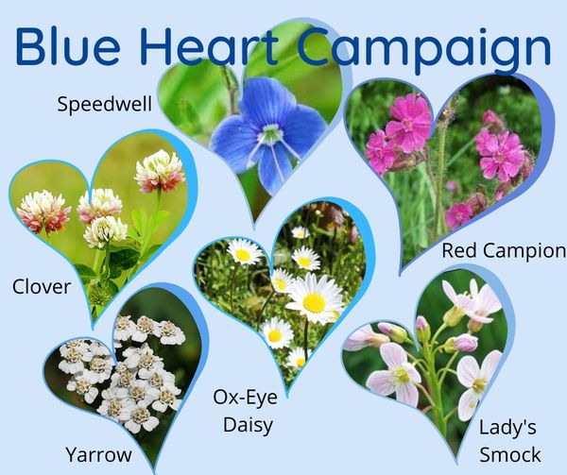
Yarrow (Achillea millefolium) is a tough plant of many grasslands, from lawns to verges and meadows; a strong-smelling perennial, clusters of white, flat-topped flower heads appear from June to November.
Red Campion (Silene dioica) is an attractive, medium to tall perennial or biennial plant with a downy stem. The flowers of red campion are important for various pollinating insects, including bees, butterflies and hoverflies.
Speedwell (Veronica chamaedrys) a low-growing plant, It has upright spikes of bright blue flowers with four petals and a white middle (giving it other common names such as 'Bird's Eye' and 'Cat's Eye’).
Clover (Trifolium repens) is a very common plant of all kinds of grassy areas in the UK. The famous trefoil leaves are collected by Wood Mice and are one of the foodplants of the Common Blue butterfly; the flowers appear from May to October and are sought after by all kinds of bumblebees.
Lady’s Smock (Cardamine pratensis) also know as Cuckoo Flower has a rosette of leaves at its base and an upright stem that bears the delicate, small, pale pink or mauve flowers.
It is very possible that your first year of rewilding that you will have shaggy grasses, this is still very useful for local wildlife!
#bluecampaign #rewilding #wildblueheart
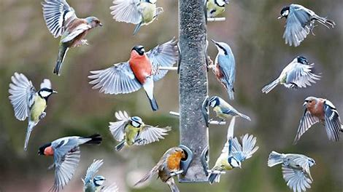
Be our eagle eyes say police
Police Wildlife Crime Officers in Devon and Cornwall is calling on the public to keep a look out for suspicious activity around wild birds’ nests.
It is part of an annual operation, which is backed by nationally-gathered intelligence, to tackle egg thieves.
This year, the police are asking members of the public to be their eagle eyes and let them know if they see any activity that suggests that nests of wild birds are being interfered with or eggs are being taken.
Some people will go to any lengths to raid the nests of rare wild birds but Operation Easter, which runs throughout the nesting season, from the spring into early summer, is aimed at tackling the problem.
PC Martin Beck, Rural Affairs Officer for Devon, said: “We have a great and varied number of birds in the South West which we should enjoy, respect and protect. This does however attract some the attention of a small number of people who want to take wild bird eggs.
If you have any information on egg thieves, or those who disturb rare nesting birds without a licence, you should contact the police by emailing 101@dc.police.uk or calling them on 101 - ask to speak to a wildlife crime officer if possible.
Information can also be passed in confidence to Crimestoppers via 0800 555111.
“This practice has been banned for many decades but sadly still goes on. The operation is asking members of the public to let the police know if they see people interfering with nests or taking eggs. The intention of this operation is to ensure that intelligence opportunities are maximised in order to prevent, disrupt or investigate possible offences. Be our eagle eyes.”

PLANNING
Whilst we await with interest the Planning Application for the Collaton Park development, a wide variety of new planning applications have been reviewed, the majority of which are of relatively minor impact.
One of interest is the revised application for a small-scale cake making business at the west end of The Fairway. 1460/21/HHO

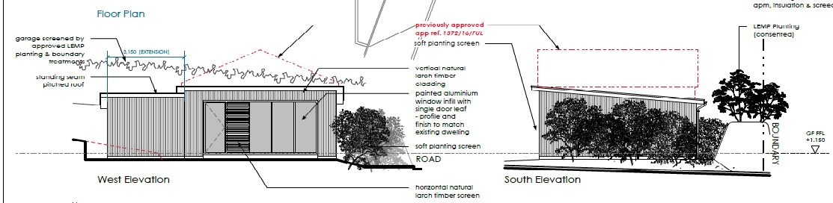

The proposal is to convert (and extend) the existing detached double garage to ancillary accommodation with external amendments (resubmission of 1251/20/HHO) that will provide work from home space with occasional use as additional living space that is to be used ancillary to the main dwelling.
The application describes the provision of a home office with WC, shower, and baking area, so that the applicants can move their specialist cake making business from the existing kitchen in the main house, to a dedicated area away from their family space. This existing business is run from home on a part time basis and, the application says, does not form a commercial bakery and will not result in a change of use at the site. They state that the cake making business is a very small-scale hobby business that provides occasion cakes which are delivered to event venues. You may wonder why for such a small scale enterprise, it needs to be moved away from the main house, and effectively nearer to neighbours.
The garage occupies a prominent position near the west end of The Fairway, quite close to the road and near neighbours, from whom a screening bank and hedge is proposed.
There is no information on any environmental impact such as noise or smell which may be generated, nor on any additional parking requirements.

For land off Court Wood, Newton Ferrers, an application for a change of use of part of the woodland, to allow two shepherd's huts and associated parking for the purpose of rural tourism has been withdrawn. 0005/21/FUL.

Whilst we support new and existing businesses, we wholeheartedly endorse the Newton and Noss Neighbourhood Plan Policy N3P-13 “businesses will be supported providing they are in keeping with the locality and would cause no detriment to local amenity or nuisance to neighbours.”

Mount Pleasant, a prominent, large house, on the higher side of Stoke Road in Noss, is the location for a proposal to increase the level of fenestration and to introduce a dormer extension, but is this likely to cause increased reflection and light pollution issues 0915/21/HHO

