The Gigaclear/Vonage Experience

For me, the best Broadband provider is a combination of reliability, speed and price, in that order. We have had a steady and good phone/broadband service from Plusnet, which including calls averaged at approx. £55 a month, and were reasonably happy with them.
To compare Gigaclear, therefore, who are strictly broadband and charge approx. £44-£49 a month, we needed to include Vonage, with a phone package which allows us to transfer our 01752 home phone number but costing the same or less than £55-ish a month.
Gigaclear as a standalone doesn’t seem very attractive, as to continue with a landline phone service as well would have had to include BT’s obligatory line rental, and therefore make the switch to Gigaclear too costly. But by including Vonage at £10 per month, it is worthwhile. There is no line rental; calls are made via WiFi, 3G or 4G with a mobile, and the house phone works via a small box which has 3 connections – ethernet, power and the telephone wire from your handset. I have not noticed any difference in voice clarity. Vonage offer a choice of packages: https://www.vonageforhome.co.uk/home/call-plans/
To compare, visit https://www.vonageforhome.co.uk/home/compare-vonage/
To me the advantage of switching to Gigaclear wasn’t only speed; there have been times when copper/fibre speeds dropped due to high demand – this doesn’t happen with fibre/fibre connections when upload and download speeds are constant.
Therefore, the argument was in favour of switching. Gigaclear offer a choice of packages:
https://www.gigaclear.com/home-broadband
My preferred choice was to go for the 100Mbps package, and then add another Linksys router to be sure of complete WiFi coverage for both ends of the house. These routers are available via Amazon at approx. £80. However, for much the same cost over the initial 18-month contract I decided on the 300Mbps deal, which includes two routers. I will probably switch to 100Mbps later.
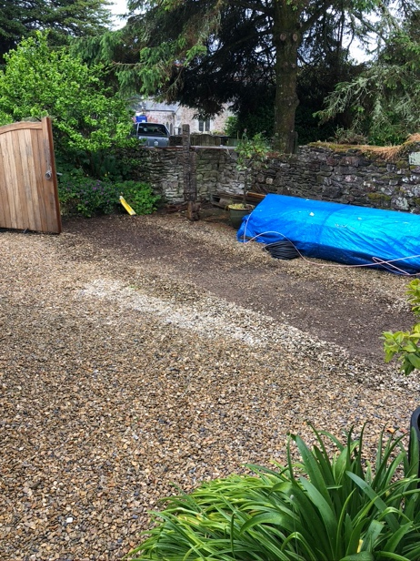
Taking the first step requires a call to Gigaclear who will then arrange for someone to visit and discuss the practical steps of connecting to the home. There is no obligation to go ahead at this time; for example, you may not accept the suggested point of entry to your house, and where the router is installed. I know some of your homes are further from the road than we are, and the geography may involve an extra cost. However, the engineer who came said that some of the properties they had successfully connected up involved very steep and challenging terrain (viz Lower Court Road).
On the day of install (I was told it would take about 5 hours to complete) the engineer reiterated with me the route across our drive, into the garage and then into the house. In very quick time the team (2 men) had drilled through the wall, cut out a channel in the drive and laid the cable through which the fibre would be blown. I attach photos of the initial stages and the final result.
Channel cut from road to house
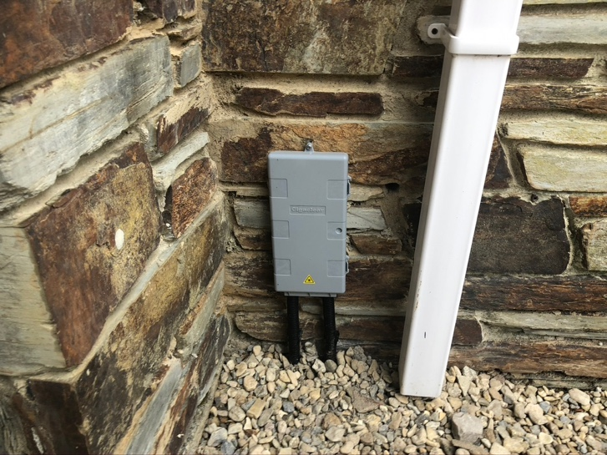
All that is visible on the outside is a small box next to the garage door. Inside, a small point of entry box is fitted to the wall, which is then connected to the Linksys router.
When all was complete the engineer took me through the process of setting up the system. This involved downloading the Linksys app via mobile phone or tablet, and following the instructions. It was all quite straightforward; at one point I was asked to give the router a name, and then a password. When this was done he performed a speed test.
Gigaclear's point of entry to the house

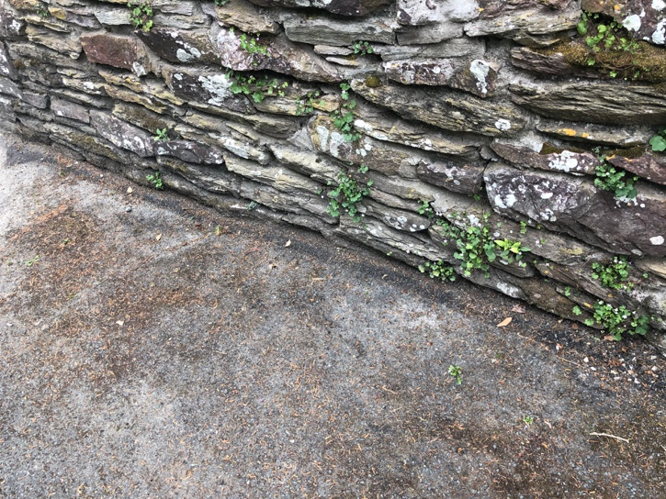

I’m happy with the result, and glad I made the decision to move. The Vonage system is easier to manage online than Plusnet, too; the switching process is simple – all you need to do is sign up to Vonage via their website. They then take over and notify your broadband/phone provider. At some point they will advise you the date of hand-over, which is when your home phone number is transferred. On that day you may experience a period when people won’t be able to call you.
All that is visible is a small scar which is fading already

At the end of the 18-month contract with Gigaclear I will decide whether to stay with them or to switch. After all, the main deciding factor was to get the connection to the house!

