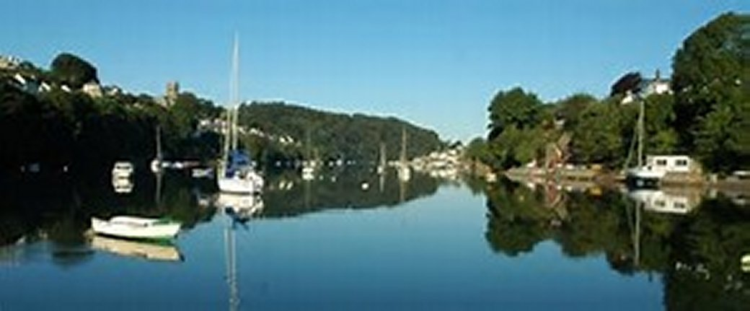
RYDA Newsletter 13/2020

2020 has been a challenging year for everyone, in many ways. It has brought out the best in many communities, including ours. Our thanks must go to the volunteers who shopped, ran errands, delivered medication and cooked meals for the elderly and vulnerable members of our community.
People say hello to each other in passing, even if we have never met before, its nice. Your cheery “hello” might be the only word a lonely person has heard all day. Neighbours have kept an eye on each other. It’s how a community should be.
We have had our challenges too, not least the parking when we were swamped with visitors many of whom were on furlough. Queues in the rain to go into our shops, and increasingly busy river use.
We will come through it, and we hope that we retain the good that came out of a horrible year.
Some Christmas facts for you
The name ‘Christmas’ comes from the old English phrase Cristes maesse, which means ‘Christ’s mass’. But what about ‘Xmas’? Lots of people think this is just a modern-day abbreviation – but it actually dates back to the 16th century! The ‘X’ is said to represent the Greek letter ‘Chi’– the first letter in the Greek word for Christ, Χριστός (pronounced ‘Chritos’).

In Scandinavian mythology, the son of Freya, Goddess of love, was killed by an arrow made of mistletoe. In his honour, Freya declared that Mistletoe would always be a symbol of peace. It was hung in doorways as a sign of friendship, hence the Christmas tradition of kissing under the mistletoe.
Now, imagine if there was no Christmas. Does it feel quite strange? Sad, perhaps? Well, believe it or not, in 1644 Christmas celebrations were made illegal in England, and soon after, in the English Colonies in America, too! At that time, members of the government felt that the religious meaning of Christmas had been forgotten, and so banned the holiday festivities. Some people still celebrated in secret, however, until Christmas was once again legal… almost 20 years later!
The Service of 9 Lessons and Carols was first created at Truro cathedral. [an attemp to keep people sober for Midnight service]
It’s technically illegal to eat mince pies on Christmas Day in England. In the 17th century, Oliver Cromwell banned Christmas pudding, mince pies and anything to do with gluttony. The law has never been rescinded.
According to tradition, you should eat one mince pie on each of the 12 days of Christmas to bring good luck.
The very first Christmas stamp in the UK was designed by a 6 year old!
The first commercial with Santa Claus was in 1923 for ginger beer
92% of shop’s Santa’s have had their beards pulled to see if it is real.
30% of the Santa’s have been urinated on by children.
Scientists calculated that Santa would have to visit 822 homes a second to deliver all the world’s presents on Christmas Eve, travelling at 650 miles a second.
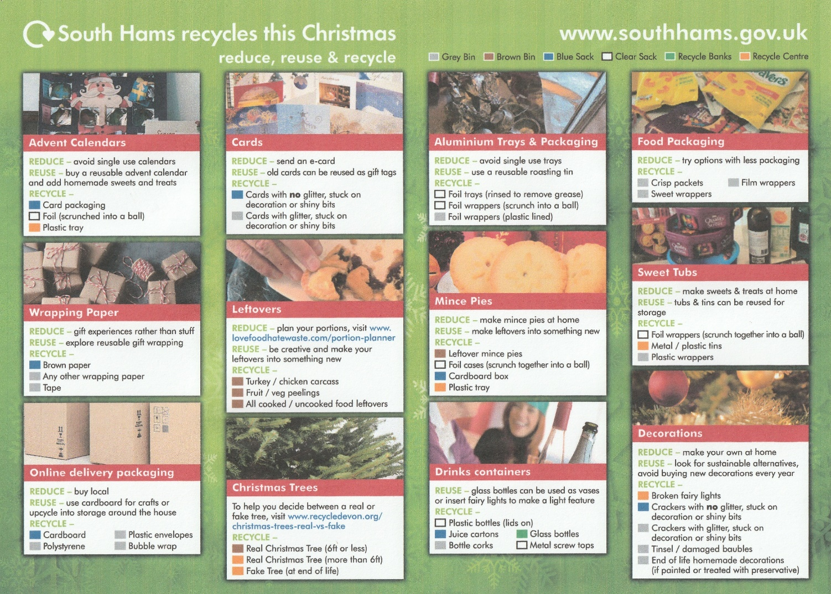
Christmas presents and festive food create waste. South Hams Council are recycling more than ever this year.

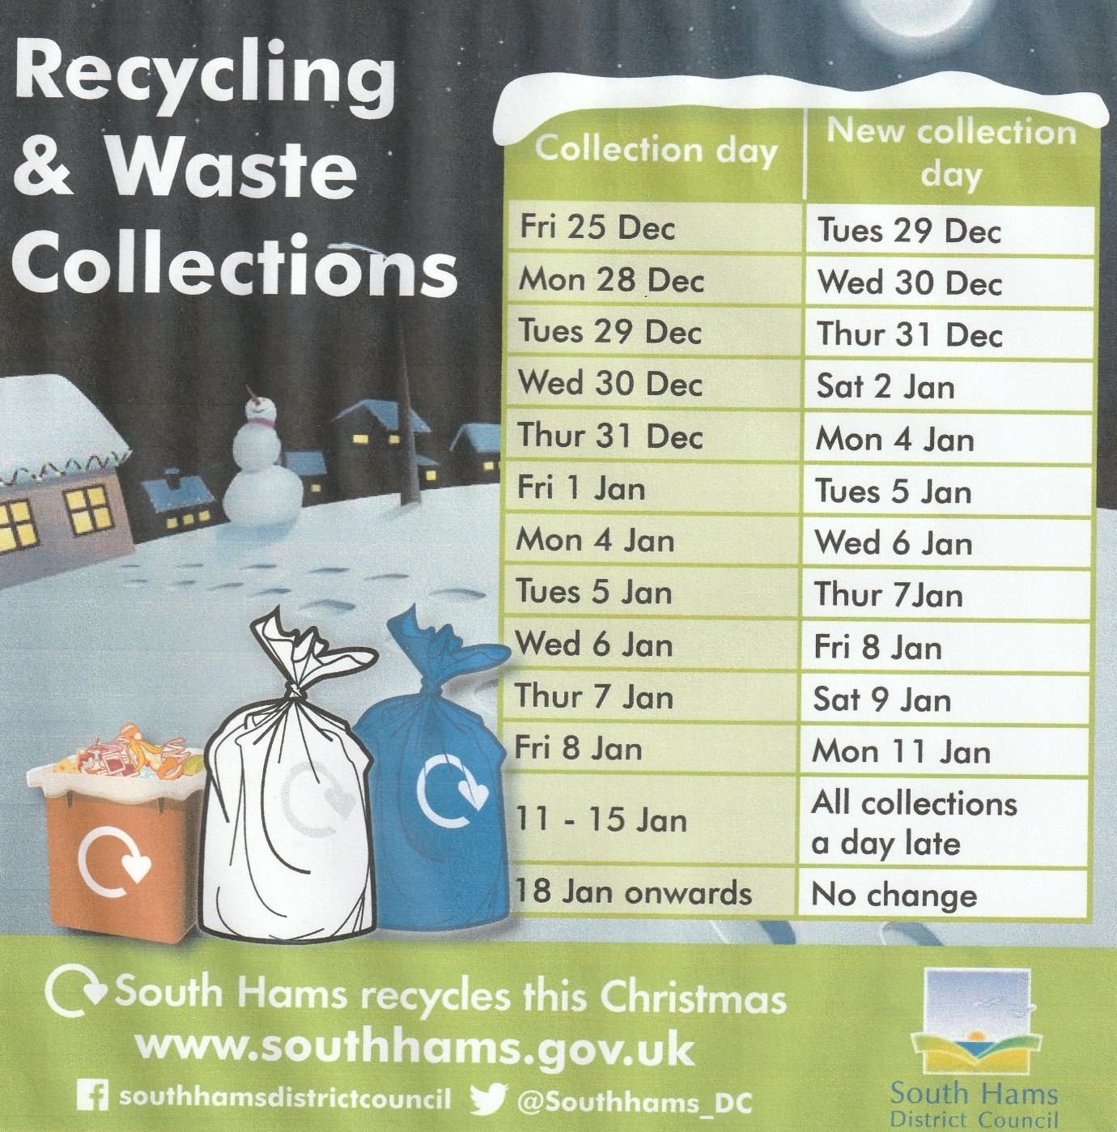

The Newton and Noss Village Hall Management Committee would like to wish you all a Happy and Healthy New Year.

We are so grateful to everyone who has contributed to the NNVH Façade Repairs project, and we realise how special this community is to offer such support to our much loved Hall.

Fund raising is still ongoing, and hopefully we can complete the major part of the works before the end of next year.

In January, we are holding a table top sale by appointment only (Covid restrictions permitting) with all proceeds going to the Facade repairs project. For more information, please contact Amanda Parry-Smith on 873057. We are planning to take photographs of everything for sale, so please do check our website: www.nnvh.org.uk and look at the ‘latest news’ at the top to see the pictures.

Seagrass

In last month’s Newsletter we included an article by LIFE remedies exploring the relationship between boating practices and seagrass. In this month’s Newsletter we have, in the interest of balance, included the article below from one of our members.
Meetings have been convened* which appear to be an unbalanced process aimed at demonstrating that anchoring (& by omission, anchoring alone) has a deleterious effect on seagrass. If successful in this study venture there seems a high risk that this long established and essential activity could in future be forbidden in the Yealm area.
The meetings are advertised as opportunities to discuss actions that are broadly described as intended to improve boater practices and behaviours as they affect sea grass. This agenda raises matters of considerable concern. The suspicion is that there will soon be a witch hunt of boaters who anchor in certain areas (as also recently highlighted on local Facebook pages amongst other places) is well founded.

An email convening one meeting suggests by its tone, quote: “ ....identify ways of improving impact of recreational boaters on seagrass.”, “...understand and improve boater practices and behaviours affecting sea grass.”, “...improve impact of recreational boating on sea grass” makes a clear insinuation that boaters by their actions adversely affect seagrass sustainability. This factually unsupported ‘belief’ has been expressed before any studies to identify any problems that may or may not actually exist have been carried out!

Identifying boaters at the outset as presumed seagrass destroyers (if indeed there has been any destruction) fails to acknowledge that there are many other very significant factors which directly impact survivability and growth, or otherwise, of seagrass.
It is little known and never mentioned (although well documented in reliable scientific research) that eelgrass (which is a seagrass) in the entire North Atlantic was almost entirely wiped out by a wasting disease (a nautical version of COVID-19?) in the 1920s and 1930s. Recovery thereafter was very slow. It was not until the 1950s that there were signs of significant regrowth and even that was put at risk by a further epidemic in the late 1980s in some Atlantic areas. Currently in the Yealm area seagrass now appears well re established although this was not the case 40 years ago.

Seagrass is acutely sensitive to excess nitrogen, phosphorus, detergents and poor water quality. The effect of this, known to scientists as Eutrophication, and the algae that results is considered by researchers to be the most significant threat to seagrass survivability. Run off from farms and waste from elsewhere such as sewage is thus a massive problem. To thrive seagrass needs clear water (to permit photosynthesis) and may also be sensitive to changes in salinity and temperature as will follow from climate change.

Seagrass propagates by shedding seeds and detached roots (rhizomes) can take root on suitable substrates.
The Yealm estuary apparently is now a potential target area for “improving boating practices” - banning anchoring perhaps? But there are a number of other specific factors which are particularly relevant to the survival of seagrass in this vicinity.

Apart from farm and other effluent run offs into the river South West Water has three sewage treatment works whose final effluent discharges into the Yealm. Although they have tertiary treatment. ie solids removal followed by percolating filtration and reed beds, abnormal operating conditions or severe weather conditions can lead to partially treated sewage entering the river. Although these occurrences are very rare, they are consented by law but can result in coliforms and ecoli entering the river. The Yealm shellfish business was forced to close recently because high levels of coliforms were found in the river, an indication that pollution can occur. It cannot be over emphasised that poor water quality is the major enemy of seagrass with potential to wreak far greater devastation than anchoring.

Nevertheless we have witnessed seagrass proliferating in the areas commonly used for anchoring near the entrance to the Yealm over many decades. In some parts now the growth is so extensive as to make safe anchoring (where the anchor has been able gently to break through the seagrass) very difficult. This even though in most winters major disturbances to the shallow and exposed seabed from winter gales leads to complete changes in the seabed profile. Divers report that seagrass beds now extend further upstream than hitherto. Yes, anchoring has increased over the years and is a visually obvious occurrence to shoreside onlookers but, arguably, anchoring encourages rather than discourages seagrass growth and spread for the reasons earlier stated. Anchoring may appear to casual onlookers to be “bad” and damaging to seagrass but the effect is probably no more than a minor disturbance of a sort that any gardener is familiar with. Think what happens with couch grass in the garden - it spreads like crazy if disturbed!

Acceptance and understanding within the sponsored study group that there are many other more significant factors that adversely affect the state of seagrass than anything boaters may do is critically absent . As highlighted by the demise of the Oyster fishery the Yealm is at considerable risk from sewage and farm run off as well as disease, cloudy water and so on.

The need to maintain healthy seagrass is well recognized. The importance of providing fish breeding areas, carbon capture, water cleansing and so on is vital.
If there is to be a survey then all factors (water purity, temperature, clarity, seagrass population etc etc) should be considered on a clean sheet basis without the bias of preconceptions (as have been outlined). Only if a real problem is identified should the possible causes and appropriate solutions be considered. To believe that boaters activities alone need be covered in any study would produce a flawed outcome.

*The organizations involved include Collingwood Environmental Planning and ReMEDIES funded by Natural England and the EU Life Programme

Having now provided both sides of this debate,the RYDA Committee does not believe that its Newsletter is the appropriate place to carry on a prolonged debate about this issue.

Winter Mini Challenge
Children can take part in a mini reading challenge from The Reading Agency, which runs throughout December and finishes on Friday 15 January.
All you have to do to complete the Winter Mini Challenge is read at least three books.
To take part and for more information please go to The Reading Agency website.

Libraries @ Christmas and New Year
Libraries will close on Thursday 24 December and reopen on Monday 4 January.
You can access their 24/7 digital library which includes eBooks, eAudiobooks, eComics, eMagazines and eNewspapers... and more!

The Newton & Noss Parking debate
"we are following this with interest and have resubmitted our views and potential solutions as suggested by you the members to the Parish Council"

Yealm Community Energy announces Community Fund 2020 is open!
YCE are delighted to announce its Community Benefit Fund is open for applications.
Grants are available for Environmental projects only.
Closing date 28th Feb 2021.
Good ideas come in all shapes and forms. The YCE community fund is designed to help small and medium sized projects with impact in the short term. Larger, long-term, and environmentally based projects take time, effort, and additional funding.
YCE is involved with ongoing horizon scanning for larger and long-term projects that might be achievable locally to benefit our communities, as well as potential external sources of funding that can help make them happen. YCE actively welcomes discussions with individuals and organisations with big ideas, to give a helping hand or to collaborate to make them happen.
Full details of the grant rules, application form and impact reporting are all available from our website www.yealmenergy.co.uk/latestnews or on our Facebook and Twitter pages.

The RYDA are sad to announce the death of two of its members.
Eric Rodmell, Who attained the grand age of 104. Eric was a committee membeer of RYDa for several years up to just short of his 100th Birthday. He was Editor of the Blue book until about the same age. & also oldest participant of harbour cleanup at 94
&
Robert Dryden, passed away at The Manor Care Home following a long fight with cancer aged 81

