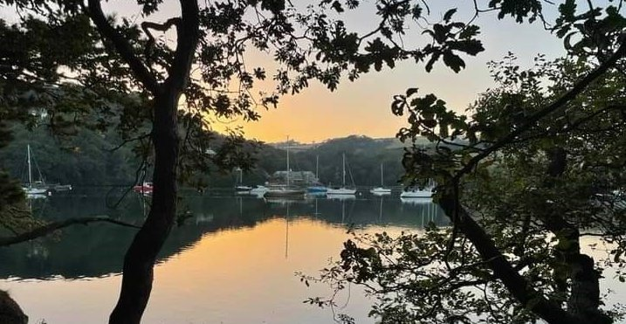
RYDA Newsletter 08/2023

August is upon us already! To us, August brings the best bounty of the season—ripened tomatoes, ripe melon, sweet corn on the cob, and courgettes are just a few of our favourites. August was named to honour the first Roman emperor, Augustus Caesar.

- August 1, traditionally known as Lammas Day, was a festival to mark the annual wheat and corn harvest. Lammas also marked the mid-point between the summer solstice and autumn equinox, and was a cross-quarter day. , Lammas day is also known as Loaf Mass Day, is a Christian holiday celebrated in some English-speaking countries in the Northern Hemisphere on 1 August. The name originates from the word "loaf" in reference to bread and "Mass" in reference to the Eucharist.
- August 10 is St. Lawrence’s Day. Saint Lawrence, who died 258, in Rome, is one of the most venerated Roman martyrs, celebrated for his Christian valour. He is the patron saint of the poor and of cooks. A farmers’ saying is “Fair weather on St. Lawrence’s Day presages a fair autumn.”
- August 11 marks the end of the Dog Days of Summer, which began on July3.
- August 17 is when the Cat Nights begin, harking back to a rather obscure old Irish legend that said that a witch could turn herself into a cat eight times, but on the ninth time (August 17), she couldn’t regain her human form. This bit of folklore also gives us the saying, “A cat has nine lives.” Because August is a yowly time for cats, this may have prompted the speculation about witches on the prowl in the first place. Also, nights continue to get longer. Cats are nocturnal hunters. Their superior night vision means that the nights belong to them.
- August 19 brings National Aviation Day, chosen for the birthday of Orville Wright who piloted the first recorded flight of a powered heavier-than-air machine in 1903.

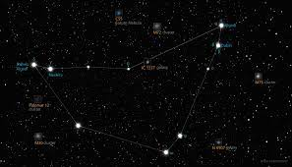
Certain meteor showers take place in August. The Kappa Cygnids are a minor meteor shower that occur at about the same time as the Perseids meteor shower which are more frequent and brighter. The star cluster of Messier 30 is best observed around August. (M30 was discovered by Charles Messier in 1764. It is located roughly 28,000 light-years from Earth in the constellation Capricornus. It has an apparent magnitude of 7.7 and can be seen through a pair of binoculars.)

Apathy noun ap·a·thy ˈa-pə-
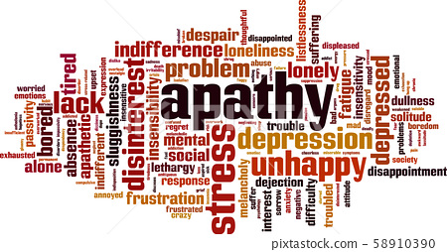
:

You may wonder why I’m talking about Apathy. – It is to do with the lack of interest in many of our clubs, organisations and communities.

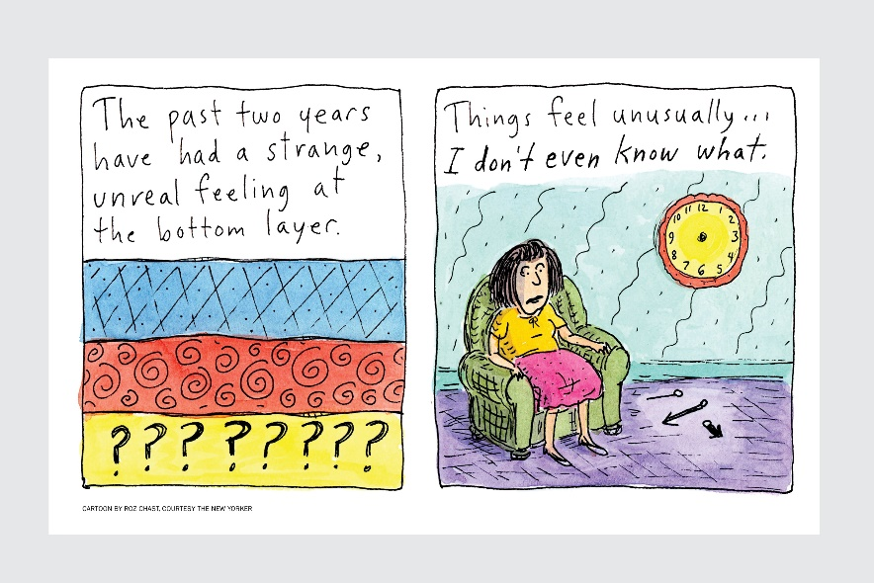
All our clubs and organisations are suffering from reduced members, & lack of interest.
Why, you may ask. – I’ve been talking to lots of organisers, and we all say it is since covid. Some people are afraid to go out, - even now;- & a lot of people have gotten out of the habit or practise of going out and joining in. We have adjusted to being insular. This in turn leads to seclusion and possibly depression which leads to apathy & indifference.

As human beings, we dream, learn, grow, and work as part of society. The society that we’re born into, and the societies that we navigate throughout our lives which shape our personal identities.
And in fact, so keen are we to communicate with each other — even beyond geographical limitations — that we’ve developed a plethora of tools to help us achieve that, including pen and paper, telegraph, telephone, and the Internet.

Apathy is contagious.
Just spare a moment to think about the organisers and leaders – Your apathy is contagious – they wonder why they bother organising speakers; find new activities, test them out, buy the equipment; cook for a group lunch - then have very few people turn up. They feel fed up, - feel that they are wasting their time.
If they did give up, there would be no activity, nowhere for people to go and join in, more social isolation, more depression, more apathy.

Benefits of Socialization:
Social interaction is good for your brain health.– it can lighten your mood and make you feel happier. Lower your risk of dementia –It promotes a sense of belonging, safety and security. It allows you to build trust and respect within your relationships and communities.
Socializing not only staves off feelings of loneliness, but also it helps sharpen memory and cognitive skills, increases your sense of happiness and well-being, and may even help you live longer.

‘Face-to-face contact is like a vaccine’.
Psychologist Susan Pinker states that direct person-to-person contact triggers parts of our nervous system that release a “cocktail” of neurotransmitters tasked with regulating our response to stress and anxiety.
In other words, when we communicate with people face-to-face, it could help to make us more resilient to stress factors in the long run. Dopamine is also generated, which gives us a little high and it kills pain, it’s like a naturally produced morphine.

So, just think; - do you want the activities in your villages to disappear? Do you want the social aspect of your villages to die and become indifferent? To lose the sense and closeness of our communities?
Do You Just Belong?
Are you an active member,
The kind that would be missed?
Or are you just contented
That your name is on the list?
Do you attend the meetings
And mingle with the crowd?
Or do you stay at home
And crab both long and loud?
Do you take an active part
To help the club along
Or are you satisfied to be
The kind that just belong?
Do you ever go to visit
A member that is sick,
Or leave the work for just a few
And talk about the clique?
There's quite a program scheduled
That means success if done,
And it can be accomplished
With the help of everyone.
So attend the meetings regularly,
And help with hand and heart—
Don't be just a member,
But take an active part.
Think this over, member:
Are we right or are we wrong?
Are you an active member?
Or do you just belong?
Anonymous

Because a lot of houses in our villages are 2nd homes, we have to work extra hard in keeping “US (our communities) together”. So please, join in, - you will always be welcome - learn something new, be sociable. September is an ideal time to start; Children start new schools, so we as adults could start a new activity.

Check out all the clubs and organisations near you on our web site https://ryda.org.uk there is Bird watching; book clubs, rowing, swimming, language groups, table tennis, cycling, archery, bridge, tai chi, yoga, gardening, parchment craft, photography, snooker, dance, the WI and its subgroups; The men’s shed ; lunch clubs (they are not just for the elderly); The dementia friendly groups around the Yealm (and its subgroups) which are not just for people with dementia, Most of the people who go, are carers, supporters, or people wishing to socialise. All our groups from bowling to cricket; from art and craft to walking are waiting to WELCOME YOU. – As the saying goes – Use it or lose it.

The Long-horned mining Bee!
These cool bees have long horns, and you guessed it - create their burrows through mining!
These bees are solitary, meaning they don't live in a hive, nesting on their own instead. However, they often nest very close to one another, and can create a buzzing community! They can be found around the world as far east as Siberia and China, with patchy distributions in Southern England and Wales. Recently, colonies were spotted at Prawle Point, where its coastal raised beaches and clay cliffs make for an optimum habitat.
The Long-horned Mining Bees live in burrows, usually in clay deposits along the coast, and create them by kneading the walls to make them smooth. Eggs are then laid onto a prepared paste of pollen and honey, which the larva will feed on once they are hatched. As an adult, they leave the burrow after scraping off remaining bits of their pupae membrane.
Interestingly, the Six-banded Nomad Bee, a parasitic bee uses the Long-horned bee as its host. It lays its eggs in the Long-horned bees’ nest, and when the larva hatches, it eats the pollen stores that the Long-horned bee has left for its own larva. As the Long-horned Bee feeds on very few plants (Including the Everlasting pea and Kidney vetch) the larva is threatened by the nomad bee. However, the two have evolved to cope with each other, and now the nomad bee cannot exist without strong numbers of the Long-horned bee. Unfortunately, as farm fields have been squeezing closer to the cliffs, the habitats for both bees have been reducing, and removing the legume-rich grasslands which the Long-horned Bees feed on.
However, through planting of wildflower margins around these fields alongside other initiatives, Life on the Edge is hoping to help bring these bees back from the edge.
Female and male Long-horned bees

Spotting Long-horned Bees: A guide!
The Long-horned Bee typically nests in aggregations (sometimes in their hundreds!) in bare or sparsely vegetated light soils, showing a preference for south-facing slopes or vertical cliff faces. Along the South Devon coast, soft rock cliffs provide especially important nesting habitat for these bees and Prawle Point is of national significance for the Critically Endangered Six-banded Nomad Bee (Nomada sexfasciata) – the special cuckoo bee of Long-horned Bee – that is now seemingly confined to this single site in Britain.
Long-horned Bees are active between mid-May to late July and are most readily encountered on warm, sunny days. To find the nests, look for large, oval-shaped holes in soft rock cliffs – the presence of Long-horned bees around cliff faces will often reveal the nesting locations. You may also encounter Long-horned bees foraging on flowers in cliff-top grasslands and along the coast path, and they are particularly fond of legumes such as bird’s-foot-trefoils, Kidney vetch and Everlasting pea.
Male Long-horned Bees are unmistakable, owing to their orange body hairs (which fade to greyish-white as they get older), a largely yellow face, large size (somewhat larger than a Honeybee) and their very long antennae. Females are less distinctive as they lack the long antennae but are of a similar size with a robust build and with pale dusting on the abdomen.

Thanks to “Life on the Edge” for this item.

What is Life on the Edge?
Life on the Edge is a multi-partner project, led by the South Devon Area of Outstanding Natural Beauty team, with their main partner, Buglife. It aims to restore viable populations of some of the UK’s rarest insects living along the South Devon coast between Berry Head and Wembury, including the last known colony of the Six-banded nomad bee. This bee faces imminent extinction unless action is taken. The project will also enable the recovery of over 20 other threatened invertebrates including the Long-horned bee, Short-necked oil beetle, and Moon spider.
If you want to know more or get involved either individually or as part of a group, please get in touch!

Volunteer Transport Scheme - PAL [ Phone a Lift ] - Update I am pleased to say that the revamped Voluntary Drivers Scheme that has now been up and running for nearly 2 months is functioning well. If you require a lift to the GP, Hospital or Dentist, or for any other medically related matter, simply ring 0300 234 0250. This number is published in the ‘Pink Pages’ of the updated Village Directory. You will be connected directly to the coordinator [ at present myself ] who will then message our group of volunteer drivers with the details of your requirements. As long as someone is available, they will contact you directly to finalise details. There is no charge for this service, but you may wish to make a small donation to the driver. At present we have 17 volunteer drivers. They are members of a WhatsApp group - PAL. When a lift is requested, the details are sent to all drivers. Only someone able to do it responds. The more drivers we have the more likely we will be able help. You do not need special insurance since we do not charge. However, it is advisable to inform your insurance company. This does not generally affect the cost of your policy. If you would like to be added to the group, please contact Dick Page at dickpage1@gmail.com.

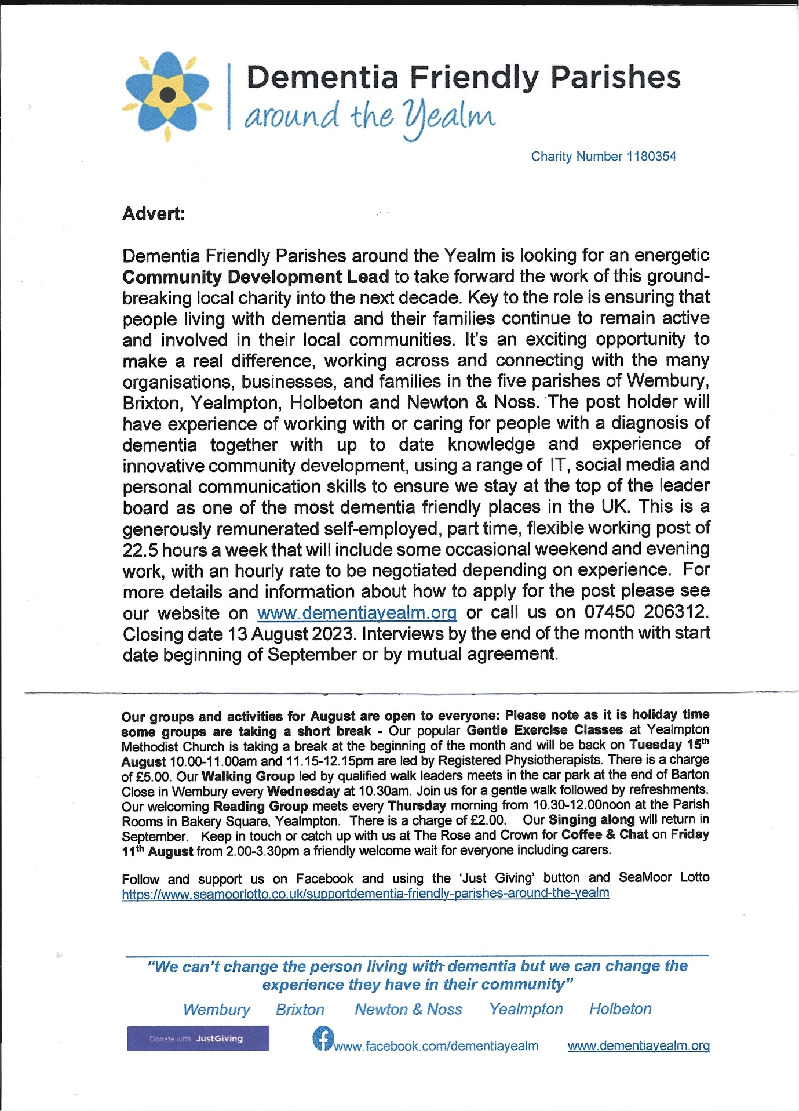

Calling all budding local historians.
British Listed Buildings web site are appealing for photographs of any date of the listed properties in our area. If you have any photos, please upload them to :-
https://britishlistedbuildings.co.uk/england/newton-and-noss-south-hams-devon

Holy Cross Clock Restoration Project

Newton Ferrers Holy Cross Church stands at the heart of the community it serves and has launched a fund-raising program for the refurbishment of the church clock.

The 2023 fund raising program was launched in June. Donors from across the Newton parish have generously contributed towards the fund. At the time of writing donations have reached £4700, which when added to previous fundraising, means we have now achieved 75% of our funding target of £22,000.

A big thank you to all who have donated to date. Holy Cross Church is extremely grateful for your donations.

There is still a way to go to reach our funding target so if you wish to support the maintenance of this historic Grade 1 listed building then please consider making a donation. Any size of donation will be greatly appreciated. All donations will be held in a dedicated fund for the clock restoration project and any surplus will be used solely for the upkeep of the church building and grounds.

Please note that your donation can be increased by 25% through Gift Aid. This can be arranged by contacting Phil Davis, the Treasurer.
Donation methods
1. To pay online please go to the Yealm and Erme Mission Community Giving page and select the Holy Cross Clock Restoration project at https://yemc.org/giving/ or use the QR code:
2. To pay by BACS, please pay to Holy Cross Church Newton Ferrers, Santander, Sort Code 09-01-51, Account Number 55625500.
3. To pay by cheque, please make it out to Holy Cross Church and send to our Treasurer, Phil Davis at 38 Court Road, Newton Ferrers
Thank you for your support of Holy Cross and the Clock Restoration Project.
Yours sincerely, Rev’d Kim Lovell 07305 155375 Phil Davis – Treasurer 01752 872891

Joint Neighbourhood Plan Review and Collaton Housing Event
Hard to believe it but it is 5 years since you all took part in preparing our very successful Neighbourhood Plan, which was adopted as law in July 2018.
Used by the Planning Department in South Hams in conjunction with the South Devon Joint Local Plan and National Planning legislation, our Neighbourhood Plan has been instrumental in guiding Planning Policy in the Parish; protecting the Waterfront and our Heritage, encouraging the right sort of Development and discouraging poor planning proposals and overdevelopment.
During the Autumn, we will be conducting the next round of Consultation events to narrow down what now needs to be added or updated.
They will be joint events with the Collaton and Community Land Trust teams, who will be advertising the criteria for the Affordable housing and helping people to work out who will be eligible, how to apply etc.
• 15th September: 12pm - 6pm
• 16th September: 9.30 - 12.30pm
• 13th October: 12pm - 6pm
• 14th October: 9.30 - 12.30pm
• 17th November: 12pm - 6pm
• 18th November: 9.30 - 12.30pm
At the moment, all of the events will be in Newton and Noss Village Hall.

After a roller coaster few years, YCE are finally in a position to offer investment in the 3 local solar farms at Newton Downs, Creacombe, and Marlands, via its share offer launching 10am, Monday 31st July, 2023.
We must thank you all for being so patient whilst we have worked tirelessly in the background through many work streams:- due diligence, risk, legal, technical and governance issues, to name but a few.
We have not been able to do this without you, and the communities unwavering support.
Read on for more details of the share offer:

Yealm Community Energy Share Offer.
The full offer and all of the associated documents will be live on YCE's website for you to view in full on Monday 31st July.
The offer will be accompanied by YCE's business plan 2023-2026, and a copy of our rules which are compliant with the FCA.
Capital at Risk
Summary of the key points of the share offer.
Min investment £250.
Maximum investment £100,000
6% p.a potential return on investment
Target raise £860,000
Opens 31st July 2023
Closes 27th October 2023
Anyone over 18 can apply for shares
It is estimated that over 27 years the YCE community Benefit Fund could generate IRO £7.6M excluding running costs.
To date YCE has granted £100,000 to local projects.

Planning

Court Orchard 9 Court Road Newton Ferrers 2011/23/HHO
Part-retrospective householder application for the replacement of an existing uPVC conservatory with an aluminium conservatory with a roof lantern.

Riverside Road West Newton Ferrers 1250/23/FUL.
Land adjacent to Poppy Cottage, a new dwelling with associated car parking and landscaping. Lots of local support but located within the Neighbourhood Plan low density policy area and close to listed buildings

7 Riverside Road East Newton Ferrers PL8 1AE 1761/23/FUL
Application for refurbishment & extension to existing front garden studio.

Oystercatchers 79 Yealm Road Newton Ferrers PL8 1BN 1725/23/HHO
Householder application for renovation and extensions to existing house, including works already undertaken as part of approval 2069/21/FUL. Re- submission of application 4130/22/HHO.

Newton Ferrers County Primary School Parsonage Road Newton Ferrers PL8 1AS 1272/23/FUL
Remove the existing roof & replace with new roof. This work is necessary to fix the leaking roof.

Searush Revelstoke Road Noss Mayo PL8 1EA 177/23/HHO
Householder application for roof extension, remodelling & extension to car parking area.
The proposed view from the west shown below is borrowed from the Application Design and Access Statement.
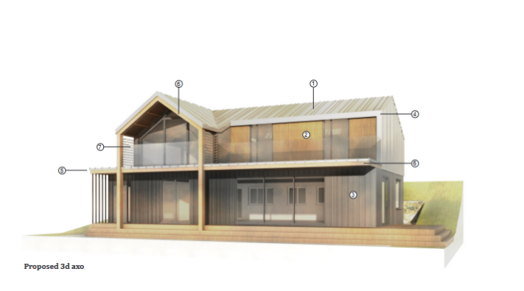
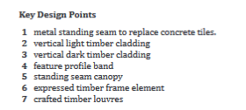

The addition of a new upper floor and refurbishment of this bungalow will give this home a new life. The addition of a standing seam metal roof and timber cladding will provide a modern appearance and allow the new building to better blend in, but some may find this is out of keeping with its location. The large balcony on the west elevation will overlook most of Noss Mayo at distance.

Agora House Stoke Road Noss Mayo PL8 1DY 2126/23/HHO
Householder application for enlargement of front driveway, bin storage & EV charging point

34 Coach Road Noss Mayo PL8 1EF 1435/23/HHO
Householder application for pitched roof above existing flat roof & new bay window

The Mooring Newton Hill Newton Ferrers PL8 1BG 1668/23/VAR
Variation of Condition 1 (approved plans) of planning consent 0068/20/VAR. Largely retrospective to overcome some omissions and changes from the approved design.

5 Yealm Road Newton Ferrers PL8 1AH 1361/23/HHO
Householder application for new vehicle/boat parking area & incidental store with access from Church Park. This proposal is for a large private parking area at the end of Church Park, there will need to be careful management during construction to ensure there is no disruption to residents or users of the adjacent public footpath.

What’s On?

Regatta Events
Tue 1, @ 17:00 Crabbing and Peanut Race at Popes Quay
Wed 2, @ 18:00 Dayboat Sailing, YYC
Thu 3, @ 18:00 Waterborne Treasure Hunt, Enter at the Yealm Steps, No Vehicles
Fri 4, @ 18:30 Pub Race + Ladies & Gents Novice Paired Oar Race, Popes Quay
Sat 5, @ 09:30 Senior Tennis
Sun 6, @ 10:00 Men’s & Ladies Cricket, Butts Park
Tue 8, @ 09:30 Junior Tennis
Sat 12, @ 19:00 Regatta Function, YYC

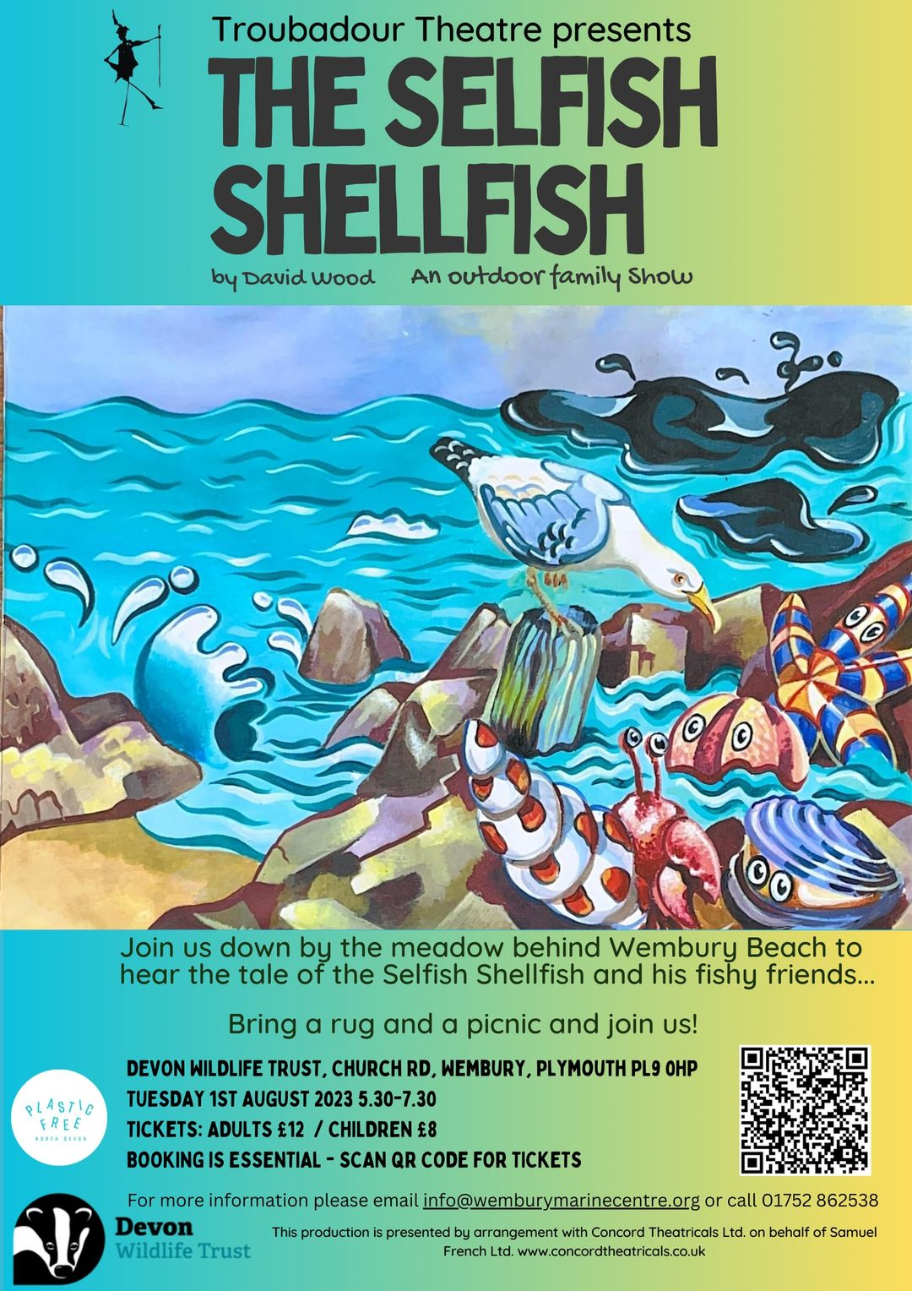

First Tuesday Lunch Club 12.00 noon 1st August in the Venning’s Garden if nice, in Newton community hall if wet. Allergies can be catered for. Please contact either Jeanne (872442) or Jane (872627)

TUES, 1 AUG at 11:30 National Marine Week Rockpool Safari Wembury Marine Centre
FRIDAY, 4 AUGUST 2023 from 13:30-15:30 Extreme Rockpool & Shoresearch Survey Wembury Marine Centre

Tuesday 15th August 13.00 WI Meeting (Presidents Tea Party)

Friday 18th August 2.00pm Yealm Parchment Group Newton Ferrers Community Hall
We will be painting using water colour and mica paints.
Contact Lesley 07838375449 for information £8

There is NO Thursday Lunch club during August, but we look forward to welcoming you back on September 28th It will be low tide. Please contact mrandmrsbarnett@gmail.com Allergies can be catered for.

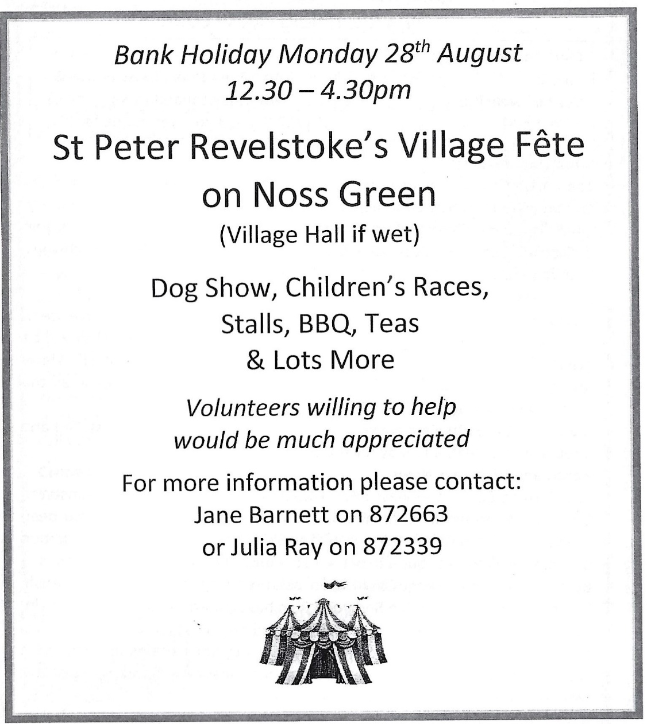

Save the Date
27 SEPTEMBER 2023 FROM 22:00-23:30
Night-Time Rockpool Safari Event by Wembury Marine Centre£9.68

30 SEPTEMBER 2023 FROM 10:00-12:30 £30.00
Snorkel Safari Event by Wembury Marine Centre

1 OCTOBER 2023 FROM 13:00-15:00 £8.61
Extreme Rockpool Safari Event by Wembury Marine Centre

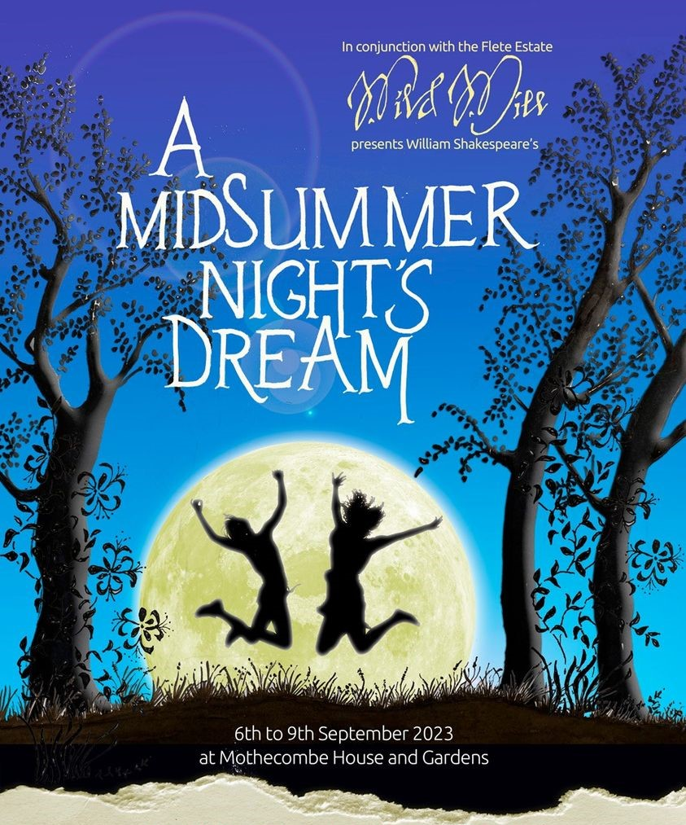
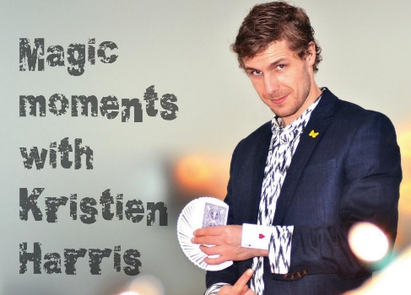
Kris Harris – Magician: Has been booked for 18th November 2023, in the WIC hall. There will also be a Cabaret.
This is a WI fund raising event open to all.
More details nearer the time

