RYDA Newsletter 05/2018
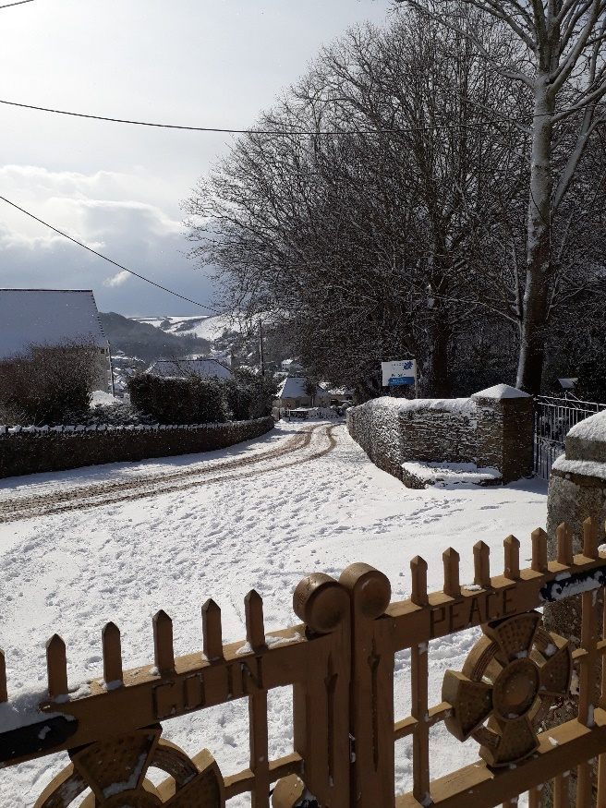
RYDA NOTICE BOARDS
It is always great to achieve a satisfactory end through embracing recycling.
Alan Lomax has undertaken the refurbishment of the RYDA Notice Boards. This involved re-use of the snooker table green baize from the Tilly Institute, which had been carefully stored complete with its dust, by Guye Roberts!
In previous years this system had been set up by the late, great Ken Davenport, who needless to say, had made the Notice Boards [cabinets] in the first place!

Do you remember this…………..?

Just a few reminders for winter weather:-

Check on your neighbours
Do they need shopping?
Are they lonely?
Are they warm enough?
Do they have a hot meal?

Check your car
Are the tyres OK?
Do your wipers need replacing?
Is the washer bottle full?

Are you driving?
Give way to drivers coming UPHILL. If they have to stop they may not regain traction and block the road; it’s easy to go downhill, but remember it will take longer to stop, so SLOW DOWN
Take a hot drink & blanket
Take a shovel
Make sure your phone is fully charged

Snow is fun, but make sure you don’t endanger other people by making the pavements a skating rink. Think before you slide.

POPES QUAY

The Association undertook a light refurbish of Popes Quay in time for Regatta this year.
Two of the capstans had been missing the caps so these were turned up in oak and replaced. All capstans were re-varnished to match.
The lifebuoy which unfortunately is viewed by some visiting children as a toy, now has a very complete bracket to hold it in place, with the words “this buoy is not a toy”.
We purchased a larger and lighter Union Flag which flew boldly during regatta and will do so in the future.

This Christmas, give the gift that keeps on giving
& Costs…. NOTHING
TIME

TIME is precious; TIME passes so fast
In the recent WW1 commemorations we heard of people who have no memories of their families; - lost, due to conflict. We never know if our TIME on earth will be long or short; so spend TIME with your loved ones. Make memories, together, to be shared down the corridors of TIME

A big handout to good causes for the Parishes around the River Yealm

The Community-owned Solar Farm at Newton Down’s Farm has just allocated it’s profit from the first year’s trading to the community’s covered by Yealm Community Energy - £20,000 in total so far.

A Community Benefit Society was formed 3 years ago in order to purchase the proposed 5MW solar farm at Newton Down’s Farm for the community. They are now the junior partner in the ownership and have 2 years to buy out our major shareholder, and in the meantime are able to benefit from the profits, all of which are placed in a Community Fund (CF).

The CF is allocated by a committee separate from the YCE Board, and priority is given to those projects locally which help to alleviate Fuel Poverty, reducing greenhouse gas emissions &education; and to projects with a tangible social benefit, including those that help conserve nature.

They had applications from village halls, schools and Brownie groups amongst others. Brookings Down Wood got £1,200 towards making trees safe in the newly acquired Eastern Hill Wood; a pilot scheme to assess those at risk of energy poverty was awarded £2,541; Yealm Girl Guides were awarded £247, & £145 to learn how to encourage bees to survive, & how to reduce plastic waste; 2 schools and 2 village halls were also amongst the beneficiaries, all of which will be announced at an open meeting in the WIC Hall on Parsonage Road in Newton Ferrers on Thursday 13th December at 7pm.

On a lighter note, early in November we said “Thank You” to three Committee members who have stepped down.

John Tighe - who managed the Community Directory for many years;
Peter Pritchard - who wrote the newsletters and dealt with planning issues, &
Christopher Lunn - retiring chairman, who is remaining on the committee

Photograph (L to R) Robin Forrester (Planning); Alan Lomax (Treasurer); Suzanne Sparrow (member) John Tighe; Christopher Lunn (member); Peter Pritchard; Chris Bradley (Chairman) & out of shot, sorry, Helen Lancina (Secretary)

Later in November, we welcomed Peter Faulkner to fold, who is taking over the Community Directory.
All members of the RYDA are invited to attend this meeting to hear briefly about all the winning projects, and to be inspired to apply for funds for any local community group.

The opportunities for community benefit are threefold. Firstly, the CF as outlined above, secondly buying into part of it by purchasing shares and finally the Grid is being decentralised, and this is likely to result in a few years’ time in us being able to sell our electricity directly to local consumers at a lower price than the ‘big six’ will be able to.

In the meantime, they are also working hard to enhance the biodiversity of the solar site by establishing a pollinator friendly wild-flower meadow, and a bee-keeper has placed some hives there, and sheep graze outside flowering and seeding times.

More information from info@yealmenergy.co.uk
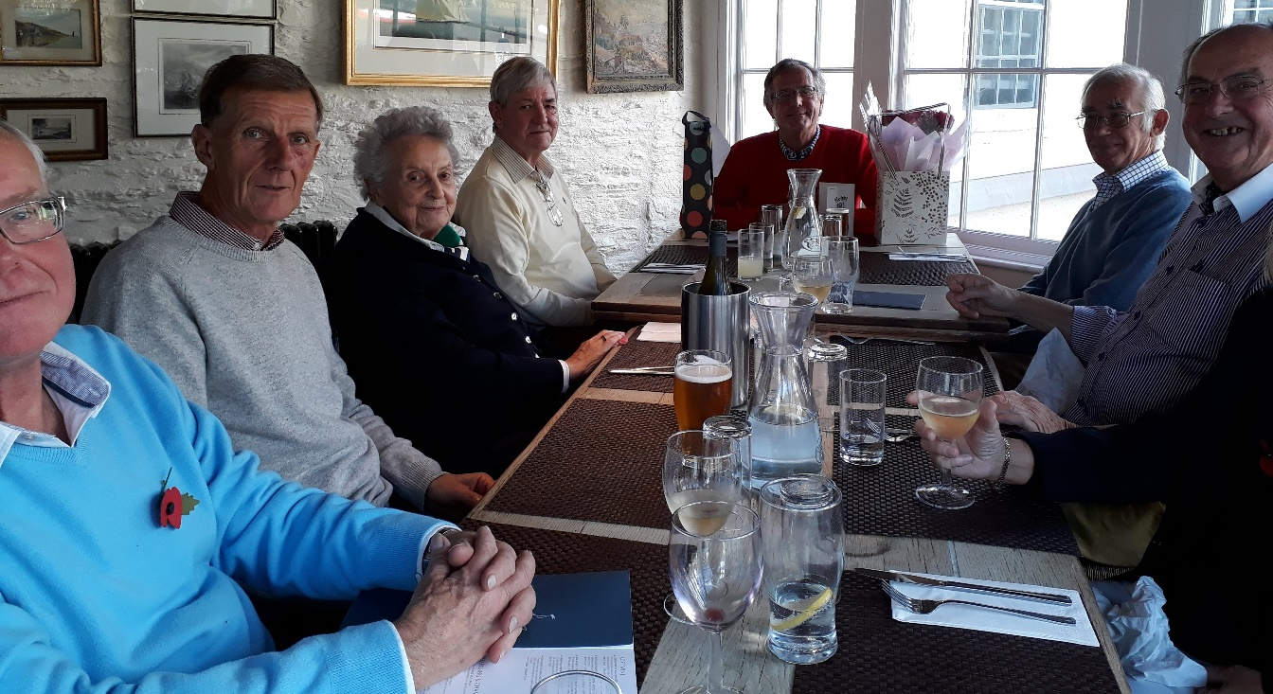

Planning Issues

The recently adopted Newton & Noss Neighbourhood Plan (N3P) included a Village Development Boundary. Outside of this, new developments should only be permitted in exceptional circumstances to meet an essential local need which could not be met elsewhere. Among the planning applications made since our last newsletter are two attempting to build close to, but outside this Boundary, one in Noss and one in Newton:
The first is a proposal for a new house on the wooded hillside above Stoke Road, opposite Junket Corner, see link for more information Stoke Road . This is outside the Village Development Boundary in an area designated as an important local view by the Neighbourhood Plan. Both the Parish Council and your committee have lodged objections.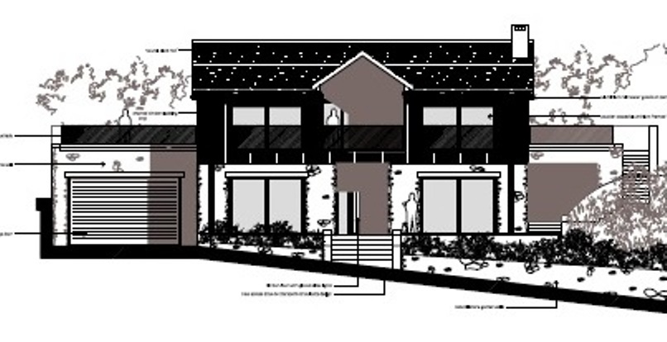
Stoke Road on Land opposite Junket Corner

The second application is for a two bedroom cottage on Lower Court Rd , adjacent to Lockalsh. Although relatively modest, this would nevertheless encroach on the lightly wooded hillside to the east and above Lower Court Road. This area consists of some widely distributed houses separated by areas of woodland, thus reducing the impact on the surrounding AONB and the nearby Court Wood. For this and other planning reasons, your Committee have also objected to this application.
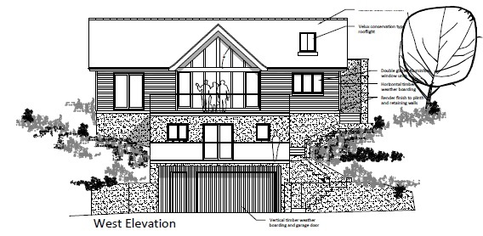
Lower Court Road, adjacent to Lockalsh

If allowed then the remainder of these areas can be expected to come under pressure for further development, seriously degrading the sylvan aspect. These two applications present an important test of the ability of the Neighbourhood Plan to limit unnecessary development outside the Village Development Boundary.
Please let us have your views on these Applications.

